Visual Study Strategies
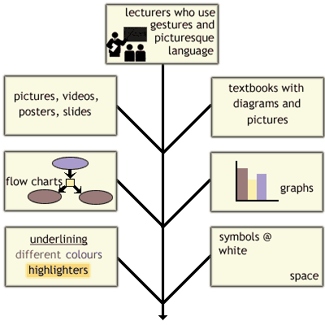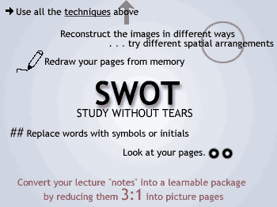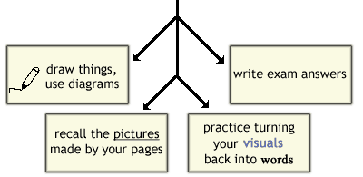
You want the whole picture so you are probably holistic rather than reductionist in your approach.. You are often swayed by the look of an object. You are interested in color and layout and design and you know where you are in your environment. You are probably going to draw something.

