AR REPORT

TEACHING MIXED ABILITIES

THROUGH PEER ASSISTED LEARNING (PAL)

Post Graduate Certificate in Learning and Teaching in Higher Education:

Theatre & Performing Arts

Elena Cester Lozano

Student nº 1800104

08/10/2018

5193 words

Background………………………………………………………….….2

Literature Review applied to ballet technique

teaching and learning……………………………………...…………..3

Action……………………………...………………….……………....…9

Survey and findings…………………………………...…………...…11

Reflections and the Future……………………………………...…...14

References………………………………………..……………..…....17

Appendices:

Survey 1…………………………………………………...……...…...21

Survey 2…………………………………………………………….....23

Task 1……………………......………………………………………...25

Task 2……………………………………………………………..…...26

Task 3……………………………………………………………..…...27

Task 4…………………………………………………………..……...28

Task 5……………………………………………………………..…...29

Task 6…………………………………………………………..……...30

**Background**

One of the most challenging classes that I am teaching at the moment is a Classical Ballet technical class for first year BA Musical Theatre students. In this class levels of ability are extremely different. Some students do not know how to tie their ballet shoes, while others have done ballet for years.

I’ve seen very often in the dance context, how teachers tend to focus (consciously or unconsciously) on brighter students, because they are easier to teach, but also because producing high level students seems to mean that teachers are better.

I deeply disagree with this practice. Using the word “producing” when talking about students seems to me pretty descriptive about the approach of the teaching: students are objectified, and therefore passive, while teachers take 100% of the credit and responsibility for the result of their teaching. This would be described by Biggs and Tang (1999) as a level 1 teacher, focusing in *what the teacher does* instead of about *what students do.*

In my opinion is not about the “final product”, but about the personal journey of each student. Some students are more difficult to teach, while others simply cannot be prevented from learning (Bucur and Thorbeck, 2016). Therefore, the level cannot be considered as a reliable indicator of the quality of the teaching. The personal evolution of each student would be a more accurate way to measure if effective teaching has occurred.

I believe from the moment a student is accepted in a course, she or he should be supported in the same way as her or his peers and adequate learning opportunities should be facilitated to him or her.

This Action Research (AR) is an attempt to offer a fair learning experience to all the students in the class, no matter what their initial level of abilities is.

**Literature review applied to Ballet Technique teaching and learning**

Ballet is a very traditional dance context. In a ballet class students reproduce the exercises demonstrated by the teacher, with a set order, in a set space, and with a set music. The discipline and protocols in class are very strict. Even if it’s an active subject by nature, the structure of the class is very rigid and unidirectional. Teachers are powerful figures, respected and admired by students. When they come in the class everybody is in silence, no one contradicts the teacher, even if the teacher is wrong. There is no debate between teachers and students. In such a strict environment, introducing new inputs to help ALL the students to learn, and promote active and deep learning, is extremely challenging.

Learning takes place through the active behaviour of the student: it is what he does that he learns, not what the teacher does.(Biggs, 2002)

**Constructivist Learning and Teaching** perspective represents “a shift from viewing learners as responding to external stimuli to seeing learners as unique individuals, who are responsible and active in constructing their own learning” (Lam, B.H., 2011).

How can this theory be related to classical ballet technique learning and teaching?

Ballet technique is hard and demanding. It requires a lot of repetition and perseverance. The difference though between a simple repetition of a movement, and a fully aware is striking. Students need to understand the purpose of each exercise, the muscles involved in each movement, the specific dynamic of each step, where their weight is, and how to transfer it, how to control their center of gravity, energy management, breath, suspension, attack...it’s not what they do, is how they do it, and there is a lot of room for discussion and debate about all of this. It is a perfect example of superficial learning, where the students just repeat the movements demonstrated by the teacher, and deep learning, where learners understand the structure of the class and experiment with the proposed movements to take them further, and perform them better and more efficiently with every repetition.

The role of the teacher can be much more than a distant figure to listen and imitate. Teachers can create an appropriate learning environment, question the students to help them to understand the principles behind classical technique by themselves, and to become autonomous lifelong learners.

Motivation in such a complex discipline is essential. Personal improvements should be recognized, and students guided and encouraged to keep searching and growing, and enjoying the challenge of it.

Accordingto **Laurillard’s conversational framework (**1993,2002) students learn by Acquisition, Inquiry, Discussion, Practice, Collaboration and Production. In a “standard” ballet class students learn by Acquisition when they look at the teacher demonstrating the exercise, Inquiry, if they ask questions, and Practice when they perform the exercises themselves. The tasks I gave to the students as part of this AR were designed to encourage them using the learning styles that are usually not included in a ballet class. Discussion and Collaboration when working in couples and as we review and discuss the given tasks in class, a deeper Inquiry when they are asked to research about a specific topic, and Production in choreographic tasks.

This particular tasks have also been designed with a scaffolded approach to classical ballet technique.

The term scaffolding was introduced in the 60s by the cognitive psychologist Jerome Bruner to describe young children oral language acquisition with the help of their parents. The Glossary of Educational Reform gives us a very clear definition of Scaffolding: “**Scaffolding** refers to a variety of instructional techniques used to move students progressively toward stronger understanding and, ultimately, greater independence in the learning process.”(([https://www.edglossary.org/scaffolding](https://www.edglossary.org/scaffolding/))

The support and guidance provided to the learner is compared to the scaffolds in building construction where the scaffolds provide both "adjustable and temporal" support to the building under construction. The support and guidance provided to learners facilitate internalization of the knowledge needed to complete the task. This support is weaned gradually until the learner is independent.(Palincsar, 1986).

In scaffolding, teachers as learning facilitators, should adapt to the learners needs.

Vygotsky argued that we learn best in a social environment, where we construct meaning through interaction with others (Wheeler, 2017).

According Vygotsky (1978), in order for learning to occur, learners should be in the “Zone of proximal Development” (**ZPD**). This is the distance between the actual developmental level as determined by their independent problem solving, and the level of potential development as determined through problem solving under the adult/teacher guidance or in collaboration with more capable peers. With help and collaboration, learners can move through the ZPD and can carry out the tasks that they cannot do by themselves. (Bekiryazıcı, 2015).

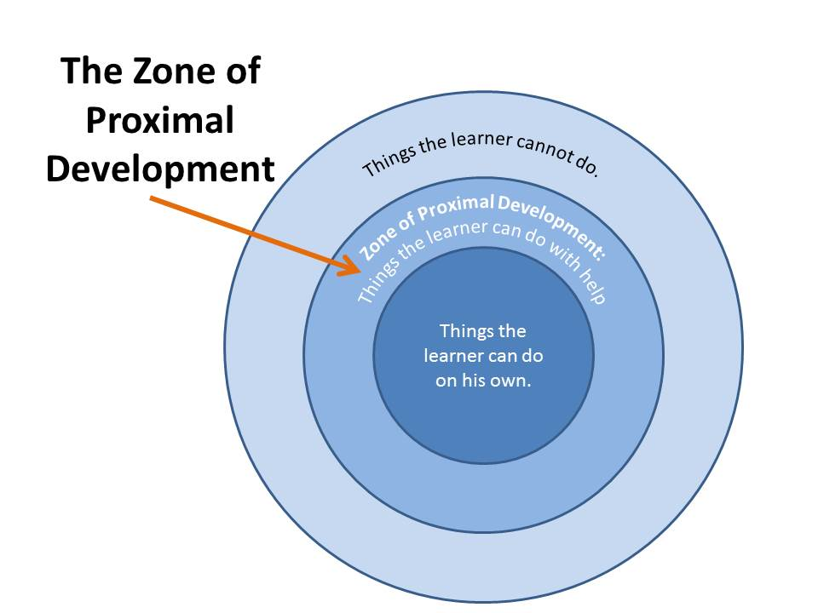

Although Vygotsky’s works mostly focus on children development, ZPD and scaffolding have been largely applied in adult teaching and for undergraduate students, and there is sufficient research about it: Wass and Golding (20013), (Dunphy & Dunphy, 2003), Tharp and Gallimore(1991)to name a few.

**Peer learning**

Peers come from ‘similar social groupings’ and engage in mutually beneficial learning partnerships that build on ‘helping each other to learn and learning themselves by teaching. (Topping’s,1996, p.322)

Peer learning has always been present in everyday life. When we need information about something, we rarely take straight a course on it, what we normally do is to ask for advice, guidance or tips from to our friends, neighbours, colleagues. Boud (2001). Asking for guidance from a person who is in a similar situation than us has multiple advantages, in terms of communication, understanding and empathy.

In formal learning context peer learning is also very valuable, and to make it effective, it needs to be properly supported and organized. According to Boud though, we need to carefully measure how much we interfere in the peer learning process. He states that the main reason to formalize the informal and natural peer learning is “to realize the potential benefits of peer learning so that all students can benefit from peer learning, not just those who are socially adept or best networked. It is neither possible nor desirable to formalize all aspects of peer learning.” (Boud, 2001, p.8)

Peer work has significant benefits for students:

-Values cooperation among competition, develops collaborative skills, and promotes tolerance, awareness of diverse perspectives, understandings and learning methods.

Developing teamwork skills is essential for a dancer. In the professional context, dancers work in companies, that is, as members of a group. The creation of a choreography is usually a collaborative process between the choreographer and the dancers, and they need to know how to behave effectively in an ensemble situation. In such a competitive world, this is contradictory and not always easy to achieve. Offering learners a situation where they will discover by themselves the advantages of collaborative work is a great value for them.

With respect to cooperative learning, Johnson & Johnson (1989) have concluded that cooperative learning consistently produces higher achievement than either competitive or individual effort. (Capstik, 2003/4).

-Promotes deep learning. Peer learning encourage graduates to become lifelong learners, as well as helping them to develop ‘reflective practice and critical self-awareness” (Candy, Crebert and O’Leary,1994)

-Enhances students’ performance and student’s retention. Students who are actively involved in learning, that is who spend more time on task especially with others, are more likely to learn, and in turn, more likely to stay. (Tinto, 2006, p.3).

-Develops self-management skills and managing with others, responsibility and learning autonomy. (Boud, 2001)

-Students offers emotional support to each other. Peer feedback is also often better accepted by the students. Peer learning can be particularly useful for first year students, in helping them to adjust to university.

Peer support can, in the right circumstances, contribute to students' social and academic integration (...). In keeping with much of the literature, we believe that engagement will only result if the student is able to integrate socially, academically and with the institution itself. (Black and MacKenzie, 2008)

-It's also important to acknowledge that peer learning helps teachers to deal with large groups, which is important in the present context in higher education.

-Peer learning has been proven to help students in terms of academic achievement, but even more important,

The value of PAL lies in its enhancement of student experience of university.

Stuart Capstick (2003/4)

Peer assisted learning is considered to be today an important part of the learning process in higher education, and there is been a lot of research about it. It is not though a very common practice in the context of dance and especially classical ballet teaching and learning.

I’ve been unable to find a single study specifically about PAL and ballet. I found some literature (not much!) about **collaborative learning** and classical ballet:

Cadence Whittier (2017), proposes a collaborative classroom environment for classical ballet teaching and learning using the **subject-centered classroom**.

Palmer (1998) presented the subject-centered classroom model as an alternative to the teacher-centered or student-centered systems, to avoid potential leaderships imbalances in the learning environment (Whittier, 2017). The subject, considered, as a being, is placed at the centre of the learning. This approach does not focus on what’s best for students or teachers in isolation, but instead what is best for the entire community engaging in the subject of study.

To implement subject-centered learning a teacher asks the question: What is the best way to teach this subject? (...) the subject is a neutral thing (i.e. politically) and serves to unite the teacher and student in a common goal. (Morrison-Saunders and Hobson, 2013)

In this teaching and learning model students are expected to engage with their learning as potential experts in the field. Collaboration and interaction between students and teachers are encouraged, and leading roles can shift between teachers and students depending on the “needs” of the subject for being learnt in the most effective way.

Cadence Whittier (2017) applies this model to classical ballet technique teaching and learning. She organizes the curriculum in units that focus on specific concepts and skills. Each unit has a different length, and the amount of sessions leaded by the teacher or the students is pre-established depending on the content.

Student-centered ballet classrooms challenge students and teachers alike to grow and develop in their art form as individuals and as members of a creative and dynamic community of learners. (...) Each person in the ballet classroom has the potential to contribute to the knowledge produced within the technique classroom. Whittier (2017).

I have included this teaching approach because it’s one of the only two sources I found about collaborative learning and classical ballet technique teaching and learning, but I don’t really agree with it. It has some positive things, as encouraging collaboration and reflection and promoting the creation of a learning community, but I believe education should be holistic, and students encouraged to inter-relate the different subjects. In my opinion the ultimate goal of teaching is not the subject, but the personal development and growth of learners. Talking about a subject as “a being”, (Palmer, 1998) is for me quite peculiar, and I have to admit it makes perfectly sense that this teaching style is used in classical ballet teaching, a context that is very often extremely rigid, and where ballet is not considered to be only a subject but *THE SUBJECT*.

The other source I found about using collaborative teaching and learning methods in ballet technique classes is called “focused listing” (McCarthy-Brown, 2017). Students produce on their own a list of concepts and thoughts about a specific topic proposed by the teacher. They discuss it in pairs, any finally share their findings with the all class.

I found a bit more literature and research about contemporary dance and peer learning, but it’s still not much:

Sandry (2014), conducted a research about peer learning and contemporary dance technique classes with the title “How Can Peer Learning have An Impact On Students’ Engagement In Dance Technique Classes – Using Second Year University Dance Students In The UK”. Her conclusions were that peer learning had a great impact on students, promoting deep learning and critical reflection.

Raman (2009) researched about enhancing dance technique learning, by promoting critical thinking, using pair work in Cunningham-based classes:

“It was found that pair work created a positive learning environment and instructions that promoted critical thinking and encouraged students to take more responsibility for their learning.” Raman (2009).

A big part of the dance teaching and learning community questions today the traditional teaching methods. Student-centered approach, constructivist and collaborative learning are becoming more and more present. In the classical ballet context though, one of the most traditional and static forms of dance, new teaching styles are only starting to appear.

**Action**

There are quite a lot of possible models of peer assisted learning.

Griffiths, Houston and Lazenbatt (1995), researchers from the University of Ulster identified at least ten different models of peer learning.

The students involved in this AR were BA (Hons) Musical Theatre Students, level 4.

I have used two different models of PAL. Students were grouped in pairs always from the same cohort. The difference was on their initial level of knowledge of the subject:

A-Beginner-Advance: Mentor-mentee model. (Garcia-Melgar et al., 2015), or Tutor-Tutee (Topping, 1996).

There is a lot of research about the benefits of tutoring for the tutors:

Existing knowledge is transformed by re-organization, involving new associations and new integration. The act of tutoring itself involves further cognitive challenge, particularly with respect to simplification, clarification and exemplification. (Topping, 1996).

This process forces peer leaders to engage with the material at a deep level, helping to solidify their own understanding of it. (Micari, Streitweiser and Light, 2006, p.270)

Benefits for tutees include a safe space to work with the support of their peers, and a closer and more personalized attention, away from the pressure of slowing down the rhythm of the class.

Pedagogical advantages for the tutee include more active, interactive and participative learning, immediate feedback, swift prompting, lowered anxiety, with correspondingly higher self-disclosure and greater student ownership of the learning process. (Topping, 1996).

B- Reciprocal peer learning (Boud, Cohen & Sampson, 2002), or the “Buddy Scheme”, two students with similar level. It’s a group without tutor.

The benefits for the learners involved in this model are related to team work, collaborative skills, self-management, etc.

It gives them considerably more practice than traditional teaching and learning methods in taking responsibility for their own learning and, more generally, learning how to learn.

Boud, Cohen & Sampson (2002)

Much learning takes place from sharing others’ experiences, existing knowledge and skills. Students learn to acknowledge the backgrounds and contributions of the people they are working with.

(Boud, 2001)

Students received a weekly task to work on outside the class, with their assigned peer. Each tasks was about a specific technical area, with a scaffolded approach to help them to understand in depth classical ballet technique. A technique that is extremely strict and physically demanding. It’s a huge challenge for late learners (and at least half of this particular class is), and it can be very frustrating. It’s essential for me that these students understand why they are doing classical ballet, when most of them do not even like it. Classical ballet is not an end for them, but a valuable tool that will give them a lot of physical control and discipline. They need to truly understand the principles of classical ballet technique, so they can use it in their own context. In this technique there are plenty of rules and restrictions. The great thing about it, is that there is an anatomic reason behind each rule. Ballet technique is how it is, in order to optimize physical performance. This is how classical dancers can physically do movements that seems impossible for the human body. Understanding the reason for each rule makes a huge difference for learners.

Some tasks were theoretical, for example about basic anatomic concepts or classical ballet nomenclature. Other tasks were practical. Students had to physically demonstrate a particular step, or choreograph and perform an exercise.

In task number 2 students were asked to choreograph an arms exercise. We all the propositions in class all the exercises the students proposed. They voted for the best one and I included it as part of their final assessment. I did not participate in the voting or interfere at all in that process, and I could see how student felt empowered, as they set themselves part of their own final assessment.

To measure the result of the AR, students filled up an anonymous survey about their engagement and understanding of the class, before and after the action.

**Survey and findings**

The answers in the first survey were far too positive. I had the feeling that students wanted to be polite and did not dare to be 100% honest about how they felt about the class. This makes very difficult to evaluate the success of the action.

The first two questions of the survey were about understanding the need of the class in their programme, and the class fulfilling their expectations. More than 90% of the students answered *yes* to both questions and in both surveys, so there was no difference before and after the AR.

For the following questions, I have marked in red the areas where there were significant differences as a result of the peer work.

It’s important to keep in mind that the group is quite small, only 15 students when we did the first survey, and 14 for the second one as a girl was absent on that day. This means only one student represents between 6 and 7%. The scale is far too small and this should be taken under consideration when analyzing the data.

|  |  |  |  |  |  |  |
| --- | --- | --- | --- | --- | --- | --- |
|  | 1st survey | | | 2nd survey | | |
|  | Yes  (always / most of the times) | Sometimes | No  (rarely/ never) | Yes  (always / most of the times) | Sometimes | No  (rarely/ never) |
| Staff has made the subject interesting | 71% | 29% |  | 73% | 21% | 6% |
| I feel challenged to achieve my best work | 72% | 28% |  | 78% | 22% |  |
| I received sufficient and clear feedback (1) | 86% | 14% |  | 54% | 33% | 13% |
| The class is useful for me | 79% | 21% |  | 80% | 14% | 6% |
| I feel comfortable asking the teacher for help | 79% | 14 | 7% | 74% | 26% |  |
| In class I feel stressed about doing mistakes or not being good enough (2) | 50% | 22% | 28% | 48% | 26% | 26% |
| I’m aware of my own improvements (3) | 29% | 43% | 28% | 47% | 40% | 13% |

**(1) Receiving sufficient and clear feedback**.

Students felt less satisfied about receiving enough feedback after the action than before.

They did receive less individual feedback from me during the action, but more from their peers. It seems they don’t recognize peer feedback to be as valuable or useful as teachers’ feedback.

**(2) Feeling stressed about doing mistakes or not being good enough**

I was very surprised by reading that half of the class felt so much pressure in class both before and after the action.

I was profoundly worried about this, as creating a safe space in class is priority number one for me in when teaching mixed abilities classes. I carefully chose the words and the tone, I always reward effort and recognize individual progresses, I never compare students, I keep repeating that we are all different and that's fine, I tell students that perfection doesn’t exist, it’s just an unreachable concept, and mistakes are not just normal but necessaries to learn...I also insist, as I have mentioned above, that ballet is a tool for them and each one has to find her or his own way to use it. There is not a specific level that all the class has to reach at the end of the year.

As I read all the surveys I realized that students didn’t feel as threatened about me as about their own peers. I also realized, (even as I read myself!) that if been very careful and thoughtful about **what I do**, but not about **what students do.**

I guess I’m still teaching from a Level 1 perspective (Biggs and Tang, 1999), and I didn’t realize that the group was not ready as a group to work collaboratively as they are not yet an effective learning community.

**(3) Being aware about their own improvements**

Students seem to be more aware of their own improvements after the action. A deeper understanding of the subject helps them to identify clearly their own strengths and weaknesses, and recognize their own progresses. Developing a better self-perception allows students to work with a more accurate focus towards what each one of them needs to focus on. This means the same ballet class can be approached differently from each student, according his or hers own needs.

**Students feeling after the class**

Around 50% of the students recognize to feel frustrated after the lass, both before and after the action.

Ballet technique is extremely difficult and demanding, specially for late learners as half of this class is. Understanding the theory is much faster than being able to perform it physically. The fact that students have a deeper understanding of the classical technique now, makes them also more aware of their own limitations and of everything they still can’t achieve. A feeling of frustration and discomfort is natural at this particular stage, but it’s important that they understand we are aware of this and support them dealing with this discomfort feeling.

**What would students change about the class**

In the first survey, as it was to be expected, the majority of the suggestions were strategies to deal with the different levels in the class. Students are perfectly aware of the obstacle that this represents for the class to be effective.

In the second survey comments were much varied. Some students still expressed concerns about the different levels in the class, but they also talked about assessment preparation process, communication between staff and other issues. It seems that mixed abilities was not their main concern any more, but as it was a completely different time of the year (assessments time) I find it totally normal and predictable.

**Was the action useful to you?**

**(Survey 2)**

Yes 60%

No 30%

Sometimes 10%

In general, tudents find that the action was useful for them, but most of the times they cannot explain why. A clear focus for the action was not communicated to them, and this also reflects on the way they approached it.

Even if the survey was anonymous, most of the times I could guess from the answers if it was from a beginner or from a more experienced student.

In general, is seemed that beginners felt more engaged with the class, and found the action more helpful that advanced students. Some of the experienced students felt they were investing time helping beginners and did n o get anything in return. Only a few of them seemed to feel they learnt through teaching. Also some of the beginners complained about not getting enough help from their experienced peers.

The worst feedback was about a student feeling that pairing beginners with more advanced students was embarrassing as it led to comparisons. It was very disappointing and frustration for me to read this as it really felt like I hadn’t been able to communicate at all the intention of the action and the value of peer work.

**Reflections and the Future**

Even if I can recognize some improvements in the level of engagement of students with the class, I cannot say it was a completely successful action.

The action cannot be effective if the students are not ready for it. The fact that students feel pressure about not being good enough in front of their peers, or that advanced students feel bothered about helping their beginner’s peers, indicates that students were not ready for the peer work. The group is not yet an effective student learning community. They don’t recognize the benefits of cooperative learning for them, and I believe they don’t actually FEEL they BELONG to any community. Creating a sense of community should have been an aim prior to the Action.

Successful use of group-work requires much more than simply putting students in groups.

(Shulman, Lotan and Withcomb, 1995)

It is crucial for groups to be trained and organized to practice active and collaborative cooperative learning. (Lenning, 1995)

There is quite a lot of research about how to create an effective learning community. Orbe (1995) proposes specific strategies to build community in the classroom, based on Peck’s (1987) six characteristics of “true community”.

Most of the advanced students of this AR didn’t understand the benefits for them of teaching their peers. They felt that helping their them was a waste of time, and even unfair, as they didn’t get anything in return. I was worried about beginner students, as they are often the ones being neglected in class, and I did not support enough advanced students.

Biggs (2002) warns about the danger of neglecting advanced students in scaffolded work.

During the process of scaffolding it should be kept in mind that while ‘more capable peer’ helps his classmate, the situation of the former should not be ignored. Advanced students also need to learn, and if they are always in the position of being assistance provider, they may face regression. In order to avoid this situation, the teacher should take into account the needs of the more advanced learners and should develop lesson plans and tasks that are also challenging for them. (Biggs, 2002)

The tasks proposed should be very carefully chosen in order to be challenging for all the students, each one at his own level or acting within her or his own role.

Some students complained about not having a proper space to work on the given tasks. Black F.M.and MacKenzie, J. (2008) recommend providing appropriate learning spaces for students to work with their peers, both with and without the interaction of the teacher.

A crucial problem of this AR is the lack of institutional support.

This (peer learning) obviously requires an institutional culture able to nurture and sustain such an environment. Peer learning will not be effective if it is introduced in isolation from other parts of the learner’s life and without regard to what is happening in other parts of the course.Boud (2001)

Teaching and learning methods such as peer work don’t occur at the moment in this institution, but I believe most of my colleagues would be open to it. I’m planning to share this AR and propose to, at least, consider implementing peer work in other subjects and programs.

According Maslow’s (1987) hierarchy of needs, humans have a range of needs from vital ones such as physiological and safety ones, to those related to belonging and feelings of worth, such as love and self-esteem, and finally self-actualisation, where humans aim to fully express their potential and talents.

”The essential feature is that an individual cannot move to the highest level in the hierarchy - self-actualisation - until lower-level needs are met.” Tennant (1997).

Taking this in consideration, another important goal for me is to offer learners strategies to deal with the natural feeling of frustration and discomfort that learners experience when engaging with a completely new and highly demanding subject. I believe that just by talking about it with them would make a significant difference, as they will understand that the way they feel is perfectly natural, they are not the only ones feeling this way, their teachers are aware and understand what they are going through, and we can talk about it openly. I found a source with simple and clear explanations and tools to help dealing with this:

Discomfort-Intolerance: Is it really unbearable? [Froggatt](http://www.rational.org.nz/misc/people/froggatt.htm) and [Lakeman](http://www.testandcalc.com/Richard/index.asp) (1998).

I would like to share this source with the students on the first day, when I introduce the subject, and we establish the ground rules of the class.

Finally, Boud (2001) warns us about the danger of to much interfering in all the aspects of students learning:

We potentially deskill students from developing the vital skills of

effectively learning from each other needed in life and work. ( Boud, 2001)

Students need to develop their own strategies to research, select and use accurate information.

**Summarizing the conclusions of this AR:**

* Working on the creation of an effective learning environment, such as an effective student learning community is important before starting peer work, and would enhance the efficacy of it. Learning communities that emphasize collaborative learning, serve both academic and social purposes for students. (Lenning,1995)
* -Learning cannot happen in a distressful situation, therefore taking care of learners well-being should also be part of being a learning facilitator. Helping students to overcome natural distress emotions, as frustration, enhances their learning and also communicates an example of social and moral values.
* Peer work has a lot of benefits for dance students and could be extremely useful in dealing with mixed abilities classes. To make it effective, it should be supported by the institution and implemented across the programme, and not just in an isolated context.
* Advanced students learning should not be neglected, challenging enough activities and roles should be proposed to them.
* Staff intervention should carefully be measured not to interfere in the process of learning from each other’s.
* Classical ballet context is still exceptionally rigid and the teaching extremely teacher-centered. It’ is possible though to approach teaching from a student-centered constructivist perspective.

**References**

-Bekiryazıc, M. (2015) Teaching Mixed-Level Classes with A Vygotskian Perspective. Procedia - Social and Behavioral Sciences

-Biggs, J and Tang, C. (1999) Teaching for Quality Learning at University. SRHE and Open University Press.

-Biggs, J.(2002). Aligning the curriculum to promote good learning.

Constructive alignment in action: Imaginative Curriculum symposium.

-Black F.M.and MacKenzie, J. (2008): Peer support in the first year

Quality Enhancement Themes:The First Year Experience.

All Enhancement Themes publications are also available at [www.enhancementthemes.ac.uk](http://www.enhancementthemes.ac.uk)

-Blessinger, (2015). Creating meaningful learning environments with STcs.

<https://es.slideshare.net/patrickblessinger/student-learning-communities>. Accessed 29/06/2018

-Boud D., (2001). Making the Move to Peer Learning. Article · January 2001

-Boud, Cohen & Sampson (2002). Making the move to peer learning, in Peer Learning in Higher Education: Learning From & With Each Other. Pp.1-21

-Bruner, J. (1960). The Process of Education: a searching discussion of shool education opening new paths to learning and teaching. Vintage Books

## -Bucur, D. and Thorbeck, R. (2016).Teaching teaching and understanding understanding part 2. Daimi Entertainment and University of Aarhus [Online]

- Candy, P., Crebert, G. & O’Leary, J. (1994) Developing Lifelong Learners Through

Undergraduate Education NBEET, Commissioned Report No 28, Canberra: Australian Government Publishing Service.

-Capstick, s. (2003/4). Benefits and Shortcomings of Peer Assisted Learning (PAL) in Higher Education: an appraisal by students. Peer Assisted Learning conference, January 2004.

-Capstick, S. and Fleming (2003/4). The Learning Environment of Peer Assisted Learning. Peer Assisted Learning conference, January 2004.

-Dunphy & Dunphy (2003), Assisted performance and the zone of proximal development; a Potential Framework for providing Surgical Education. Australian Journal of Educational &Developmental Psychology, 3 (2003), pp.48-58

-Garcia-Melgar, East and Meyers (2015). Hiding in plain sight: the ‘relationship’ in peer assisted learning in higher education.

Journal of Learning Development in Higher Education. Special Edition: Academic Peer Learning

-Glasser, W. (1998): Association for Supervision and Curriculum Development Guide

-Green, P. (2011). A Literature Review of Peer Assisted Learning (PAL). University of Bath May 2011.

<http://www.uni-bielefeld.de/Universitaet/Einrichtungen/SLK/peer_learning/pal/pdf/A-Literature-Review-of-Peer-Assisted-Learning.pdf>

-Griffiths, S.,Houston, K. and Lazenbatt, A. (1995). Enhancing student learning through peer tutoring in Higher Education: a Compedium resource Pack with Case Study Contributions Implementing. University of Ulster.

- [Froggatt](http://www.rational.org.nz/misc/people/froggatt.htm) and [Lakeman](http://www.testandcalc.com/Richard/index.asp) (1998). Discomfort-Intolerance: Is it really unbearable?

<http://www.testandcalc.com/Self_Defeating_Beliefs/sup4.asp>. (accessed the 24/06/2018)

-Lam B.H.(2011). Constructivist Perspectives of Learning. In S.N.Phillipson & B.H. Lam (Eds.) Learning and Teaching in the Chinese Classroom.

-Laurillard, D. M. (1993). Rethinking University Teaching: A Framework for the Effective Use of Educational Technology. Routledge, London.

-Laurillard, D. (2002). Rethinking University Teaching. A conversational framework for the effective use of learning technologies. London: Routledge [ISBN 0415256798](http://edutechwiki.unige.ch/en/Special:BookSources/0415256798) .

-Lenning and Ebbers (1999). The powerful potential of learning communities: Improving Education for the future. ASHE-ERIC Higher Education Report

-Johnson, R. & Johnson, D. (1989). Cooperation and Competition Theory and Research. Edina, MN: Interaction Book.

-Maslow, A (1987) Motivation and Personality (3rd ed), New York: Harper and Row

-McCarthy-Brown (2017). Dance pedagogy for a diverse word: Culturally relevant teaching in theory, research and practice. McFarland & Company, Inc., Publishers. Jefferson, orth Carolina.

-McLeod, S. A. (2008). Bruner. Retrieved from www.simplypsychology.org/bruner.html

-McNiff, J. (1995). Action research for professional development: Concise advice for action researchers.

-Micari, M, Streitwieser, B. and Light, G., 2006. Undergraduates Leading Undergraduates: Peer Facilitation in a Science Workshop Program. Innovative Higher Education, 30 (4).

-Morrison-Saunders and Hobson.(2013). Being subject-centred: A philosophy of teaching and implications for higher education. Murdoch University and North West University, South Africa.

-Orbe (1995). Building community in the diverse classroom: Strategies for the communication professors

-Palincsar, A. S. (1986). The role of dialogue in providing scaffolded instruction. Educational Psychologist, 21(1 & 2), 73–98

-Palmer, P. J. (1998). The courage to teach. San Francisco: Jossey-Bass.

-Peck (1987). The different drum: Community making and peace.New York, NY: Simon and Schuster

-Raman, T. (2009) Collaborative learning in the dance technique class. Research in Dance

-Sandry, S. (2014) How can peer learning have an impact on students’ engagement in dance technique classes – using second year university dance students in the UK.

Cardiff School of Sport Dissertation.

-Shulman, Lotan and Withcomb (1995). Group Work in diverse classrooms. A casebook for educators. San Francisco: Far West Lab for Educational research and developement.

.Tharp and Gallimore (1919). The Instructional Conversation: Teaching and Learning in Social Activity

-Tinto, V., 2006. Taking Student Retention Seriously

-Tennant (1997). Psychology and adult learning. (2nd Ed) London: Routledge

-Topping, K.J. (oct 1996). The Effectiveness of Peer Tutoring in Further and Higher Education: A Typology and Review of the Literature. Source: Higher Education, Vol. 32, No. 3 (Oct., 1996), pp. 321-345. Published by: Springer

Stable URL: <http://www.jstor.org/stable/3448075>

-Vygotsky, L.S. (1978). Mind in society: The development of higher mental processes, eds & trans. M.Cole, V.John-Steiner, S.Scribner & E.Souberman. Cambridge, MA: Harvard University Press

-Wass and Golding (2013). Sharpening a tool for teaching: the zone of proximal development

-Wheeler (2017). Learning Theories: Jerome Bruner On The Scaffolding Of Learning

-Whittier C.(2017). Creative Ballet Teaching: Technique and Artistry for the 21st Century Ballet. Published by Routledge. N.Y. Routledge

**Survey 1**

|  |
| --- |
| BA Musical Theatre 1.  2017-2018  Date: |

|  |
| --- |
| Ballet Technique |

|  |  |  |  |
| --- | --- | --- | --- |
|  | YES | NO | I DON’T KNOW |
|  |  |  |  |
| 1. I understand why ballet technique is part of my program. |  |  |  |
| 2. The class fulfils the expectations I had about it at the beginning of the year. |  |  |  |

|  |  |  |  |  |  |
| --- | --- | --- | --- | --- | --- |
|  | ALWAYS | MOST OF THE TIMES | SOMETIMES | RARELY | NEVER |
| 3. Staff has made the subject interesting. |  |  |  |  |  |
| 4. I feel challenged to achieve my best work. |  |  |  |  |  |
| 5. I receive sufficient and clear feedback. |  |  |  |  |  |
| 6. The class is useful for me. |  |  |  |  |  |
| 7. I feel comfortable asking the teacher for help. |  |  |  |  |  |
| 8. In class is feel stressed about doing mistakes or not being good enough. |  |  |  |  |  |
| 9. I’m aware of my improvements in the subject. |  |  |  |  |  |

|  |  |  |  |  |  |
| --- | --- | --- | --- | --- | --- |
|  | SATISFIED WITH MY WORK | UNSATISFIED WITH MY WORK | FRUSTRATED | I DON’T REALLY CARE | OTHERS |
| 10. After the class I feel |  |  |  |  |  |

|  |
| --- |
| 11. What would you change about the class? |
|  |

|  |
| --- |
| Other comments: |
|  |

**Survey 2**

|  |
| --- |
| BA Musical Theatre 1.  2017-2018  Date: |

|  |
| --- |
| Ballet Technique |

|  |  |  |  |
| --- | --- | --- | --- |
|  | YES | NO | I DON’T KNOW |
|  |  |  |  |
| 1. I understand why ballet technique is part of my program. |  |  |  |
| 2. The class fulfils the expectations I had about it at the beginning of the year. |  |  |  |

|  |  |  |  |  |  |
| --- | --- | --- | --- | --- | --- |
|  | ALWAYS | MOST OF THE TIMES | SOMETIMES | RARELY | NEVER |
| 3. Staff has made the subject interesting. |  |  |  |  |  |
| 4. I feel challenged to achieve my best work. |  |  |  |  |  |
| 5. I receive sufficient and clear feedback. |  |  |  |  |  |
| 6. The class is useful for me. |  |  |  |  |  |
| 7. I feel comfortable asking the teacher for help. |  |  |  |  |  |
| 8. In class is feel stressed about doing mistakes or not being good enough. |  |  |  |  |  |
| 9. I’m aware of my improvements in the subject. |  |  |  |  |  |

|  |  |  |  |  |  |
| --- | --- | --- | --- | --- | --- |
|  | SATISFIED WITH MY WORK | UNSATISFIED WITH MY WORK | FRUSTRATED | I DON’T REALLY CARE | OTHERS |
| 10. After the class I feel |  |  |  |  |  |

|  |
| --- |
| 11. What would you change about the class? |
|  |

|  |
| --- |
| 12. Do you feel the working with a peer has been useful for you? |
|  |

|  |
| --- |
| Other comments: |
|  |

**Task 1: ALIGNMENT AND STABILITY**

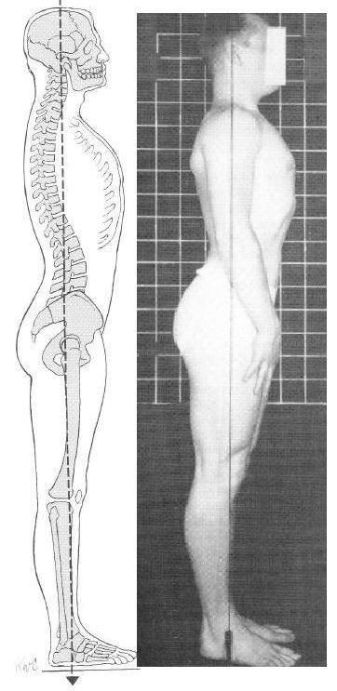

TYPES OF POSTURAL ALIGNMENT

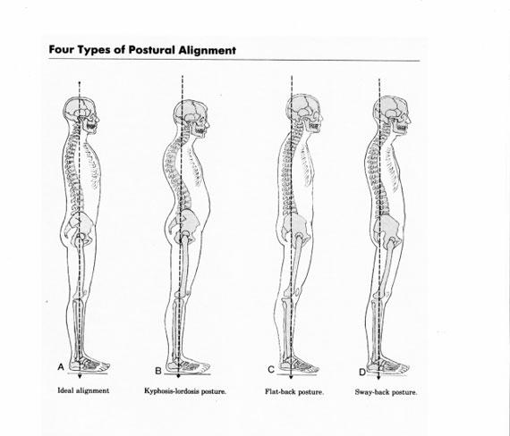

1- Can you identify your postural type?

2- In an ideal alignment, which physical structures are aligned?

3- How can you maintain your alignment?

4- Practical demonstration: *Plié* and *relevé* in 1st, 2nd, 3rd and 4th

**Task 2: Port de bras**

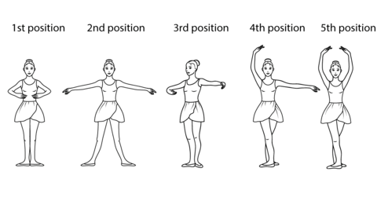

1. Why are all the arm ballet positions round?

2. Which arm position gives you more stability?

3. Where does the movement of the arms start?

4. Using a classical ballet repertoire piece of music, choreograph a port-de bras exercise using 1st, 2nd, 3rd, 4th and 5th position.

**TASK 3: Leg extension**

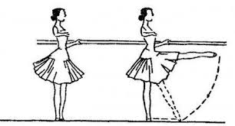

1. Translate, explain, and demonstrate:

.Tendu:

.Degagé

.Rond de Jambe

.Grand battement

2. Name the main muscles involved.

3. What’s the relation between those steps?

**Task 4: WALTZ**



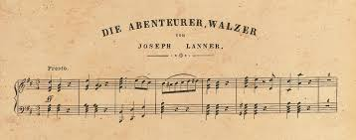

1. What is a waltz?
2. Describe and perform a waltz
3. Different kind of waltz
4. Choreograph a 1-minute waltz with a non-classical music

**Task 5: Jumps**

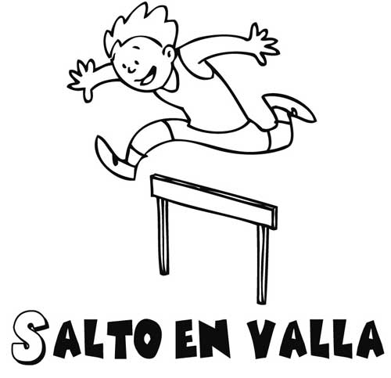

1. Which parts of your body receives the biggest impact in jumps?

2. Which anatomic structures would suffer from jumping in a non-aligned position?

3. How can you prevent this from happening?

4. Which leg gives the main impulse in a travelled jump?

5. Which steps travel and which ones not:

.Jeté

.Assemblé

. Glissade

. Pas-de chat

. Echappé

6. Choreograph an exercise with these steps (you can use other steps to).

**Task 6: Healthy practice**

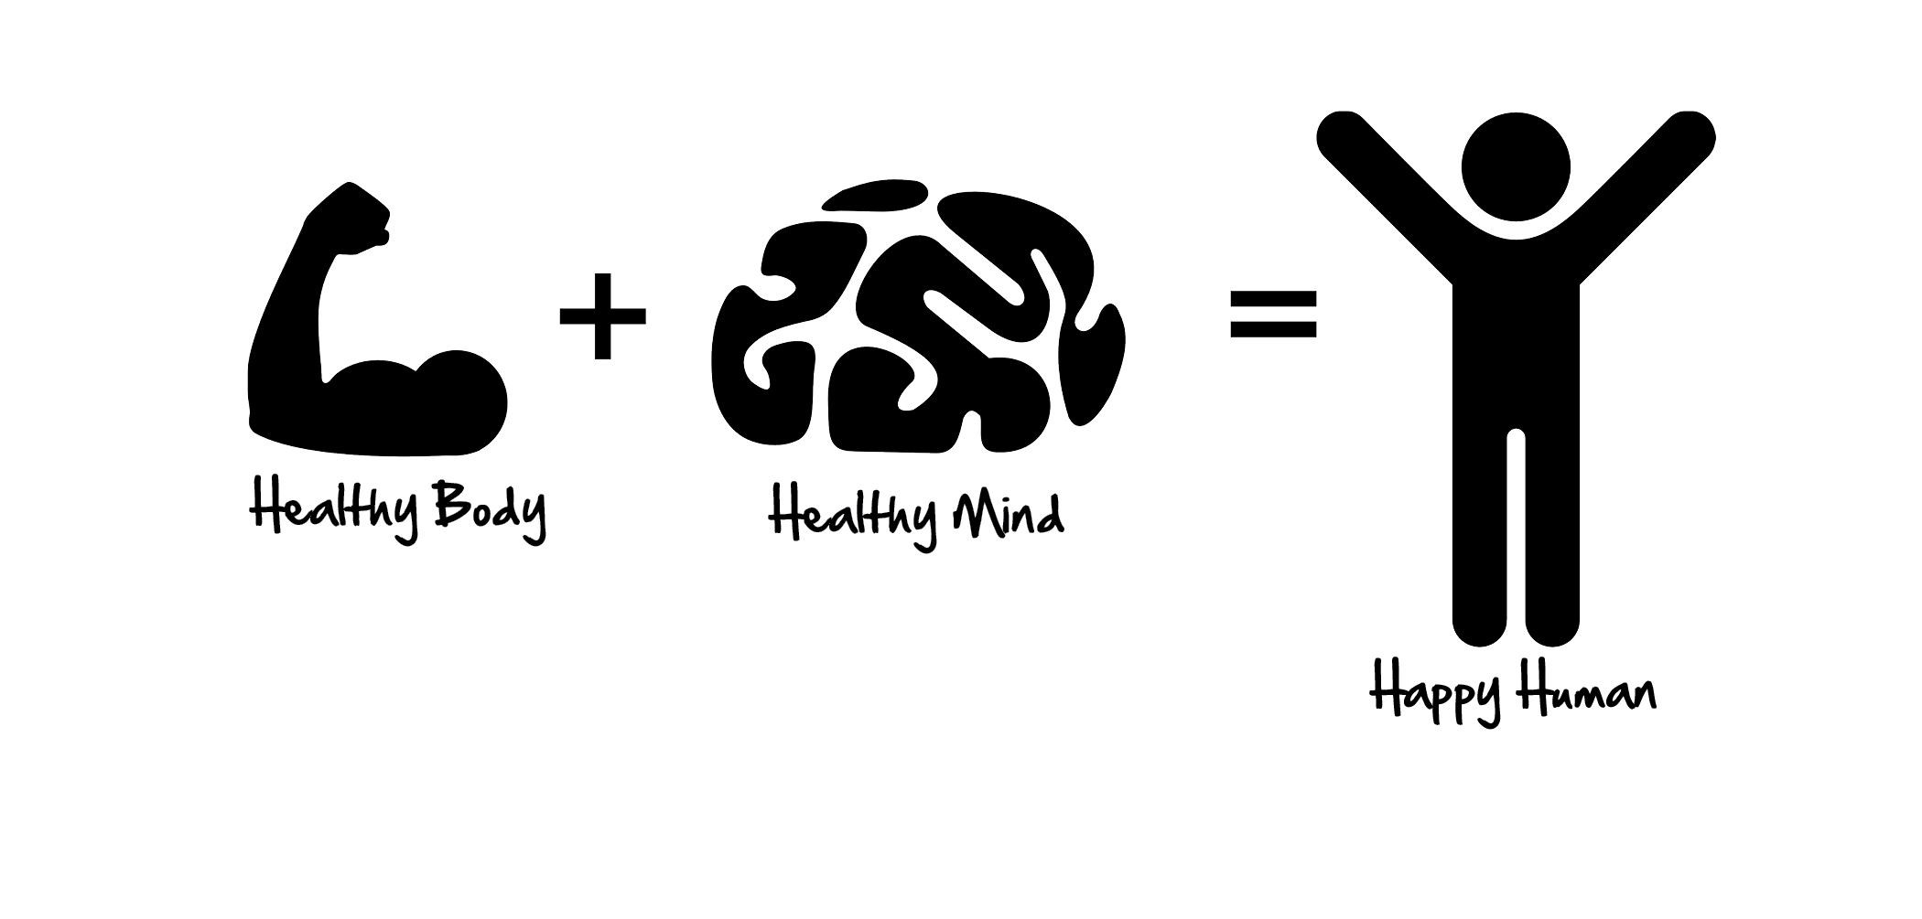

1. Design and explain a warm up.
2. Design and explain a cool down.
3. Name and explain 5 Healthy habits to keep you fit and in a good physical condition.