**SHOW ME THE MONEY!**

An exploration of how Enterprise Skills are embedded within curricula across The Liverpool Institute for Performing Arts, with specific concentration on the teaching of Budgeting and Cash Flow Forecasting.

Post Graduate Certificate in Teaching and Learning in Higher Education: Theatre and Performing Arts

**Action Research Report**

**WORD COUNT: 5495**

**Liz Carlisle 1800330**

**15th October 2018**

**Acknowledgements**

It has been over 30 years since I last engaged in academic study and I entered this process with considerable trepidation. The path was smoothed every step of the way by Carol Maynard. My thanks cannot be shouted loudly enough.

Thanks to my PGCert peers at LIPA – Lauren, Simeon, Vidar, Jake, Ann - it’s been great getting to understand what you do, watch you teach, marvel at your research, share your journey. Thanks too to Onur Orkut for being there and sharing your research prowess, and to the rest of the PGCert cohort whose contributions across continents via the VLE has been astonishing. My respect is due to Cordelia Bryan who pulls everything together, guiding our learning without us being in the same place at the same time – this is no mean feat.

To Dr Maria Barrett and Susanne Burns for being inspirational, and even though you don’t know it, you have helped me reach this point.

And finally, to Mark Featherstone-Witty for your support and enthusiasm for this research, to the students who participated, and to my colleagues Gillian, John, Dave, Dawn, Phil and Jeremy in the Management department at LIPA for your understanding, wit, and encouragement.

Contents

Introduction 1

Literature Review 3

Methodology 10

Limitations 11

Findings and Analysis 13

Applications to LIPA Enterprise 13

The LIPA Curriculum 15

Conclusion 29

Recommendations 31

Bibliography 34

Appendices 38

Table 1 Enterprise Education Methods 9

Table 2 LIPA Enterprise Allocations 2004 to 2018 13

Table 3 Enterprise and Employability in LIPA Modules 17

Table 4 Do you know what a Budget is? 21

Table 5 Do you know what a Cashflow Forecast is? 21

Table 6 Please use a few words to describe a Cashflow Forecast 22

Table 7 Have you studied or been taught how to CREATE a Budget and Cashflow Forecast whilst studying at LIPA? 26

Table 8 Comments on creating Budgets and Cashflow Forecasts 27

Table 9 Comments on Understanding Budgets and Cashflow Forecasts 27

Figure 1………………………………………………………………………….………… 19

Figure 2…………………………………………………………………………………… 20

Figure 3…………………………………………………………………………….……… 23

Figure 4…………………………………………………………………………….……… 23

Figure 5………………………………………….………………………………………… 23

Figure 6……………………………………………………………………………….…… 25

Figure 7……………………………………………………………….…………………… 25

Figure 8………………………………..…………………………………………………... 25

# Introduction

The Liverpool Institute for Performing Arts (LIPA) understands that portfolio working is central to employment within the cultural industries. Enterprise is an essential part our teaching in all disciplines and funding is available to undergraduates and alumni through the LIPA Enterprise scheme.

In my role for LIPA Enterprise I am responsible for assessing funding applications and noticed that many contain considerable weaknesses in the presentation of financial information.

LIPA Enterprise is more flexible and supportive than most other grant/loan giving bodies, but it is important for the CPD of students and alumni that applications, particularly the financial forecasts, are robust.

Since October 2017 I have been proactive in offering direct support to applicants, including one-to-one meetings helping to develop the bid with tutoring to create balanced, workable budgets and cashflows. All applicants who have accessed this support have been successful. Many of the applications received without this direct support have resulted in requests for more information, mainly regarding financial forecasts.

This led me to believe that tuition in enterprise skills, specifically in financial forecasting, might not be consistent across LIPA, resulting in this research.

The results show that whilst enterprise education is embedded across the curriculum, teaching of financial forecasting skills should be more comprehensive, strengthened and better aligned.

On the whole, the outcomes identified in the research proposal are met. The report recommends that financial forecasting skills are standardised within The Professional Modules and include bids to LIPA Enterprise; if possible Management department staff should deliver this element of teaching. An Enterprise page should be established on Moodle, replicated where possible on LIPA’s website so alumni can access resources for CPD purposes. There is no value in introducing elective modules, however refresher workshops could be offered for LIPA Enterprise applicants, and voluntary meetings with me should continue ahead of bids being submitted.

# Literature Review

Within the wide range of literature regarding enterprise education in HE the terms enterprise, employability, career development and entrepreneurship are often used in similar contexts and are sometimes interchangeable. Additionally, there are no fixed definitions for enterprise education or entrepreneurship. However, Brown’s definition “enterprise can be interpreted as being more about ‘ways of doing, seeing, feeling and communicating things’, ‘ways of organising things’ and ‘ways of learning things’” (2004, p.4) forms the starting point for this review.

Lord Young set out to “empower educators to embed enterprise in their teaching” (2014, p.4) in response to the economic landscape of portfolio careers, the gig economy and increase in business start-ups. He proposed that enterprise education should “should extend to all areas of faculty and study” (ibid p.6) stating it supports a range of skills and capabilities useful to employers and gives students the belief that “starting a business is a viable career choice” (ibid p.4). He recommended enterprise education should take the form of elective modules, and practical and financial support should be available to students looking to establish social enterprises.

The QAA agree enterprise education can have a significant impact on students’ future careers, adding “economic, social and cultural value to the UK” (2018, p.1). They refer to the Teaching and Excellence Framework’s statement that high quality enterprise education has career benefits for students, and HEI’s could use statistics relating to student enterprise as “examples of evidence for the ‘Student Outcomes and Learning Gain’ aspect of the TEF” (ibid p.3).

They go on to define enterprise education as generating and applying ideas; and entrepreneurship education as applying behaviours and skills (ibid p.7) – definitions which can be interpreted as mirroring Brown’s noted above.

The guidance states teaching methods “will ideally align to students’ prior learning and context along with any subject specialism” taking “a contextualised approach that enables students to enhance their entrepreneurial capabilities” (ibid p.11).

Tallantyre notes successful enterprise educators are likely to have experience in professional practice and enjoy the practical rather than theoretical application of teaching (2010, p.83). However, Brown notes that a majority of graduates surveyed felt their studies had not prepared them adequately and enterprise skills should be explicit and integral to performing arts courses (2003, p.2).

The QAA supports Young, recommending HEIs “determine funding streams (for) enterprise and entrepreneurship education” (2018, p.26), however they do not make specific reference to offering elective modules.

Brown (2003) noted Performing Arts schools are more likely to concentrate on developing practitioners rather than focusing on enterprise skills, suggesting elective modules as a solution. Conversely, Evans’ research found few HEIs offered electives, indicating that “entrepreneurship education is seen as important enough to be more than an elective option” (2010, p.10) and the majority of HEIs surveyed preferred ensuring it is embedded across the curriculum.

Clews and Harris note enterprise education should be coherent, effective, and sustainable, and “entrepreneurship is inherent to effective creative practice and needs to be explicit in the curriculum” (2007, p.14). They found enterprise education is more likely to be embedded or integrated, suggesting that individual enterprise modules or elements of enterprise within modules could be the way forward (ibid). They recommend enterprise education should form part of the core curriculum with learning outcomes achieved through practice-based modules, and educators draw upon pedagogies that support deep learning (ibid).

They consider Gibb’s (2005) research that enterprise education should relate to the core subject of study rather than being delivered by business and management schools, suggesting teaching is “best aligned with the pedagogic practice appropriate to a subject, and that definitions of entrepreneurship need to be broad in order to encompass a range of practices or adaptable to different learning contexts” (Clews and Harris, 2007, p.27).

Clews and Harris also note that ensuring enterprise education is aligned with pedagogic practice could mean teaching is delivered by an external agency and not managed by discipline departments, might be mandatory or elective and will have a broader range of learning outcomes than those modules that are fully embedded. However, delivery of this nature could mean the learning is disconnected from the discipline (ibid p.53):

students and graduates think that learning outcomes are sometimes not explicit enough. Where they are not made fully aware of what is being taught there is a risk that it might not be learned … This view is consistent with a substantial body of research showing that alignment between the aims of the teaching, the learning outcomes and methods of assessment delivers the most effective learning experience (ibid p.87)

Gibb went further, stating enterprise education is often delivered as a bolt on by visiting professionals, however embedding it must “be reflected in the culture of the education institution itself […] and the ability of the teacher” (2007, p.7).

The QAA recommend all students participate in enterprise education, and it should be aligned with their core subjects (2018, p.3). Achieving alignment requires well designed curricula that reflect learning outcomes, the vision of the HEI, and feedback from students and stakeholders (ibid p.12). They go on to note learning should be theoretical, practical and reflective, recognising Biggs (nd) in stating that assessment should be constructively aligned (QAA, 2018, p.14).

Cramner (2006, pp171-2) considers the efficacy of embedded and integrated learning, agreeing with Gibb embedded learning may result in students not recognising they are developing specific skills, whereas bolt on (or elective) modules might result in learning being disconnected from or not contextualised with the main area of study. Williamson et al (2013, p.76) showed enterprise education was still based in more traditional business subjects and Owens and Tibby (2014, pp4-41) evidenced good practice where HEIs embed enterprise education.

Cope (2003, p429) explored discontinuous events as methods of learning, citing Rae and Carswell’s (2000) opinion enterprise education is experiential, affirming Brown’s notion of deep learning being key and reflecting Biggs and Tang (2011). Blenker et al (2012, pp418-428) go further believing enterprise education should be more tailored to the individual so learners engage in activities that are personal, relevant, interesting and achievable.

Wedgwood (2005, p.12) and Burns (2007, pp7,13,32) assert enterprise education is vital to prepare emerging artists for life after graduation, though do not discuss the possibility of ongoing provision in the form of CPD. However, they both cite Leadbeater and Oakley who state “cultural entrepreneurs need to develop a mix of creative and business skills often at different stages of their careers. Education institutions are often too inflexible to deliver these skills as and when the entrepreneurs need them” (1999, p.42) encouraging HEIs to make CPD available to alumni.

Clews and Harris explored alternatives to embedded, integrated, and aligned learning in enterprise education. Facilitated learning has a role to play – where learning is not linked directly to assessment but has an impact on it – for example though visiting professionals or enterprise support schemes (2007, p.51). They also consider self-directed learning which is valued by students for developing enterprise skills (ibid p.48). As with facilitated learning there is no direct link to but an impact on assessment, especially when students are running independent enterprise projects or are engaged in work-based projects or placements. The QAA note as students progress towards graduation there is more focus on self-directed learning and academic and career goals. They may have plans to “start their own business, or to extend an informal activity such as freelancing or trading into more formalised opportunities” (2018, p20).

Finally, Clews and Harris conclude embedding enterprise education will not be effective unless assessment is aligned with learning outcomes, or if the learning outcomes are not explicit. They recognise that if it is linked to practice, applied, and project learning, enterprise education can be effective as a separate module (2007, p.50).

The literature has shown enterprise education is delivered in a variety of ways, (summarised by Clews and Harris (2007, pp.52-3) and shown in Table 1), each of which have merit. Whilst the literature favours embedded enterprise education it is clear that for delivery to be effective it must be experiential, based in the discipline of study and constructively aligned.

Table 1 Enterprise Education Methods

|  |  |  |
| --- | --- | --- |
| Method | Detail | Responsibility |
| Embedded | * Core component of curriculum * Mandatory * Assessed | * Delivered and managed by discipline departments |
| Integrated | * Core component of curriculum * Assessed but either mandatory or elective | * Wholly delivered by external departments * Managed by departments |
| Aligned | * Learning may not be linked to core curriculum * Assessed but can be mandatory or elective | * Wholly delivered and managed by external departments |
| *Facilitated learning* | * Unlikely to be linked to core curriculum * Not assessed but impacts on assessment | * Delivered through masterclasses, placements, enterprise support schemes etc |
| *Self-directed learning* | * Can be linked to core curriculum and assessed * Can be extra-curricular activities that can impact on assessment | * May include elements of formal supervision or informal support from teaching and learning staff |

# Methodology

The research proposal aimed to use a mixed, multi method qualitative and quantitative approach, however as the research progressed it became clear the original design was too expansive for the scale of this report, consequently it was narrowed to utilise only primary and secondary quantitative research.

Primary research was gathered through a survey of LIPA undergraduates using an online survey emailed directly to the student body with a link and explanation. Surveys provide “a quantitative or numeric description of trends, attitudes or opinions of a population by studying a sample of that population” (Creswell, 2014, p.201) and “allow the collection of a large amount of data from a sizeable population in a highly economical way” (Saunders et al, 2009, p.144).

A purposive sample (Kelly et al, 2003, p.264) was selected for primary research – that is the whole student body at LIPA was invited to participate as they were best placed to help “answer (the) research question(s) and meet (the research) objectives” (Saunders et al, 2009, p.237).

Participation was voluntary, and no targets for participation were set (ibid p.241). Those who participated are representative of the population, in as much as they were all undergraduates in July 2018.

The survey results cannot be generalised as there are too few respondents. However, the data collected gives an insight into student views and experiences regarding enterprise teaching and, more specifically, the teaching of budget and cashflow forecasting skills.

Ethics were important - all personal information was redacted from secondary research before analysis and was not required from survey participants. Free text answers were not edited and are shown verbatim.

Secondary research was used to understand where enterprise education takes place within LIPA’s curriculum, and to examine financial skills displayed in applications to LIPA Enterprise.

## Limitations

The sample size is a limitation to this research. Less than 0.5% of the student body

responded to the survey – a greater response rate may well give different results. The timing of the survey was problematic as it was circulated at the end of the summer term. Had it been released earlier in the teaching year more data might have been captured.

The lack of data regarding interaction with LIPA Enterprise applicants prior to 2015 is also a limitation, as is the lack of any recorded information for the year 2016-17.

The time and scale restrictions of this research also prevented qualitative research taking pace. Interviews with teaching staff would have gathered

in-depth information about enterprise education content and delivery.

Similarly, had the alumni survey generated responses the research would have been richer, gathering data regarding any enterprise CPD undertaken after graduation. Focus groups with under graduates might have gathered more in-depth data regarding students’ perceived skills and confidence in enterprise activities.

Interpreting module information proved difficult, especially in separating enterprise education from employability, so they have been analysed together for this study. Additionally, some module pages on Moodle were not populated with the information required for this research, meaning it is possible that more teaching is taking place than is reflected in the findings.

The research was also slightly impacted as all LIPA’s degree programmes were adapted and re-validated in 2016, meaning Level 6 respondents had studied modules with different names and slightly different content. Information about the old modules is no longer available on Moodle.

# Findings and Analysis

The rationale for this Action Research project is that financial forecasting skills seem to be weak amongst applicants to LIPA Enterprise, which raised the question how teaching of these skills is embedded within the curricula at LIPA.

## Applications to LIPA Enterprise

Between September 2004 and August 2018 LIPA Enterprise allocated over £257,000 in grants and loans to students and alumni, proving that LIPA are achieving the TEF’s evidence criteria for student involvement in enterprise.

Table 2 LIPA Enterprise Allocations 2004 to 2018

Full information available in Appendix 1

Information regarding any issues or queries with applications is not available for 2004 to 2014. Consequently, this report focusses on applications from 2014-15 onwards.

Information regarding the funding decision process is available for 24 of the 61 applications received in 2014-15. Ten applications were successful without a request for additional information. There were four requests for revised financial information, and nine for other action including confirming matched funding and improved marketing plans.

There were 17 applications in 2015-16, five of which were successful without a request for additional information. There were eight identified budget or cashflow issues and six queries about matched funding, marketing activities or whether the enterprise was sustainable.

In 2017-2018 there were 40 recorded contacts with LIPA Enterprise, resulting in 17 completed applications, 12 of which were successful. There were proportionately more requests for improved financial information during this period with only one application being recommended for support without a request for further information. There were 29 requests for revised financial forecasts and seven comments that the application needed strengthening in general.

It is unclear whether the increase in requests for improved financial information is because of how applications are reviewed, or simply because of how information is recorded before the application is considered by the panel.

However, it is apparent from 2017-2018 data that financial forecasting skills are generally weak amongst the applicants.

## The LIPA Curriculum

Having analysed applications to LIPA Enterprise, it was necessary to review the curriculum to ascertain where enterprise, and specifically financial forecasting is taught.

The curriculum was researched using Moodle where module handbooks and proformas detailing learning outcomes and assessments should be available.

It became clear that each department has a slightly different approach towards module handbook design and that there is no standardised terminology for assessment criteria and module proformas.

Consequently, it was necessary to interpret some of the information where learning outcomes and assessment include enterprise activity, and more specifically when financial forecasting skills are implied as opposed to being specifically mentioned.

It was also clear that, as noted in the literature, many modules combine enterprise and employability skills, therefore for the purposes of this research these skills were not separated out. Some of the modules do not make specific mention of budgetary or cashflow skills but note a requirement for financial planning.

The modules were analysed by researching Learning Outcomes, Assessment Criteria, Assessment Briefs and module descriptions, resulting in 40 modules being identified (Table 3). The full analysis is available in Appendix 2.

The analysis shows that all programmes teach enterprise education, with specific mentions in 36 modules. Except for Foundation levels and Sound Technology, all programmes include some element of financial forecasting as module requirement, with skills development being implied or explicit in 35 modules.

All programmes place an emphasis on employability, mainly through The Professional modules, but it is interesting to note that enterprise and employability are also requirements of many contextual or skills development modules.

Table 3 Enterprise and Employability in LIPA Modules

|  |  |  |  |
| --- | --- | --- | --- |
| **Module Code** | **Module Name** | **Enterprise & Employability** | **Financial Skills** |
|
| **ACTING** | | | |
| 4521ACT | Artistic Practice I |  |  |
| 5522ACT | Artistic Practice II |  |  |
| 5524ACT | The Professional II |  |  |
| 6517ACT | The Actor’s Performance: Production I |  |  |
| 6518ACT | The Actor’s Performance: Production II |  |  |
| 6519ACT | The Actor's Performance: Production III |  |  |
| 6523ACT | The Professional III |  |  |
| **APPLIED THEATRE AND COMMUNITY DRAMA** | | | |
| 5505ATCD | The Professional 2 |  |  |
| 6500ATCD | Theatre for Democracy and Advocacy |  |  |
| 6501ATCD | The Professional Facilitator/ Director |  |  |
| 6502ATCD | Individual Final Project |  |  |
| **DANCE** | | | |
| 5535DAN | The Professional 2 |  |  |
| 6544 DAN | Professional Development 3 |  |  |
| **MUSIC** | | | |
| 4550MUS | Music Professional Practice 1 |  |  |
| 5595MUS | Music Professional Practice (The Professional 2) |  |  |
| 6594MUS | The Music Professional |  |  |
| 6597MUS | The Producer |  |  |
| **SOUND TECHNOLOGY** | | | |
| 4523STE | Sound Reinforcement 1 |  |  |
| **THEATRE AND PERFORMANCE DESIGN AND TECHNOLOGY** | | | |
| 4535TPR | Making Skills part 1 |  |  |
| 4537TPR | Essential Stage Management |  |  |
| 4500PD1 TPTD | The Professional 1 |  |  |
| 5534/ 5538TPR | Vocational Skills |  |  |
| 5536TPR | The Professional 2 |  |  |
| 5539TPR | The Production Process |  |  |
| 5541TPR | Design from Text 2 |  |  |
| 5540TPR | Production Management |  |  |
| 6540TPR | The 21st Century Venue |  |  |
| 6510TPR | Vocational Practice |  |  |
| 6511TPR | Professional Development 3 |  |  |
| **POPULAR MUSIC AND MUSIC TECHNOLOGY** | | | |
| 3520PMMT | Music Business |  |  |
| **FOUNDATION DANCE** | | | |
| 3534FDAN | Professional Studies |  |  |
| **SHARED MODULE** | | | |
| 4500PD1 | The Professional 1 |  |  |
| **Management** | | | |
| 4500MMET | Raising Funds and Managing Finance |  |  |
| 4501MMET | Introduction to Professional Practice |  |  |
| 5500MMET | The Professional 2 |  |  |
| 5501MMET | Practical Management Project |  |  |
| 5503MMET | The Producers |  |  |
| 5505MMET | Live Performance and Event Management |  |  |
| 5506MMET | Enterprise & Business Planning |  |  |
| 6500MMET | The Professional 3 |  |  |

|  |  |  |  |  |
| --- | --- | --- | --- | --- |
| **KEY** |  |  |  |  |
| Enterprise and Employability | | | |  |
| Financial Skills | |  |  |  |
|  | Budget and Cashflow | | |  |
|  | Generic Financial Planning | | |  |

It is not surprising that the Management curriculum place an emphasis on financial skills, with a specific module where students develop the essential skills and competencies required for the rest of their studies and future professional practice.

However, it is more striking that financial skills are prominent within Theatre and Performance Design and Technology modules, and they show a progression from working within a set budget at level 4 to setting and managing budgets at Level 6. This progression does not seem to be reflected in the rest of the disciplines.

Research shows enterprise education is embedded in all modules except for The Professional 2 (ATCD) and Professional 2 and 3 (DANCE) where it is integrated, being delivered by Management teaching staff. The research also implies that on the whole teaching is contextualised, explicit, coherent, and aligned as recommended by Clews and Harris (2007).

UNDERGRADUATE SURVEY

Have established that enterprise and financial forecasting skills are requirements of many modules across LIPA, it was important to ascertain whether students recognise the skills they are learning, and they feel confident in utilising them.

47 undergraduates from all disciplines and levels participated in the online survey. Full Survey results are available at Appendix 3.

Figure 1 Figure 2

Management students were the largest group of respondents, and because they study financial skills as part of a bespoke module their responses might distort results. Consequently, survey data was analysed to present information including and excluding this group.

The survey focussed on budgeting and cashflow forecasting (as opposed to generic enterprise skills), also asking if participants are aware of LIPA’s Enterprise scheme. The responses about LIPA Enterprise have not been here even though their function was to ascertain whether revised information had been requested in support of the bid. Three survey respondents had applied to LIPA Enterprise, and only one reported being asked for more information, however that application was not resubmitted. Consequently, the data has no bearing on this research.

Survey results showed participants are aware of what a budget is, but are less certain about cashflow forecasts, with only 34% of non-management students answering Yes regarding knowledge of cashflow forecasts. These results reflect the module analysis, where budgetary skills are mentioned in many modules, but cashflow forecasting seems to be a learning outcome only for Management students.

Table 4 Do you know what a Budget is?

|  |  |  |  |  |
| --- | --- | --- | --- | --- |
|  |  |  |  |  |
|  | Management inc | | exc Management | |
|  |  | % |  | % |
| YES | 45 | 95.74 | 33 | 94.29 |
| NO | 0 | 0.00 | 0 | 0.00 |
| MAYBE | 2 | 4.26 | 2 | 5.71 |
| **totals** | **47** | **100.00** | **35** | **100.00** |

Table 5 Do you know what a Cashflow Forecast is?

|  |  |  |  |  |
| --- | --- | --- | --- | --- |
|  | Management inc | | exc Management | |
|  |  | % |  | % |
| YES | 22 | 46.81 | 12 | 34.29 |
| NO | 12 | 25.53 | 12 | 34.29 |
| MAYBE | 13 | 27.66 | 11 | 31.43 |
| **totals** | **47** | **100.00** | **35** | **100.00** |
| NB One Answer YES/MAYBE so counted as Maybe | | | | |

When asked to describe a budget, all but one management student identified the need for income and expenditure projections. Responses from the rest of the students were less accurate – the majority recognised expenditure as a factor, but fewer noted income (See Appendix 4).

Respondents were asked to describe a cashflow. Of 16 responses from non-managers, eight were accurate in their description of cash movement, and two responses mentioned scheduled spending (See Appendix 5).

It is noticeable however, that the remaining eight students have confused the function of a cashflow with that of a budget.

Table 6 Please use a few words to describe a Cashflow Forecast

|  |  |  |  |
| --- | --- | --- | --- |
| 2nd Year (Level 5) | Acting |  | What you expect the income to be based on past projects and other factors |
| 2nd Year (Level 5) | Sound Tech |  | It’s a comprehensive tool to help work out expected income and expenditure. |
| 1st Year (Level 4) | Acting |  | What you predict you will spend in future on a project specifically looking at various areas of spending |
| 2nd Year (Level 5) | Acting |  | Attempting to make an accurate guess of how much cash will be spent in comparison to how much will be made back |
| 3rd Year (level 6) | Music |  | Using available data, what is the foreseeable gross turnover of a project |

Respondents were asked to rate their confidence on a scale of “One” to “Ten” when creating budgets. Results were spread regardless of the student’s discipline of study, with most responses being in the mid-range between “Four” and “Eight”.

Unsurprisingly, Management students displayed the highest levels of confidence, with nine out of twelve respondents scoring themselves at “Six” or higher.

FIGURES 3 to 5: On a scale of one to ten, how confident are you in creating a Balanced Income and Expenditure budget?

Figure 3

Figure 4

Figure 5

These overall levels of confidence imply students are aware of what they are learning, bearing in mind that respondents might be inclined to under-estimate their level of skill, especially if the skills have not been formally assessed. However, this confidence is not reflected in the budgets submitted to LIPA Enterprise.

Respondents appear to be less confident when it comes to creating cashflow forecasts, with a majority of answers (regardless of the discipline of study) being between “One” and “Five”.

Confidence amongst Managers is relatively high, with the majority scoring themselves at “Seven” or above which is unsurprising considering the content of the Management curriculum.

As with creating budgets, confidence levels amongst non-managers could be low because people might be more likely to under-estimate their skills level, however the implication that there is a general lack of confidence when it comes to cashflow forecasting is worrying, as it is a necessary skill when managing the personal finances, a portfolio career, or the viability of a business enterprise. These confidence levels are demonstrated in the quality of cashflow forecasts submitted to LIPA Enterprise.

FIGURES 6 to 8 - On a scale of one to ten, how confident are you in creating a Balanced Cashflow Forecast?

Figure 6

Figure 7

Figure 8

Respondents were asked whether they had studied creating budgets and cashflow forecasts as part of their LIPA studies. It is noticeable that whilst the module analysis shows that the curriculum for all students except Sound Technology and Foundation levels includes financial forecasting, 24 respondents (excluding Management) answered “No”, or that they were unsure.

Table 7 Have you studied or been taught how to CREATE a Budget and Cashflow Forecast whilst studying at LIPA?

|  |  |  |  |  |  |  |
| --- | --- | --- | --- | --- | --- | --- |
|  | Management inc | | | exc Management | | |
|  | Yes | No | Not Sure | Yes | No | Not Sure |
| Level 3 |  | 2 |  |  | 2 |  |
| Level 4 | 8 | 2 | 3 | 4 | 2 | 3 |
| Level 5 | 7 | 4 | 7 | 4 | 4 | 7 |
| Level 6 | 10 | 4 |  | 5 |  | 4 |
|  | **25** | **12** | **10** | **13** | **8** | **14** |

These results may arise because some (mainly Level 4) students are yet to study modules where the skills are included. However, most respondents are Level 5 and 6 students, and therefore should have already studied financial forecasting skills.

Finally, students were asked to comment on both creating and understanding budgets and cashflow forecasts. The survey included the opportunity to give free text answers to research their understanding of financial forecasting skills and terminology. Full responses are available in Appendices 6 and 7.

There were few responses to these questions; all came from non-managers, but they seem to indicate that some students would like to see either increased or improved teaching:

Table 8 Comments on creating Budgets and Cashflow Forecasts

|  |  |  |  |
| --- | --- | --- | --- |
| **What is your year of study?** | **What did you study?** |  | **If you want to make any comment about CREATING a budget or cash-flow forecast please feel free!** |
| 2nd Year (Level 5) | Acting |  | Creating the budget is fine, although I'm not very sure about the cash-flow forecast (I guessed the last answer for it) |
| 1st Year (Level 4) | Acting |  | I think we do that in second and third year |
| 2nd Year (Level 5) | Music |  | i've been taught something in the first year that never developed after |
| 2nd Year (Level 5) | Acting |  | We've been roughly taught how to create a budget but not a cashflow forecast |
| 3rd Year (level 6) | Music |  | We did learn about it but not enough |

Table 9 Comments on Understanding Budgets and Cashflow Forecasts

|  |  |  |  |
| --- | --- | --- | --- |
| **year of study in 2017/2018** | **What did you study** |  | **If you want to make any comment about UNDERSTANDING a budget or cash-flow forecast please feel free!** |
| 2nd Year (Level 5) | Acting |  | If they are set out too extra I gently, they make no sense to me, but they are quite simple and so should read simply too, otherwise it's just a badly presented document |
| 2nd Year (Level 5) | Acting |  | Extensively taught in 2nd year at LIPA- very specific with highly knowledgeable teacher |
| 3rd Year (level 6) | Music |  | I feel like LIPA has still a way to go on teaching the music business to musicians |

Finally, respondents were asked to identify which modules include creating or understanding budget and cashflow forecasting. Please see Appendix 8 for full results.

It is interesting that some of modules named were not identified as including financial forecasting skills (including Law, Marketing, and Community Performance as Counter Narrative). This might imply that financial forecasting skills are needed to complete a module task but are not featured in the learning outcomes or assessment process (and therefore not fully aligned).

Results show that students recognised The Professional strand focusses on enterprise and employability skills, and that financial forecasting forms part of teaching on these modules. Management students recognised all the modules where the financial forecasting skills are key.

However, whilst the module analysis identified 40 modules across all disciplines where enterprise teaching is either implied or implicit, only eighteen were identified by students (including some modules from the “old” degrees). Does this then reflect findings in the literature that if students are unaware of what and why they are studying a subject they may not benefit from the learning, raising the question of whether teaching aims, learning outcomes and assessment needs are aligned across all disciplines?

# Conclusion

It is clear from the research enterprise education at LIPA reflects Brown’s (2004) definition; teaching embedded, embraced by all disciplines, explicit within the curriculum and all students participate (Young, 2014), (Evans, 2010), (Clews and Harris, 2007), (QAA, 2018). Students are encouraged to view enterprise activities as viable and essential career pathways, and LIPA provides support through the Enterprise funding scheme (Young, 2014), (QAA, 2018).

Enterprise teaching is aligned and contextualised (QAA, 2018), though some of the results reflect Brown’s (2003) findings that enterprise studies are still not adequately preparing students for enterprise activities, especially where financial forecasting is required. LIPA are not more concerned with developing practitioners rather than enhancing employability. The school sees enterprise and employability skills as key components of the practitioner’s tool kit and employ methods of developing those skills.

LIPA’s enterprise teaching is designed to support deep learning and is delivered through experiential, practice based free-standing modules and as component elements of others, all of which are related to the individual disciplines (Clews and Harris, 2007), (Biggs, 2011), (Gibbs, 2005), (Rae and Carswell, 2000).

However, the primary research implies that financial skills teaching is not wholly successful, and whilst students seem reasonably confident in creating budgets, they are, with the exception of management students, less knowledgeable or confident when it comes to cashflow forecasting. Applications to LIPA enterprise do not reflect the confidence displayed in the survey results.

As the majority of respondents reported they have not been or are unsure of being taught financial forecasting skills it is possible that learning outcomes are not explicit enough (Cramner, 2006), or that this aspect of teaching is not fully aligned (Clews and Harris, 2007).

# Recommendations

The limitations of the research should be addressed. A larger sample for quantitative research is needed, and the qualitative research originally proposed should take place. This should result in better understanding module aims, learning outcomes and content, and gather richer data about undergraduate perceptions and skills levels. A survey of alumni would add valuable data, discovering whether CPD training was sought to enhance financial forecasting skills. This research should happen in March or April to gather as much data as possible before students finish their studies for the summer, and take place within two years.

Module Handbook and Proforma design and terminology should be standardised and all departments should ensure that modules are fully populated on Moodle allowing students and staff to access accurate and relevant information. This should be completed within one year.

The Professional 2 and 3 modules should be adapted to include an application to LIPA Enterprise (possibly as an assessment tool), thus ensuring all students graduate with an acceptable level of financial forecasting skills.

Research and development should explore if Management staff can deliver these elements. This is not a slur on teaching staff in other departments but would be one way to ensure teaching is standardised. Teaching would still be aligned and integrated as Management staff are cultural industries practitioners, understanding the managerial aspects of each discipline. If this recommendation proves unfeasible, in-depth CPD should be offered to develop a unified approach across departments.

Changes to The Professional modules and the R&D process should happen over the next teaching year, with a view to rolling out full implementation over four years, allowing time for CPD if required.

Even if changes to teaching financial forecasting skills were made, some applicants to LIPA Enterprise will need additional support. Therefore, an Enterprise Moodle page should be established. This could include on-line tutorials, exemplars of strong/successful applications, application forms and financial templates (with annotated examples), and links additional support including funding bodies, crowd funding sites, sources of advice and information etc. This may take up to two years to develop.

CPD for alumni could be made available through the Enterprise page of LIPA’s website, replicating links to online resources on the Enterprise Moodle page, and online tutorials made available through LIPA Enterprise’s Facebook Group. In the longer term a dedicated LIPA Enterprise website could be developed where users must sign up before accessing resources.

Refresher workshops and tutorials should be offered for potential applicants to recap skills taught in the Professional Modules. There is no perceived value in establishing elective modules.

One to one meetings with potential applicants should continue as they are proven to be beneficial and lead directly to successful applications but would not need to be mandatory if the recommendations above are implemented.

# Bibliography

Biggs J., (no date) **Constructive alignment in university Teaching** *(HERDSA Review of Higher Education)* available at www.herdsa.org.au

Biggs, J., & Tang, C. (2011) **Teaching for Quality Learning at University**, 4th Edition. (*Open University Press*) available at https://www.nmbu.no/download/file/fid/27219

Blenker, Hedeboe Frederiksen, S., Korsgaard, S, Müller, S., Neergaard, H., & Thrane, C., (2012) **Entrepreneurship as everyday practice: towards** **a personalized pedagogy of enterprise education** (*Industry & Higher Education vol 26, no 6)* available at https://www.effectuation.org/wp-content/uploads/2017/05/Entrepreneurship-as-everyday-practice-1.pdf

Bridgstock, R. (2009) **The graduate attributes we’ve overlooked: enhancing graduate employability through career management skills** *(Higher Education Research & Development)* available at <https://www.tandfonline.com/doi/abs/10.1080/07294360802444347>

Brown, R. (2003) **Employability Issues in H.E. Performing Arts** (*PALATINE)* https://www.heacademy.ac.uk/knowledge-hub/employability-issues-he-performing-arts

Brown, R. (2004) **Performing Arts Entrepreneurship** (*PALATINE)* available at https://slidedocuments.org/philosophy-of-money.html?utm_source=performing-arts-entrepreneurship

Bryan, C. (2012) **Preparing for a Portfolio Career in Performing Arts** *(Higher Education Academy)* available at https://www.heacademy.ac.uk/knowledge-hub/preparing-portfolio-career-performing-arts

Burns, S. (2005) **A Partnership of Equals? How HEIs and Arts Organisations can work together to develop the creative entrepreneur - A Practitioner’s Perspective** (*University of Lancaster)* available at <https://vle.bruford.ac.uk/mod/resource/view.php?id=53775>

Burns, S. (2007) **Mapping Dance** (*PALATINE)* available at <https://www.heacademy.ac.uk/knowledge-hub/mapping-dance>

Burns, S. (2017) **Supporting the Self Employed Artist as Citizen: Looking up, looking down, looking around and looking forward** (*Winston Churchill Memorial Trust)* available at https://www.wcmt.org.uk/sites/default/files/report-documents/Burns%20S%20Report%20%202017%20Final.pdf

Christopher, P. (2018) **Thinking Again About PD – the importance of expertise** *(Liverpool Institute for Performing Arts)*

Clewes, D., & Harris, M. (2007) **Creating Entrepreneurship in higher education and the creative industries** *(Higher Education Academy and National Endowment for Science Technology and the Arts)* available at https://www.heacademy.ac.uk/knowledge-hub/creating-entrepreneurship-entrepreneurship-education-creative-industries

Coles, N. (nd) **Pedagogy for enterprise education** (online) *(Higher Education Academy)*available at https://www.heacademy.ac.uk/pedagogy-enterprise-education

Cope J. (2003) **Entrepreneurial Learning and Critical Reflection Discontinuous Events as Triggers for ‘Higher-level’ Learning** (*Sage Publications)* available at <http://citeseerx.ist.psu.edu/viewdoc/download?doi=10.1.1.831.3377&rep=rep1&type=pdf>

Cramner, S. (2006) **Enhancing graduate employability: best intentions and mixed outcomes** *(Routledge, Taylor and Francis Group)* available at https://www.tandfonline.com/doi/abs/10.1080/03075070600572041

Easterby-Smith, M., Thorpe, R., & Jackson, P. (2008) **Management Research** (3rd ed.) (*Sage Publications*)

Evans, M. (2010) **Making Theatre Work** (*PALATINE*) available at https://www.heacademy.ac.uk/system/files/making-theatre-work.pdf

Gibb, A. (2005) **Towards the Entrepreneurial University. Entrepreneurship education as a lever for change** (*National Council for Graduate Entrepreneurship)* available at http://ncee.org.uk/wp-content/uploads/2018/01/towards_the_entrepreneurial_university.pdf

Gibb, A. (2007). **Enterprise in education. Educating tomorrow’s entrepreneurs** (*Pentti Mankinen)* available at <http://www.enorssi.fi/opetus-ja-materiaalit/yrittajyyskasvatus/pdf/Gibb.pdf>

Gorman, G., Hanlon, D., & King W. (1997) **Some research perspectives on entrepreneurship education, enterprise education and education for small business management: a ten-year literature review** *(International Small Business Journal, April-June 1997 v15 n3)* available at https://www.researchgate.net/publication/247738407_Some_Research_Perspectives_on_Entrepreneurship_Education_Enterprise_Education_and_Education_for_Small_Business_Management_A_Ten-Year_Literature_Review

Gurney-Read, J. (2014) **Enterprise education: a debate worth having** (online) (The Telegraph) available at https://www.telegraph.co.uk/education/educationopinion/10862703/Enterprise-education-a-debate-worth-having.html

Higher Education Academy (2016) **Framework for embedding employability in higher education.** *(Higher Education Academy)* available at https://www.heacademy.ac.uk/knowledge-hub/framework-embedding-employability-higher-education

Hytti, U., & O’Gorman, C. (2004) **What Is ‘Enterprise Education'? An Analysis of the Objectives and Methods of Enterprise Education Programmes in Four European Countries** *(Research Gate)*available at https://www.researchgate.net/publication/242346928_What_Is_%27Enterprise_Education%27_An_Analysis_of_the_Objectives_and_Methods_of_Enterprise_Education_Programmes_in_Four_European_Countries

[Jarman](https://entrepreneurhandbook.co.uk/author/dave-jarman/), D, (2018) **What is enterprise education and how does it work in the UK?** (online) *(Entrepreneur Handbook)* available at https://entrepreneurhandbook.co.uk/enterprise-education-about-for-or-through/

Kelley, K., Clark, B., Brown V., & Sitzia, J., (2003) **Methodology Matters: Good practice in the conduct and reporting of survey research** *(International Society for Quality in Health Care and Oxford University Press)* available at <https://academic.oup.com/intqhc/article/15/3/261/1856193>

Leadbeater, C., & Oakley, K., (1999) **The Independents: Britain’s new cultural entrepreneur** *(Demos)* available at https://www.demos.co.uk/files/theindependents.pdf

Lominé, L., & Richards, R. (nd) **The role of higher education in promoting enterprise in the creative sector** *(Higher Education Academy)* available at <https://vle.bruford.ac.uk/mod/resource/view.php?id=53776>

Owens, J., & Tibby, M. (eds.) (2014) **Enhancing employability through enterprise education: Examples of good practice in higher education** *(Higher Education Academy)* available at https://www.heacademy.ac.uk/system/files/resources/enhancing_employability_through_enterprise_education_good_practice_guide.pdf

Pegg, A., Waldock, J., Hendy-Isaac, & S., Lawton R. (2012) **Pedagogy for employability** *(Higher Education Academy)* available at https://www.heacademy.ac.uk/system/files/pedagogy_for_employability_update_2012.pdf

Quality Assurance Agency. (2018) **Enterprise and Entrepreneurship Education: Guidance for UK Higher Education Providers** (*Quality Assurance Agency*) available at <https://www.qaa.ac.uk/docs/qaas/enhancement-and-development/enterprise-and-entrpreneurship-education-2018.pdf?sfvrsn=15f1f981_8>

Saunders, M., Lewis, P., & Thornhill, A. (2012) **Research methods for business students (5th ed.)** (*Pearson Education M.U.A.)* available at <https://www.dawsonera.com/abstract/9781292016641>

Tallantyre, F. (ed.) (2010) **University management of work-based learning** (*Higher Education Academy)* available at https://www.heacademy.ac.uk/knowledge-hub/university-management-work-based-learning

Tibby M. (nd) **Enhancing employability through enterprise education** *(online)* <https://www.heacademy.ac.uk/blog/enhancing-employability-through-enterprise-education>

Times Higher Education (2003) **Armed for a multitude of tasks.** (online) (*Times Higher Education).* available at <https://www.timeshighereducation.com/features/armed-for-a-multitude-of-tasks/176460.article>

Wedgwood M. (2005) **Developing entrepreneurial students and graduates** *(PALATINE)* available at: <https://vle.bruford.ac.uk/mod/resource/view.php?id=53780>

Williams E. (2018) [**Enterprise in higher education**](https://www.hepi.ac.uk/2018/02/02/enterprise-higher-education/) (*Higher Education Policy Institute)* available at <https://www.hepi.ac.uk/2018/02/02/enterprise-higher-education/>

Williamson, N., Shane Beadle, & S., Charalambous, S. (2013) **Enterprise education impact in higher education and further education**. (*Department for Business, Innovation and Skills)* available at https://www.aoc.co.uk/sites/default/files/ENTERPRISE%20EDUCATION%20IMPACT%20IN%20HIGHER%20EDUCATION%20AND%20FURTHER%20EDUCATIONFull_Report.pdf

Young, D. (2014) **Enterprise for All: The relevance of Enterprise in Education** (*Department for Business, Innovation & Skills* *and* [*Prime Minister's Office, 10 Downing Street*](https://www.gov.uk/government/organisations/prime-ministers-office-10-downing-street)*)* available at <https://www.gov.uk/government/publications/enterprise-for-all-the-relevance-of-enterprise-in-education>

# Appendices

**Appendix 1 LIPA Enterprise Applications**

|  |  |  |  |  |  |  |  |
| --- | --- | --- | --- | --- | --- | --- | --- |
| **Year** | **No** | | **Final** | | **Amount** | | **Fund** |
| 2005-2006 | 1 | Yes | | 500.00 | | 1st Yr | |
| 2005-2006 | 2 | Yes | | 500.00 | | 1st Yr | |
| 2005-2006 | 3 | Yes | | 500.00 | | GBDF | |
| 2005-2006 | 4 | Yes | | 500.00 | | GBDF | |
| 2005-2006 | 5 | Yes | | 500.00 | | 1st Yr | |
| 2005-2006 | 6 | Yes | | 500.00 | | 1st Yr | |
| 2005-2006 | 7 | Yes | | 500.00 | | 1st Yr | |
|  | total | |  | | 3500.00 |  | |

|  |  |  |  |  |
| --- | --- | --- | --- | --- |
| **Year** | **No** | **Final** | **Amount** | **Fund** |
| 2006-2007 | 1 | Yes | 500.00 | 1st Yr |

|  |  |  |  |  |
| --- | --- | --- | --- | --- |
| **Year** | **No** | **Final** | **Amount** | **Fund** |
| 2007-2008 | 2 | Yes | 500.00 | 1st Yr |

|  |  |  |  |  |
| --- | --- | --- | --- | --- |
| **Year** | **No** | **Final** | **Amount** | **Fund** |
| 2008-2009 | 1 | Yes | 1500.00 | GBDF |
| 2008-2009 | 2 | Yes | 1500.00 | GBDF |
| 2008-2009 | 3 | Yes | 1500.00 | GBDF |
| 2008-2009 | 4 | Yes | 1350.00 | GBDF |
| 2008-2009 | 5 | Yes | 1500.00 | GBDF |
| 2008-2009 | 6 | Yes | 1500.00 | GBDF |
| 2008-2009 | 7 | Yes | 500.00 | 1st Yr |
| 2008-2009 | 8 | Yes | 500.00 | GBDF |
|  | total |  | 9850.00 |  |

|  |  |  |  |  |  |  |
| --- | --- | --- | --- | --- | --- | --- |
| **Year** | **No** | | **Final** | **Amount** | **Fund** | |
| 2009-2010 | 1 |  | |  | GBDF |
| 2009-2010 | 2 | Yes | | £1,100 | GBDF |
| 2009-2010 | 3 | Yes | | £511 | 1st Yr |
| 2009-2010 | 4 | Yes | | £1,000.00 | GBDF |
| 2009-2010 | 5 | Yes | | £750.00 | 1st Yr |
| 2009-2010 | 6 | Yes | | 1000.00 | GBDF |
| 2009-2010 | 7 | Yes | | 1000.00 | GBDF |
| 2009-2010 | 8 | Yes | | 1000.00 | GBDF |
| 2009-2010 | 9 | Yes | | 1000.00 | GBDF |
| 2009-2010 | 10 | Yes | | 1000.00 | GBDF |
| 2009-2010 | 11 | Yes | | 99.98 | 1st Yr |
| 2009-2010 | 12 | Yes | | 1000.00 | GBDF |
| 2009-2010 | 13 | | Yes | 1000.00 | GBDF |
| 2009-2010 | 14 | | Yes | 1526.34 | Edin |
| 2009-2010 | 15 | | Yes | 1000.00 | GBDF |
| 2009-2010 | 16 | | Yes | 1000.00 | GBDF |
| 2009-2010 | 17 | | Yes | 1100.00 | GBDF |
| 2009-2010 | 18 | | Yes | 1100.00 | GBDF |
| 2009-2010 | 19 | | Yes | 1000.00 | GBDF |
| 2009-2010 | 20 | | Yes | 500.00 | Edin |
| 2009-2010 | 21 | | Yes | 1000.00 | GBDF |
| 2009-2010 | 22 | | Yes | 1475.00 | GBDF |
| 2009-2010 | 23 | | Yes | 1000.00 | GBDF |
| 2009-2010 | 24 | | Yes | 1100.00 | GBDF |
| 2009-2010 | 25 | | Yes | 1500.00 | GBDF |
| 2009-2010 | 26 | | Yes | 1000.00 | GBDF |
| 2009-2010 | 27 | | Yes | 1000.00 | GBDF |
| 2009-2010 | 28 | | Yes | 1000.00 | GBDF |
|  | total | |  | 26762.32 |  | | |

|  |  |  |  |  |
| --- | --- | --- | --- | --- |
| **Year** | **No** | **Final** | **Amount** | **Fund** |
| 2010-2011 | 1 | Yes | 911.00 | GBDF |
| 2010-2011 | 2 | Yes | 1000.00 | GBDF |
| 2010-2011 | 3 | Yes | 2130.00 | GBDF |
| 2010-2011 | 4 | Yes | 1000.00 | GBDF |
| 2010-2011 | 5 | Yes | 1000.00 | GBDF |
| 2010-2011 | 6 | Yes | 1000.00 | GBDF |
| 2010-2011 | 7 | Yes | 1000.00 | GBDF |
| 2010-2011 | 8 | Yes | 1000.00 | GBDF |
| 2010-2011 | 9 | Yes | 1000.00 | Edin |
| 2010-2011 | 10 | Yes | 1000.00 | GBDF |
| 2010-2011 | 11 | Yes | 991.25 | GBDF |
| 2010-2011 | 12 | Yes | 1000.00 | GBDF |
| 2010-2011 | 13 | Yes | 800.00 | GBDF |
| 2010-2011 | 14 | Yes | 1000.00 | GBDF |
| 2010-2011 | 15 | Yes | 1000.00 | GBDF |
| 2010-2011 | 16 | Yes | 1000.00 | GBDF |
| 2010-2011 | 17 | Yes | 1000.00 | GBDF |
| 2010-2011 | 18 | Yes | 1000.00 | GBDF |
| 2010-2011 | 19 | Yes | 1000.00 | GBDF |
| 2010-2011 | 20 | Yes | 1000.00 | GBDF |
| 2010-2011 | 21 | Yes | 1000.00 | GBDF |
| 2010-2011 | 22 | Yes | 1000.00 | GBDF |
| 2010-2011 | 23 | Yes | 1000.00 | GBDF |
| 2010-2011 | 24 | Yes | 570.00 | GBDF |
| 2010-2011 | 25 | Yes | 750.00 | GBDF |
| 2010-2011 | 26 | Yes | 250.00 | GBDF |
| 2010-2011 | 27 | Yes | 1000.00 | GBDF |
| 2010-2011 | 28 | Yes | 1000.00 | GBDF |
| 2010-2011 | 29 | Yes | 1000.00 | GBDF |
| 2010-2011 | 30 | Yes | 1000.00 | GBDF |
| 2010-2011 | 31 | Yes | 200.00 | 1st Yr |
| 2010-2011 | 32 | Yes | 1000.00 | GBDF |
| 2010-2011 | 33 | Yes | 1000.00 | GBDF |
| 2010-2011 | 34 | Yes | 1000.00 | 1st Yr |
| 2010-2011 | 35 | Yes | 1000.00 | GBDF |
| 2010-2011 | 36 | Yes | 1000.00 | GBDF |
| 2010-2011 | 37 | Yes | 1000.00 | GBDF |
| 2010-2011 | 38 | Yes | 1000.00 | GBDF |
| 2010-2011 | 39 | Yes | 100.00 | GBDF |
| 2010-2011 | 40 | Yes | 1000.00 | GBDF |
| 2010-2011 | 41 | Yes | 1000.00 | GBDF |
| 2010-2011 | 42 | Yes | 1000.00 | GBDF |
| 2010-2011 | 43 | Yes | 1000.00 | GBDF |
| 2010-2011 | 44 | Yes | 1000.00 | GBDF |
| 2010-2011 | 45 | Yes | 1000.00 | GBDF |
| 2010-2011 | 46 | Yes | 1000.00 | GBDF |
| 2010-2011 | 47 | Yes | 1100.00 | 1st Yr |
| 2010-2011 | 48 | Yes | 1000.00 | GBDF |
|  | total |  | 45802.25 |  |

|  |  |  |  |  |
| --- | --- | --- | --- | --- |
| **Year** | **No** | **Final** | **Amount** | **Fund** |
| 2011-2012 | 1 |  |  | GBDF |
| 2011-2012 | 2 | Yes | 1130.00 | GBDF |
| 2011-2012 | 3 | Yes | 1130.00 | GBDF |
| 2011-2012 | 4 | Yes | 1180.00 | GBDF |
| 2011-2012 | 5 |  |  | GBDF |
| 2011-2012 | 6 | Yes | 1380.00 | GBDF |
| 2011-2012 | 7 | Yes | 1130.00 | GBDF |
| 2011-2012 | 8 | Yes | 1380.00 | GBDF |
| 2011-2012 | 9 | Yes | 1130.00 | GBDF |
| 2011-2012 | 10 | Yes | 1180.00 | GBDF |
| 2011-2012 | 11 |  |  | GBDF |
| 2011-2012 | 12 | No |  | GBDF |
| 2011-2012 | 13 |  |  | GBDF |
| 2011-2012 | 14 | Yes | 1130.00 | GBDF |
| 2011-2012 | 15 |  |  | GBDF |
| 2011-2012 | 16 | No |  | GBDF |
| 2011-2012 | 17 | No |  | GBDF |
| 2011-2012 | 18 |  |  | GBDF |
| 2011-2012 | 19 |  |  | GBDF |
| 2011-2012 | 20 |  |  | GBDF |
| 2011-2012 | 21 |  |  | GBDF |
| 2011-2012 | 22 | Yes | 1380.00 | GBDF |
| 2011-2012 | 23 | No |  | GBDF |
| 2011-2012 | 24 | Yes | 1230.00 | GBDF |
| 2011-2012 | 25 | Yes | 1130.00 | GBDF |
| 2011-2012 | 26 | Yes | 1130.00 | GBDF |
| 2011-2012 | 27 | Yes | 800.00 | 1st Yr |
| 2011-2012 | 28 | Yes | 800.00 | 1st Yr |
| 2011-2012 | 29 | Yes | 750.00 | 1st Yr |
| 2011-2012 | 30 | Yes | 750.00 | 1st Yr |
| 2011-2012 | 31 | Yes | 1963.84 | 1st Yr |
| 2011-2012 | 32 | Yes | 1000.00 | 1st Yr |
| 2011-2012 | 33 | Yes | 4000.00 | GBDF |
| 2011-2012 | 34 | Yes | 530.00 | Edin |
| 2011-2012 | 35 | Yes | 2130.00 | GBDF |
| 2011-2012 | 36 | Yes | 1230.00 | GBDF |
| 2011-2012 | 37 | Yes | 500.00 | 1st Yr |
| 2011-2012 | 38 | Yes | 1395.00 | GBDF |
|  | total |  | 31488.84 |  | |

|  |  |  |  |  |
| --- | --- | --- | --- | --- |
| **Year** | **No** | **Final** | **Amount** | **Fund** |
| 2012-13 | 1 |  | 920.00 | GBDF |
| 2012-13 | 2 | Yes | 1000.00 | GBDF |
| 2012-13 | 3 | Yes | 870.00 | GBDF |
| 2012-13 | 4 | Yes | 1000.00 | GBDF |
| 2012-13 | 5 | No |  | GBDF |
| 2012-13 | 6 | Yes | 967.00 | GBDF |
| 2012-13 | 7 | Yes | 1736.50 | GBDF |
| 2012-13 | 8 | Yes | 1000.00 | GBDF |
| 2012-13 | 9 | Yes | 1000.00 | GBDF |
| 2012-13 | 10 |  |  | GBDF |
| 2012-13 | 11 |  |  | GBDF |
| 2012-13 | 12 | No |  | GBDF |
| 2012-13 | 13 | Yes | 1000.00 | GBDF |
| 2012-13 | 14 | No |  | GBDF |
| 2012-13 | 15 |  |  | GBDF |
| 2012-13 | 16 |  |  | GBDF |
| 2012-13 | 17 | No |  | GBDF |
| 2012-13 | 18 | No |  | GBDF |
| 2012-13 | 19 | No |  | GBDF |
| 2012-13 | 20 | No |  | GBDF |
| 2012-13 | 21 | No |  | GBDF |
| 2012-13 | 22 | Yes | 1000.00 | GBDF |
| 2012-13 | 23 | No |  | GBDF |
| 2012-13 | 24 | Yes | 1000.00 | GBDF |
| 2012-13 | 25 | No |  | GBDF |
| 2012-13 | 26 | Yes | 1000.00 | GBDF |
| 2012-13 | 27 | No |  | GBDF |
| 2012-13 | 28 | Yes | 2500.00 | GBDF |
| 2012-13 | 29 | Yes | 600.00 | 1st Yr |
| 2012-13 | 30 | Yes | 1000.00 | GBDF |
| 2012-13 | 31 | Yes | 800.00 | 1st Yr |
| 2012-13 | 32 | Yes | 1000.00 | 1st Yr |
| 2012-13 | 33 | Yes | 1000.00 | GBDF |
| 2012-13 | 34 | Yes | 1000.00 | GBDF |
| 2012-13 | 35 | Yes | 1012.00 | 1st Yr |
| 2012-13 | 36 | Yes | 500.00 | GBDF |
| 2012-13 | 37 | Yes | 98.16 | 1st Yr |
|  | total |  | 22003.66 |  |

|  |  |  |  |  |
| --- | --- | --- | --- | --- |
| **Year** | **No** | **Final** | **Amount** | **Fund** |
| 2013-14 | 1 |  |  | GBDF |
| 2013-14 | 2 | No |  | GBDF |
| 2013-14 | 3 | Yes | 2000.00 | GBDF |
| 2013-14 | 4 | No |  | GBDF |
| 2013-14 | 5 | Yes | 1000.00 | GBDF |
| 2013-14 | 6 | Yes | 2000.00 | GBDF |
| 2013-14 | 7 | Yes | 1811.30 | GBDF |
| 2013-14 | 8 | Yes | 3170.00 | GBDF |
| 2013-14 | 9 | Yes | 1000.00 | GBDF |
| 2013-14 | 10 | Yes | 2250.00 | GBDF |
| 2013-14 | 11 | Yes | 1000.00 | Show |
| 2013-14 | 12 | Yes | 100.00 | 1st Yr |
| 2013-14 | 13 | Yes | 1000.00 | GBDF |
| 2013-14 | 14 | Yes | 1218.68 | Show |
| 2013-14 | 15 | Yes | 1000.00 | GBDF |
| 2013-14 | 16 | Yes | 1200.00 | GBDF |
| 2013-14 | 17 | Yes | 600.00 | 1st Yr |
| 2013-14 | 18 | Yes | 2512.00 | GBDF |
| 2013-14 | 19 | Yes | 1000.00 | GBDF |
| 2013-14 | 20 | Yes | 1000.00 | GBDF |
| 2013-14 | 21 | Yes | 300.00 | Show |
| 2013-14 | 22 | Yes | 1000.00 | GBDF |
| 2013-14 | 23 | Yes | 1000.00 | GBDF |
| 2013-14 | 24 | Yes | 1000.00 | GBDF |
| 2013-14 | 25 | Yes | 1000.00 | GBDF |
| 2013-14 | 26 | Yes | 1000.00 | GBDF |
| 2013-14 | 27 | Yes | 507.09 | 1st Yr |
| 2013-14 | 28 | Yes | 1229.00 | GBDF |
| 2013-14 | 29 | Yes | 1000.00 | GBDF |
| 2013-14 | 30 | Yes | 1000.00 | GBDF |
| 2013-14 | 31 | Yes | 1000.00 | GBDF |
|  | total |  | 33898.07 |  |

|  |  |  |  |  |  |  |  |  |  |  |  |  |  |  |  |  |  |  |  |  |  |
| --- | --- | --- | --- | --- | --- | --- | --- | --- | --- | --- | --- | --- | --- | --- | --- | --- | --- | --- | --- | --- | --- |
| **Year** | **No** | **Final** | | **Request** | | **Conditions/Feedback** | | | **Fund** | **OFFER** |  | | NO ACTION | | | BUDGET ACTION | | CASH FLOW ACTION | | OTHER ACTION | |
| 2014-15 | 1 | Yes | | £383 | | Bank details needed. Short report after event including outturn budget | | | Show | £383 |  | |  | | |  | |  | |  | |
| 2014-15 | 2 | Yes | | £383 | | Bank details needed. Short report after event including outturn budget | | | Show | £383 |  | |  | | |  | |  | |  | |
| 2014-15 | 3 | Cond | | £565 | | We really like your idea but would have liked more detail about how you would promote it. If you were able to give us a more detailed marketing plan, we would be happy to support it and give you the full amount (£565). The deadline for a fuller marketing plan would be Friday 24th July. Any later than that and we couldn't consider it before October. What do you think? | | | GBDF |  |  | |  | | |  | |  | |  | |
| 2014-15 | 4 | Cond | | £500 | | Love it but not for us it’s a charitable donation rather than a business. If you can make it break even by charging institutions eg, do apply for the GBDF. If going ahead/viable a one-off ex gratia payment of £500. We can help set up social enterprises but not help with running costs. Standard conditions apply. | | | GBDF |  |  | |  | | |  | |  | |  | |
| 2014-15 | 5 | No | | £0 | | We liked some elements of your business idea, especially the audition prep element. However we thought that overall your idea lacked focus. Concentrating on one idea rather than all of them would be better, at least at first - there is only one of you! We also had some misgivings about how well they would work together (would the coaching element mean the agency lacked credibility?). And we wondered about the efficacy of having anyone 'regardless of ability' both in ethical terms (are you wasting their money/time and building up hopeless hopes?) and results (you will only be as good as your successes). We weren't sure how effective your marketing would be (would newspaper advertising be effective? If so tell us how and how you know that). In the longer term though we would be interesting in supporting you. We would suggest that you spend the next year piloting one element of the plan. For instance, doing a small scale version of your coaching scheme for a limited number of participants so you have a betteridea of its viability. If you do this, we would love to reconsider supporting you next year. In the meantime, good luck! Best wishes, | | | GBDF |  |  | |  | | |  | |  | |  | |
| 2014-15 | 6 | Yes | | £500 | | Needs more experience. Hires for now. Come back later. Money is for marketing not equipment. We'd like to see you gathering a larger portfolio of clients before investing in an expensive piece of equipment that could be hired. | | | GBDF | £500 |  | |  | | |  | |  | |  | |
| 2014-15 | 7 | Yes | | £1,000 | | XXX has written back | | | GBDF | £1,000 |  | |  | | |  | |  | |  | |
| 2014-15 | 8 | Cond | | £500 | | Subject to XX checking. Cashflow not credible but has done this consistently and we would like to encourage you. Send us a detailed marketing plan. | | | GBDF |  |  | |  | | |  | |  | |  | |
| 2014-15 | 9 | Cond | | TBC | | Yes but can you be specific. Clarify plan. | | |  |  |  | |  | | |  | |  | |  | |
| 2014-15 | 10 | Yes | | £900 | | Standard conditions apply. | | | 1st Yr | £900 |  | |  | | |  | |  | |  | |
| 2014-15 | 11 | Cond | | £650 | | Contingent on ACE or other funding or conts to make up the difference to ensure it happens. Standard conditions apply. | | | 1st Yr |  |  | |  | | |  | |  | |  | |
| 2014-15 | 12 | Cond | |  | | Lacked SMART. Can you convince us with a more focused and smarter marketing plan? Contingent on ACE | | | GBDF |  |  | |  | | |  | |  | |  | |
| 2014-15 | 13 | Cond | |  | | Lacked SMART. Can you convince us with a more focused and smarter marketing plan? Contingent on ACE | | | GBDF |  |  | |  | | |  | |  | |  | |
| 2014-15 | 14 | Cond | |  | | Lacked SMART. Can you convince us with a more focused and smarter marketing plan? Contingent on ACE | | | GBDF |  |  | |  | | |  | |  | |  | |
| 2014-15 | 15 | Cond | | TBC | | Yes conditional on a budget that clarifies the amount sought. Standard conditions apply. | | | GBDF |  |  | |  | | |  | |  | |  | |
| 2014-15 | 16 | Yes | | £1,000 | | Standard conditions apply. | | | GBDF | £1,000 |  | |  | | |  | |  | |  | |
| 2014-15 | 17 | No | | £0 | | No. Far too much. | | | GBDF |  |  | |  | | |  | |  | |  | |
| 2014-15 | 18 | No | | £0 | | No. Far too much. | | | GBDF |  |  | |  | | |  | |  | |  | |
| 2014-15 | 19 | No | | £0 | | Out for more than one year. Not in UK. Incomplete budget showing no income so in fact a shopping list. Poor application; doesn't use form fully to sell it to us. A pity because this soundedlike an interesting project. | | | Show |  |  | |  | | |  | |  | |  | |
| 2014-15 | 20 | Yes | | £500 | | We loved this but couldn't contribute to running costs as this seemed to question the viability of the business. However, we note you are planning to invest in the business (books etc) and we will give you £500 towards this. Standard conditions apply. | | | GBDF | £500 |  | |  | | |  | |  | |  | |
| 2014-15 | 21 | Yes | | £1,000 | | Production costs. Show and coverage are great. If you want us to contribute to the development costs you need to re-apply being much more specific about what you will do and what you hope to achieve. Think SMART. | | | GBDF | £1,000 |  | |  | | |  | |  | |  | |
| 2014-15 | 22 | Yes | | £2,000 | | Standard conditions, plus 'make us proud'! | | | GBDF | £2,000 |  | |  | | |  | |  | |  | |
| 2014-15 | 23 | Yes | | £500 | | xxx dealt with | | | Show | £500 |  | |  | | |  | |  | |  | |
| 2014-15 | 24 | Cond | | £1,000 | | If anyone can do this, you can. Our grant is contingent on achieving confirmation of match funding. We are impressed by you, { } made us make an exception. | | | GBDF |  |  | |  | | |  | |  | |  | |
| 2014-15 | 25 | Yes | | £1,000 | |  | | | GBDF | £1,000 |  | |  | | |  | |  | |  | |
| 2014-15 | 26 | Yes | | £1,444 | |  | | | Edin | £1,444 |  | |  | | |  | |  | |  | |
| 2014-15 | 27 | Yes | | £1,444 | |  | | | Edin | £1,444 |  | |  | | |  | |  | |  | |
| 2014-15 | 28 | Yes | | £2,400 | |  | | | Edin | £2,400 |  | |  | | |  | |  | |  | |
| 2014-15 | 29 | Yes | | £2,870 | |  | | | Edin | £2,870 |  | |  | | |  | |  | |  | |
| 2014-15 | 30 | Yes | | £1,000 | |  | | | GBDF | £1,000 |  | |  | | |  | |  | |  | |
| 2014-15 | 31 | Yes | | £1,117 | |  | | | GBDF | £1,117 |  | |  | | |  | |  | |  | |
| 2014-15 | 32 | Yes | | 1000.00 | |  | | | GBDF | £1,000 |  | |  | | |  | |  | |  | |
| 2014-15 | 33 | Yes | | 2000.00 | |  | | | GBDF | £2,000 |  | |  | | |  | |  | |  | |
| 2014-15 | 34 | Yes | | 416.67 | |  | | | Spons | £417 |  | |  | | |  | |  | |  | |
| 2014-15 | 35 | Yes | | 2000.00 | | Loan | | | GBDF | £2,000 |  | |  | | |  | |  | |  | |
| 2014-15 | 36 | Yes | | 500.00 | |  | | | Edin | £500 |  | |  | | |  | |  | |  | |
| 2014-15 | 37 | Yes | | 467.00 | |  | | | GBDF | £467 |  | |  | | |  | |  | |  | |
| 2014-15 | 38 | Yes | | 1836.00 | |  | | | GBDF | £1,836 |  | |  | | |  | |  | |  | |
| 2014-15 | 39 | Yes | | 383.00 | |  | | | Show | £383 |  | |  | | |  | |  | |  | |
| 2014-15 | 40 | Yes | | 1000.00 | |  | | | GBDF | £1,000 |  | |  | | |  | |  | |  | |
| 2014-15 | 41 | Yes | | 800.00 | |  | | | GBDF | £800 |  | |  | | |  | |  | |  | |
| 2014-15 | 42 | Yes | | 600.00 | |  | | | GBDF | £600 |  | |  | | |  | |  | |  | |
| 2014-15 | 43 | Yes | | 1000.00 | |  | | | GBDF | £1,000 |  | |  | | |  | |  | |  | |
| 2014-15 | 44 | Yes | | 1000.00 | |  | | | GBDF | £1,000 |  | |  | | |  | |  | |  | |
| 2014-15 | 45 | Yes | | 1000.00 | |  | | | GBDF | £1,000 |  | |  | | |  | |  | |  | |
| 2014-15 | 46 | Yes | | 1000.00 | |  | | | GBDF | £1,000 |  | |  | | |  | |  | |  | |
| 2014-15 | 47 | Yes | | 1139.00 | |  | | | 1st Yr | £1,139 |  | |  | | |  | |  | |  | |
| 2014-15 | 48 | Yes | | 500.00 | |  | | | GBDF | £500 |  | |  | | |  | |  | |  | |
| 2014-15 | 49 | Yes | | 1512.00 | |  | | | GBDF | £1,512 |  | |  | | |  | |  | |  | |
| 2014-15 | 50 | Yes | | 1000.00 | |  | | | GBDF | £1,000 |  | |  | | |  | |  | |  | |
| 2014-15 | 51 | Yes | | 500.00 | |  | | | GBDF | £500 |  | |  | | |  | |  | |  | |
| 2014-15 | 52 | Yes | | 1000.00 | |  | | | GBDF | £1,000 |  | |  | | |  | |  | |  | |
| 2014-15 | 53 | Yes | | 5650.00 | |  | | | Edin | £5,650 |  | |  | | |  | |  | |  | |
| 2014-15 | 54 | Yes | | 1000.00 | |  | | | GBDF | £1,000 |  | |  | | |  | |  | |  | |
| 2014-15 | 55 | Yes | | 650.00 | |  | | | GBDF | £650 |  | |  | | |  | |  | |  | |
| 2014-15 | 56 | Yes | | 260.00 | |  | | | GBDF | £260 |  | |  | | |  | |  | |  | |
| 2014-15 | 57 | Yes | | 1000.00 | |  | | | GBDF | £1,000 |  | |  | | |  | |  | |  | |
| 2014-15 | 58 | Yes | | 250.00 | |  | | | 1st Yr | £250 |  | |  | | |  | |  | |  | |
| 2014-15 | 59 | Yes | | 2000.00 | |  | | | GBDF | £2,000 |  | |  | | |  | |  | |  | |
| 2014-15 | 60 | Yes | | 2000.00 | |  | | | Spons | £2,000 |  | |  | | |  | |  | |  | |
| 2014-15 | 61 | Yes | | 3000.00 | |  | | | GBDF | £3,000 |  | |  | | |  | |  | |  | |
|  |  | |  | |  | |  |  |  | | |  | |  |  | |  | |  | |
| Value of Applications | | | | | £59,119 | |  |  |  | | |  | | 10 | 3 | | 1 | | 9 | |
|  |  | |  | |  | |  |  |  | | |  | |  |  | |  | |  | |

|  |  |  |  |  |  |  |  |  |  |  |  |  |  |  |  |  |  |  |  |
| --- | --- | --- | --- | --- | --- | --- | --- | --- | --- | --- | --- | --- | --- | --- | --- | --- | --- | --- | --- |
| **Year** | **No** | **Fund** | **£** | **Summary/issues** | **Outcome of meeting** | | | **Final** | | | **Offer** | **Feed back** |  | NONE | Bud | Cash Flow | | other | |
| 15-16 | 1 | Edin | £1,200 | Needs to submit by 19th February 2016 • a more thought through marketing plan (no more than 1 page) • a better written press release • a budget and cash flow forecast that are comprehensible, agree, don’t show a deficit (or explain how that can be carried), have realistic sources of funding, and use our template. | |  | | | Yes | | 1200.00 |  |  |  |  |  | |  | |
| 15-16 | 2 | GBDF | £975 |  | |  | | | Yes | | 975.00 |  |  |  |  |  | |  | |
| 15-16 | 3 | GBDF | £1,000 | Yes subject to a little more detail on budget. Well written and thought through application for a potentially viable business | | Agreed to fund £1000, with an additional £500 for licence. | | | Yes | | 1500.00 |  |  |  |  |  | |  | |
| 15-16 | 4 | Show | £500 | This might or might not be repayable depending on the audiences you achieve and also depending upon, should you make a profit, on what we might agree to advance for your next show | |  | | | Yes | | 500.00 |  |  |  |  |  | |  | |
| 15-16 | 5 | 1st Yr | £280 | Asking for second half of first year out fund. XXX emailed to ask for invoice for { venue name } and we would then forward £280 (once paid total contribution £730) | |  | | | Cond | |  |  |  |  |  |  | |  | |
| 15-16 | 6 | 1st Yr | £1,000 | Worthy project and well thought through budget and cash flow. Would like more info: how this will be marketed is not well sold; how will you keep yourself on such a low income. | | Need more information on marketing and supplementary income.  Agreed to fund £1000 | | | Cond | | 1000.00 | more information on income and marketing |  |  |  |  | |  | |
| 15-16 | 7 | GBDF | £3,500 | Excellent application, would fund all day, great work so far and huge potential. BUT paying yourself? And asking for too much. | | Need clarification on how much he is requesting.  Need further information on supplementary income. Agreed to go to £1500 | | | Cond | | 1500.00 | more information on income |  |  |  |  | |  | |
| 15-16 | 8 | GBDF | £2,000 | Has any photography actually taken place? Seems very speculative, although marketing section relatively good and this is what they want the money for. Has FT job, building up hobby over time to business. Not convinced, but maybe. | | Questions raised on what equipment is used, how much/what type of work has already been completed and salaries. Agreed not to fund but to encourage to work on company for a year and apply next year with testimonials/pricings etc. | | | No | |  |  |  |  |  |  | |  | |
| 15-16 | 9 | GBDF | £1,000 | Not sure budget makes sense/is viable. Nice website/logo etc., and project has potential. | | Need more information on what budget is based on, XX to get reassurance.  Possible 4:19 licence of £500 TBC | | |  | |  |  |  |  |  |  | |  | |
| 15-16 | 10 | GBDF | £1,170 | Detailed, realistic and specific projects. Wanted to know a little more about markets (how many schools, and is this sustainable)? Asking for reasonable amount. Is there enough to live on? | | name of company may be an issue, need projections for 2nd and 3rd years. Possible 4:19 licence of £500 TBC | | |  | |  |  |  |  |  |  | |  | |
| 15-16 | 11 | GBDF | £2,000 | Had 1st grant last year; did grads panel. Incredibly thorough and well thought through; entirely viable and growing business; good marketing for us. Exceptionally asks for £2k, but yes if we've got it.. | | Agreed to fund £2000 | | | Yes | | 2000.00 |  |  |  |  |  | |  | |
| 15-16 | 12 | GBDF |  | No info on amount applying for | | Need clarification on how much money is being asked for and what the best use is i.e. if courses which ones/how much or publicity? What jobs have been missed out on because lack of skill set. XX to get clarification. TBC | | |  | |  |  |  |  |  |  | |  | |
| 15-16 | 13 | GBDF | £1,500 | Stong application, sensible budgets, good to have as an exemplar | | XXto ask is can use as exemplar.Agreed to fund £1500 | | | Yes | | 1500.00 |  |  |  |  |  | |  | |
| 15-16 | 14 | GBDF | £500 | Applying for help with start up costs e.g. DBS certificates. Worthwhile project | | Agreed to fund £500 on condition of receiving other funding first | | | Cond | | 500.00 | conf other funding |  |  |  |  | |  | |
| 15-16 | 15 | 1st Yr | £1,500 | Thorough application but asking to help contribute to an existing business. | | Cannot fund or give donation. If he was doing a project might be able to help. | | | No | |  |  |  |  |  |  | |  | |
| 15-16 | 16 | Show | £550 | Funding no longer needed for this. | |  | | |  | |  |  |  |  |  |  | |  | |
| 15-16 | 17 | Show | £490 | Guarantee against loss, working with YYYY and ZZZZ | | Agreed on loan of £490 | | | Yes | | 200.00 |  |  |  |  |  | |  | |
|  | value of Applications | | | £19,165 | | |  | | |  |  |  | | | |  |  | |  | | 4 | 6 |

|  |  |  |  |  |  |  |  |  |  |  |  |  |  |  |  |  |  |  |  |
| --- | --- | --- | --- | --- | --- | --- | --- | --- | --- | --- | --- | --- | --- | --- | --- | --- | --- | --- | --- |
| **date** | **No** | **Amount** | **FUND** | **Summary/issues** | | **Outcome** | **Final** | | **Offer** |  | NO ACTION needed | | BUDGET ACTION | | CASH FLOW ACTION | | | OTHER ACTION | |
| 2017-18 | 1 | £1,200 | Edinb |  | | AGREED | Yes | | £1,200.00 |  |  | |  | |  | | |  | |
| 2017-18 | 2 |  | Graduate |  | | APPLICATION NOT YET SUBMITTED |  | |  |  |  | |  | |  | | |  | |
| 2017-18 | 3 | £1,000 | 1st Year | more indepth info required. No financial information attached | | APPLICATION NOT YET SUBMITTED |  | |  |  |  | |  | |  | | |  | |
| 2017-18 | 4 |  |  |  | | no formal application submitted |  | |  |  |  | |  | |  | | |  | |
| 2017-18 | 5 |  |  |  | | no formal application submitted |  | |  |  |  | |  | |  | | |  | |
| 2017-18 | 6 |  |  |  | | no formal application submitted |  | |  |  |  | |  | |  | | |  | |
| 2017-18 | 7 |  |  |  | | no formal application submitted |  | |  |  |  | |  | |  | | |  | |
| 2017-18 | 8 |  |  |  | | no formal application submitted |  | |  |  |  | |  | |  | | |  | |
| 2017-18 | 9 |  |  | informal approach to XXX directly. No application submitted. No suitable for our support as not a viable business idea | | not suitable for support | No | |  |  |  | |  | |  | | |  | |
| 2017-18 | 10 |  | Edinb |  | | NO APPLICATION MADE |  | |  |  |  | |  | |  | | |  | |
| 2017-18 | 11 |  | Show | NOT SUITABLE - assessed project and fundraising for a charitable cause | | not suitable for support | No | |  |  |  | |  | |  | | |  | |
| 2017-18 | 12 | £700 | Show |  | | Formal Application not submitted |  | |  |  |  | |  | |  | | |  | |
| 2017-18 | 13 | £1,000 | 1st Year | not an enterprise proposal - no income generation apparent | | not suitable for support | No | | £1,000.00 |  |  | |  | |  | | |  | |
| 2017-18 | 14 | £5,000 | Edinb | requiring too much investment. Issues around some of the figures and accuracy of cashflow | |  | No | | £5,000.00 |  |  | |  | |  | | |  | |
| 2017-18 | 15 |  |  |  | | NO APPLICATION MADE |  | |  |  |  | |  | |  | | |  | |
| 2017-18 | 16 |  |  |  | | NO APPLICATION MADE |  | |  |  |  | |  | |  | | |  | |
| 2017-18 | 17 | £5,000 | Spons | some isses around financial information and projections supplied | | financial issues resolved. Recommended for support | Yes | | £5,000.00 |  |  | |  | |  | | |  | |
| 2017-18 | 18 | £1,000 | Edinb | work needed on financials ahead of resubmission | | recommended for support | Yes | | £1,000.00 |  |  | |  | |  | | |  | |
| 2017-18 | 19 | £1,000 | Graduate |  | | recommended for support | Yes | | £1,000.00 |  |  | |  | |  | | |  | |
| 2017-18 | 20 | £1,000 | 1st Year | some issues around financial projects | | information resubmitted | Yes | | £1,000.00 |  |  | |  | |  | | |  | |
| 2017-18 | 21 | £1,200 | Edinb | work needed on financials ahead of resubmission | | recommended for support | Yes | | £1,200.00 |  |  | |  | |  | | |  | |
| 2017-18 | 22 |  | Graduate |  | | NO APPLICATION MADE |  | |  |  |  | |  | |  | | |  | |
| 2017-18 | 23 |  | 1st Year |  | | NO APPLICATION MADE |  | |  |  |  | |  | |  | | |  | |
| 2017-18 | 24 |  | Show | date of event changed. | | revised application not submitted |  | |  |  |  | |  | |  | | |  | |
| 2017-18 | 25 | £1,500 | Graduate |  | | not considered as application already submitted to show fund | No | | £1,500.00 |  |  | |  | |  | | |  | |
| 2017-18 | 26 | £900 | Show | cashflow and budget issues | | revised figures returned | Yes | | £900.00 |  |  | |  | |  | | |  | |
| 2017-18 | 27 | £900 | Show | initial issues around cashflow and budget but revised and resubmitted | | recommended for support | Yes | | £900.00 |  |  | |  | |  | | |  | |
| 2017-18 | 28 |  |  |  | | NO APPLICATION MADE |  | |  |  |  | |  | |  | | |  | |
| 2017-18 | 29 | £500 | 1st Year | very weak application - request for more information in all areas and completed financial information | | resubmission pending |  | |  |  |  | |  | |  | | |  | |
| 2017-18 | 30 | £750 | 1st Year | more detail required in application. Not clear what the application is for. More information required on budget and cashflo | | resubmission pending |  | |  |  |  | |  | |  | | |  | |
| 2017-18 | 31 |  |  | Project cancelled | | application withdrawn |  | |  |  |  | |  | |  | | |  | |
| 2017-18 | 32 | £900 | Show | Concern over match income generation | | budgets and projections revised. Recommended for support | Yes | | £900.00 |  |  | |  | |  | | |  | |
| 2017-18 | 33 | £1,500 | Edinb | budget really tight, suggested looking to maximise income and minimise expenditure | | recommended for support | Yes | | £1,300.00 |  |  | |  | |  | | |  | |
| 2017-18 | 34 | £760 | Graduate | needs work on financial information and projections | | budgets & cashflow revised. Recommended for support | Yes | | £760.00 |  |  | |  | |  | | |  | |
| 2017-18 | 35 | £800 |  | more info regarding touring element. Revised financial information. Generally strengthen application | | resubmission pending |  | |  |  |  | |  | |  | | |  | |
| 2017-18 | 36 |  | 1st Year |  | | application pending |  | |  |  |  | |  | |  | | |  | |
| 2017-18 | 37 | £1,400 | 1st Year | application in general needed strengthening. Financial information needed clarification | | revised application received. Recommended for support | Yes | | £1,400.00 |  |  | |  | |  | | |  | |
| 2017-18 | 38 | £3,122 | Graduate | needs more specific information regarding income generation, business development etc | | revised information received, recommended for support |  | |  |  |  | |  | |  | | |  | |
| 2017-18 | 39 | £1,000 | Show |  | | APPLICATION NOT YET SUBMITTED |  | |  |  |  | |  | |  | | |  | |
| 2017-18 | 40 |  | Spons | need more specific information regarding potential application | | application pending |  | |  |  |  | |  | |  | | |  | |
| total value of applications | | £32,132 |  | |  | | |  | | | |  | |  | |  |  | |  | |  |  |

**Appendix 2 Full Module Analysis**

|  |  |  |  |  |  |  |  |
| --- | --- | --- | --- | --- | --- | --- | --- |
| Module Code | Module Name | Learning Outcome | Assessment Criteria | Assessment Brief | Module Aims/ Descriptors | ENTERPRISE /EMPLOY | FINANCE SKILLS |
| **ACTING** | | | | | | | | |
| 4521ACT | Artistic Practice I | Demonstrate project management skills | Research and perform a project management role carrying out the duties effectively | You will create a company, assume a management role in the production, such as Production Management, Stage Management | project management skills |  |  |
| 5522ACT | Artistic Practice II | Employ project management skills | Apply organisational /project management skills and collaborate with others to realise the production /presentation of an original work/event | Pathway intended for anyone interested in forging own company or managing creative events | Producing & project management |  |  |
| 5524ACT | The Professional II | Analyse and apply appropriate project planning, examining risk factors and ethical considerations for safe working | Project Proposal & Funding Application | select an actual or hypothesised project and work toward a funding bid  apply for funding  In order to achieve the correct grant, you may choose to research the following to assist your bid: budgets | necessary components to plan and propose a project  planning and funding  consider industry demands, promotional tools and initiatives,  analysis of audience targets and demographics |  |  |
| 6517ACT | The Actor’s Performance: Production I | Amalgamate professional practice, personal and interpersonal management skills as an enhancement of industry profile  Critique appropriate technical interrelationships in live/recorded media, assessing their technological value in digital enterprise |  | highlight the use of digital enterprise | self-promotional tools, initiatives and facilities to enhance exposure as an artist and self-employed business entity.  professional profiling in a public production |  |  |
| 6518ACT | The Actor’s Performance: Production II | Rise to challenging working contexts utilising professional management skills under creative and collaborative pressures within a timeframe | Demonstrate personal and professional management skills, working to budgetary pressures within a timeframe | Production  working to minimal costs |  |  |  |
| 6519ACT | The Actor's Performance: Production III | Produce and enhance a developing industry profile |  | consider importance of professional relationships, managing discussion, negotiation, and the ethical considerations of work pressures within strict timeframes. |  |  |  |
| 6523ACT | The Professional III | Generate pragmatic management initiatives in the production of a performance, event or creation of new work | production planning and pragmatism in a production role,  production management in preparation of a performance project/event  collaboration, problem solving and enhancing professional working relationships  rise to challenging working pressures, meeting goals/targets whilst calculating risk factors and negotiating positive outcomes | adopt a production role for completion of an Artistic Product  identify necessities of personal, company and project management,  submit a proposal, and funding bid to secure a grant  assume a role to manage preparation and realisation of a project or event.  Maintain operational budget | project/event management and realisation.  consolidate knowledge and understanding of enterprise skills |  |  |
| **Applied Theatre & Community Drama** | | | | | | | | |
| Module Code | Module Name | Learning Outcome | Assessment Criteria | Assessment Brief | Module Aims/ Descriptors | Interpretation |  |
| 5505ATCD | The Professional 2 | Apply a range of operational management skills including scheduling, basic finance planning and evaluation to a live project  Identify and appraise the key issues in self-employment including Schedule D and Insurance.  Identify and analyse potential employment and enterprise opportunities for the freelance facilitator/director | see potential viable opportunities and create work that suits and matches personal skills and experience;  detail creative vision in the construction of a suitable freelance career path;  identify realistic weekly earnings and expenditure in line with current trends. | create a Freelance Outline detailing approaches to working freelance  detail potential opportunities within the field.  a cashflow and budget | demonstrate understanding of issues surrounding the development of a freelance portfolio of work including tax, insurance and workflow. |  |  |
| 6500 ATCD | Theatre for Democracy and Advocacy | Efficiently co-ordinate all external factors, including invitations, marketing, catering and utilisation of performance space, in order to maximise the efficacy of the event;  Work efficiently and effectively, as a member of a facilitation team with an ability to organise time and negotiate and pursue goals with others | competence in event organisation and problem solving to ensure the efficacy of the project | event organisation and problem solving to ensure efficacy of project.  co-ordination of external factors such as invitations, marketing, catering and appropriate use of performance space. | draw on project management skills developed in The Professional II |  |  |
| 6501 ATCD | The Professional Facilitator/ Director | Identify and appraise the key issues of incorporating a business | identify and appraise the key issues of incorporating a business;  application and interview process paying close attention to the requirements of the post | Employment and Enterprise Portfolio demonstrating how to access, apply and fund projects.  key issues of incorporating a business | focuses on employment and enterprise.  become familiar with business structures and employment processes |  |  |
| 6502 ATCD | Individual Final Project | Assess the financial requirements of a particular project, and develop appropriate financial forecasts and plans  Demonstrate advanced project management skills utilising a synthesis of analysis and creative thinking; effectively managing time and prioritising workload. | analyse and evaluate the requirements of project stakeholders, participants and workers to define aims and objectives for project planning  assess financial requirements, develop financial forecasts and plans;  project management skills | project outline of creative, practical and logistical aspects  suitable budgets for practical and financial requirements  demonstrate project management skills | draws on the skills and knowledge developed across the entire programme, particularly Level 5 modules Facilitating and Directing 2, CPCN, Professional 2, Theatre for Democracy and The Professional Facilitator and Director |  |  |
| **DANCE** | | | | | | | | |
| Module Code | Module Name | Learning Outcome | Assessment Criteria | Assessment Brief | Module Aims/ Descriptors | Interpretation | |
| 5535DAN | The Professional 2 | Assess the fundamental financial and organisational structures and systems employed in the dance industry  Identify potential employment and enterprise opportunities within the dance industry  Demonstrate the skills required to construct and devise industry relevant promotional materials | NOT SPECIFIED | produce a viable pitch for short tour, short run production in an external venue.  LIPA Enterprise fund application  pitch idea for a new business for a start-up loan, specified funding, a sponsor or business angel/investor. | industry specific employment and enterprise skills (i.e. employment and business structures practices, self-employment, financial and tax planning).  consolidate generic and e specific industry skills through employment, audition, career and enterprise planning. |  |  |
| 6544 DAN | Professional Development 3 | Promote and market themselves appropriately for various facets of the dance Industry  Apply knowledge of the recruitment process  Implement a comprehensive, considered, realistic and realisable personal career Plan | NOT SPECIFIED | On-going Professional Development Plan | builds upon the Professional Development modules  develop a strategy and approach based on aspirations and plans for the future.  Personal marketing and promotion  Audition and interview technique  Career and budget planning |  |  |
| **MUSIC** | | | | | | | | |
| Module Code | Module Name | Learning Outcome | Assessment Criteria | Assessment Brief | Module Aims/ Descriptors | Interpretation | |
| 4550MUS | Music Professional Practice 1 | Explain the professional, legal, financial, music industry and IT frameworks and practices necessary to organize, perform and present professionally focused musical outputs | project plan that illustrates the aims of the project,  researched the project giving reasons for choices, and how the project relates to career aspirations  organise and employ time management techniques, creating a production timetable included in the project plan | Research and evaluate the music business environment that relates to career Aim.  explore industry related practices that are particularly relevant to future career. | project design and management, planning, producing and presenting  exploring processes leading to performance (planning, rehearsal etc.) |  |  |
| 5595MUS | Music Professional Practice (The Professional 2) | Work within the relevant professional, legal, financial, music industry and IT frameworks necessary to organize, perform, and present professionally focused musical outputs | project plan that illustrates the aims of the project  reasons for choices, and how the project relates to career aspirations, and Level 6 projects /performances.  organise and employ effective time management techniques.  knowledge and understanding of relevant industry practices that relates to project and evaluates the music business environment relevant to future career. | appraise professional practice across the module and show how the process informs future studies and career objectives. | manage and direct their project /performance. |  |  |
| 6594MUS | The Music Professional | Generate, analyse and appraise professional, artistic, legal, financial, commercial and market outputs as part of a portfolio career | understanding and knowledge of market(s),  business and creative plans that identify and target commercial project/career outputs with promotional materials or branding. | Professional Development Plan - a blueprint for the start of post-LIPA professional life | realistic employment and self-employment opportunities  Marketing & Promotion  relevant legal and income generating activities related to portfolio career  financial planning and management  knowledge of the various funding bodies that promote music and culture |  |  |
| 6597MUS | The Producer | Exercise initiative and personal responsibility to manage the professional, commercial, legal, financial, promotional and technical practices, frameworks and contexts in which professional music producers operate | selection, negotiation and implementation of professional, commercial, legal, financial, promotional and technical documentation  demonstrates project registrations and contracts /agreements  industry traction | projects with a specific market focus,  effective project planning (using a GANTT chart or other planning system)  Portfolio Plan including target market statement for each project addressing audiences, clients, genres and so on | develop to a professional level as an individual producer  identify and establish production activities and projects |  |  |
| **SOUND TECHNOLOGY** | | | | | | | | |
| Module Code | Module Name | Learning Outcome | Assessment Criteria | Assessment Brief | Module Aims/ Descriptors | Interpretation | |
| 4523STE | Sound Reinforcement 1 | Plan for a small to medium live music event including appropriate sound reinforcement system design/deployment and non-technical considerations |  | organise all aspects of live performance e.g. book equipment, organise performers, health and safety etc. | ensuring that you have booked and checked equipment needed for the live sound gigs |  |  |
| **Theatre and Performance Design and Technology** | | | | | | | | |
| Module Code | Module Name | Learning Outcome | Assessment Criteria | Assessment Brief | Module Aims/ Descriptors | Interpretation | |
| 4535TPR | Making Skills part 1 | Differentiate from a range of basic equipment, materials and processes used during costume construction and prop making, in accordance with health and safety. |  | research, design, make and budget a 3D period frame and a period costume – including hair and make–up | Budgeting materials |  |  |
| 4537TPR | Essential Stage Management |  |  | Stage Management Project | Research, buy, borrow and make props to a specified budget |  |  |
| 4500PD1 TPTD | The Professional 1 | Plan for your future professional development |  | 50 hours professional practice  reflection | develop and demonstrate enterprise skills  budgeting, marketing, intellectual property, negotiation, team working, project planning. |  |  |
| 5534/ 5538TPR | Vocational Skills | ***NOTE: Has multiple streams/electives (scenic art, costumes, props, stage management & prop making, LX, design, puppets, sound***. | work is organised within budget and time constraints  costings and calculations resulting in a total expenditure and presented clearly showing workings out. | Various briefs dependent on stream/elective taken  Time management  Budgeting materials | interpersonal and group support skills  creation and production of live performance, team-work, negotiation, management and compromise  design & budget costumes, props, including hair, make up and prosthetics |  |  |
| 5536TPR | The Professional 2 | Assess the fundamental financial and organisational structures and systems employed in the live entertainment industries.  Identify potential employment and enterprise opportunities within live entertainment and the arts.  Apply generic and discipline-specific skills in the development of career or business planning.  Demonstrate the skills required to construct and manage an enterprise or event. | business structure is evident for the company or for an individual event.  suitable job description and person spec are examined and/or created for a similar professional staging of project / event. | Working on collaborative project within LIPA or with an external practitioner or company.  Self-generating work is a key skill that the successful graduate needs to develop | Generic and specific employment and enterprise skills  The arts economy Employment and self-employment, Planning & managing a career, CPD, Finance & funding  business and event planning, negotiation, self-employment, financial and tax planning, etc.).  consolidate generic and allied live industry skills through focused application on employment, career or enterprise planning |  |  |
| 5539TPR | The Production Process | Engage in collaborative endeavour, negotiate effectively and sensitively, and contribute to a group process with tact and enthusiasm. Accept collective responsibility for setting goals, meeting deadlines and fulfilling set briefs | technical aspects dealt with  work is organised within budget and time constraints. | role on a LIPA production, although this could also be an external project, if suitable | interpersonal and group support skills in team-work, negotiation, management and compromise.  Engage in and contribution to group work. |  |  |
| 5541TPR | Design from Text 2 | Develop imaginative ideas, judging the practical and technical considerations of a given space, and work to a specified budget. |  | give a realistic awareness of working to budget in collaboration with a production manager | working to budget in collaboration with a production manager |  |  |
| 5540TPR | Production Management | Apply initiative and creativity to calculate and evaluate project specifications, scheduling & budgetary issues, using production management skills to solve varied problems within the limitations of specific working environments and briefs. | The production budget is developed through stages of estimation, actual expenditure and final summary | allocated a production management role in groups of two, on a LIPA production, | role of the production manager,  the implications of being senior management with related management duties.  Union agreements and contracts Scheduling and finance  management, finances, communication skills |  |  |
| 6540TPR | THE 21ST CENTURY VENUE |  |  | response to client led brief demonstrating project management skills, budgetary considerations, knowledge of industry suppliers and services.  construct necessary staffing structures  technical, legal and creative requirements when transforming a found space or public space into a performance venue.  licensing application, detailed events plan. | issues such as automation, network technology, health and safety, ecological and economic factors  cost of running performance arts buildings, marketing policies and box office systems. |  |  |
| 6510TPR | VOCATIONAL PRACTICE | Be resourceful and enterprising in their working processes and in their support of others, managing own workloads, setting goals and fulfilling set briefs with responsibility and meeting deadlines | technical aspects dealt with.  work is organised within budget and time constraints | work collaboratively on major projects or series of smaller events that you propose, execute and evaluate  work to resource constraints, timescales and scope of projects being realisable. | simulated professional practice within industry role,  employment/career aspirations.  how chosen area of industry functions, |  |  |
| 6511TPR | Professional Development 3 | Evaluate the potential issues and processes leading to employment in chosen fields and construct a clear plan for personal management and administration.  Make an informed assessment of the routes into employment in your chosen field, showing an awareness of a wide range of personal management and administrative systems that will support your working life. | documentation of working life of a freelancer or graduate job seeker  employment opportunities within chosen sector  transferable skills and necessities of future training.  CV and other promotional tools.  career pathway, supported by planning.  vocational ambition or ambitions supported by, for example, business plans, interviews with established practitioners and analysis of existent job descriptions. | A business plan  career action plan, curriculum vitae (CV), business cards, website, resources/contacts lists,  further vocational training,  a template for personal accounting,  hypothetical funding application,  interview technique,  a personal statement, research  industry publications, associations, agents and union bodies. | seeking out, developing and securing employment opportunities  understand practice  developing a personal industry database.  developing understanding of the sector;  transferable skills,  funding structures and artistic and commercial trends and policies.  interview techniques |  |  |
| **Popular Music and Music Technology (Foundation)** | | | | | | | | |
| Module Code | Module Name | Learning Outcome | Assessment Criteria | Assessment Brief | Module Aims/ Descriptors | Interpretation | |
| 3520PMMT | Music Business | Music Business | develop basic business skills and knowledge to back up career  context in which industries operate,  Practical business skills including project and action planning | Identify and appraise the music industry structures in which you hope to work  basic principles of contract and copyright law  career/project plan | structure of the music industry and discover some of what to expect as a professional musician in a business that sometimes may not feel particularly straight forward. |  |  |
| **Foundation Dance** | | | | | | | | |
| Module Code | Module Name | Learning Outcome | Assessment Criteria | Assessment Brief | Module Aims/ Descriptors | Interpretation | |
| 3534FDAN | Professional Studies | 3 Promote and market themselves appropriately for dance auditions | understanding of how to promote and market themselves appropriately for dance auditions | Portfolio to promote and market for professional dance auditions.  should include, · Headshot · CV · Application Forms | broad overview of performing arts economy  prepares students for further education and/or professional industry. |  |  |
| **SHARED MODULE** | | | | | | | | |
| 4500PD1 | The Professional | Describe and reflect on your own personal and professional attributes and skills.  Identify concisely what you have learned and demonstrate an understanding of the relevance of this to your future both as a student and as a professional practitioner.  Plan for your future professional development on the basis of self-awareness and reflection utilising a number of recognised skills and strategies |  | deliver a production that will develop and demonstrate understanding of enterprise skills | foundation towards sustained employment.  Essential skills include understanding production process, collaborative working and realities of work in the performing arts. |  |  |
| **Management** | | | | | | | | |
| Module Code | Module Name | Learning Outcome | Assessment Criteria | Assessment Brief | Module Aims/ Descriptors | Interpretation | |
| 4500MMET | Raising Funds and Managing Finance | Identify a range of possible sources of funding available to projects and organisations and recognise the advantages and disadvantages of the different sources of funding which are available.  Develop a project budget for a specific project, and a structured plan for securing resources for the project.  Explain the role of the finance function within organisations.  Review and explain the meaning of financial statements in order to describe the financial performance and position of an organisation  Describe the role and importance of working capital in ensuring the successful ongoing operation of an organisation or project. | understanding differing requirements of range of funding options.  match project to requirements of relevant funders | Develop a project budget for a specific project, and a structured plan for securing resources for the project.  EXAM | securing resources and support for organisations,  public funding opportunities available for organisations and individuals  budgets for projects and organisations  management of finance and working capital |  |  |
| 4501MMET | Introduction to Professional Practice | Recognise the skills requires to fulfil a role within music, entertainment, theatre and event management | recognise and understand the relevant skills the role requires.  evidence professionalism, reliability and performance | undertake a minimum of 100 hours of professional practice | Creativity and enterprise.  **Budget not mentioned but required** |  |  |
| 5500MMET | The Professional 2 | Apply knowledge and understanding of employment and self-employment opportunities in order to develop a suitable career plan | CV and Letter of Application, illustrating skills and abilities, matching experience to person specification.  use the to interview to illustrate skills and abilities, matching the person specification.  designing, producing and customising CV and letter of application  career plan | minimum of 50 hours of Continuing Professional Practice,  A Career Plan.  Building on work from level 4 modules IPP and The Professional 1  a coherent and focused career plan that considers future career activities  Job application for a specific job opportunity, a cover letter, targeted CV and interview role play. | employment and self-employment possibilities  develop career plan and employment application  relevant professional practice.  preparing a professional job application package  career development and planning, interview processes and techniques |  |  |
| 5501MMET | Practical Management Project | Apply the necessary management principles and techniques required to fulfil an allocated job/role within a project team. 2 Analyse the factors promoting and hampering effective management of music, theatre and entertainment projects and events. 3 Evaluate their personal effectiveness with relation to their specific role within the project. 4 Analyse resource and operational requirements with reference to a particular project, and develop operational plans to fulfil these requirements using appropriate project planning techniques. 5 Apply professional and practical skills to collaborate with creative and technical partners to deliver successful music, theatre and entertainment projects, events, facilities and activities | Apply management principles and techniques to fulfil job/role within a project team.  Analyse resource and operational requirements  develop operational plans using project planning techniques. | Project work  Portfolio  Essay | concepts related to project planning, and apply to practical project  extensive planning ahead of rehearsal, performance and delivery  work outside traditional time boundaries as required.  project planning skills and managing 'company' systems and protocols (financial regulations, tech support etc.) |  |  |
| 5503MMET | The Producers | Use initiative and creativity to initiate an idea focused on a target market and apply industry standard working methods to propose and promote it for production  Apply an understanding of management working/ production processes that enables the learner to plan a short production from conception to final product anticipating potential constraints (legal, ethical, practical, budgetary) and demonstrating awareness of current markets.  Apply an understanding of working/production processes in order to deliver a short production to final product in a suitable format using appropriate professional procedures, technologies and working practices and demonstrating awareness of current markets  Examine the effectiveness of their contribution to this project comparing this with the standards necessary to gain and maintain work in the industry. Identify the key concepts of the marketing mix, its component parts, market segmentation, targeting and positioning. | contribution to the project.  problem solving;  application management and project management practices;  commitment;  support for team members;  liaise productively with project members, stakeholders /tutors. | Portfolio  Production project | plan a short production from conception to final product  anticipate potential constraints (legal, ethical, practical, budgetary) and demonstrate awareness of current markets.  engagement with, and understanding of, the production process. |  |  |
| 5505MMET | Live Performance and Event Management | Evaluate resource requirements and costs relating to a specific venue, tour, event or festival  Identify and analyse planning and logistical requirements relating to a specific venue, tour, event or festival  Evaluate resource requirements and costs relating to a specific venue, tour, event or festival  Identify and analyse legal issues relating to a specific venue, tour, event or festival  Evaluate Human Resource requirements relating to a specific venue, tour, event or festival in order to produce a detailed HR recruitment and management plan  Discuss and evaluate performance monitoring and evaluation procedures relating to a specific venue, tour, event or festival  identify and analyse audience needs in order to plan content for a venue, tour, event or festival | understanding of resource and planning requirements of the chosen, venue, tour, event or festival.  evaluation of  resource requirements; financial and cost information; legal issues; human resource requirements; monitoring and evaluation procedures; and analysis of audience needs. | Operational Plan to include: programme or itinerary; implementation plan; geographical location(s); Health and Safety documentation; Marketing Plan; Human Resources plan; Licensing information; Financial information (balanced budget, cashflow and sources of funding); Monitoring and Evaluation; Key Performance Indictors; Sustainability and Risk Register | relevant techniques and methods of management operations and resources  utilise skills and knowledge gained throughout this module AND other modules throughout study to date |  |  |
| 5506MMET | Enterprise & Business Planning | Apply knowledge to produce an effective and efficient marketing plan as an integral element in a consistent and coherent business plan  Apply knowledge to produce an effective and efficient resources plan as an integral element in a consistent and coherent business plan  Analyse relevant sources of funding for a business proposal as an integral element in a consistent and coherent business plan  Calculate and analyse relevant data in order to produce realistic financial forecasts as an integral element in a consistent and coherent business plan  Analyse legal and ethical factors affecting a business proposal as an integral element in a consistent and coherent business plan | produce a business plan, including introductory section, marketing, resources and implementation plans  use appropriate templates and produce financial forecasts | A completed Professional Business Plan. | utilise entrepreneurial skills and apply knowledge and understanding of marketing, finance, funding, law, resources, and operations gained in earlier modules, to create business plan |  |  |
| 6500MMET | The Professional 3 | Articulate future career and personal development plans | evidence engagement with professional practice and understanding of personal development. | summarising and evaluating professional practice  future career and personal development plans. | synthesise, evaluate and document professional practice within the music, entertainment, theatre and events industries. |  |  |

**Appendix 3**  **Full Survey Results**

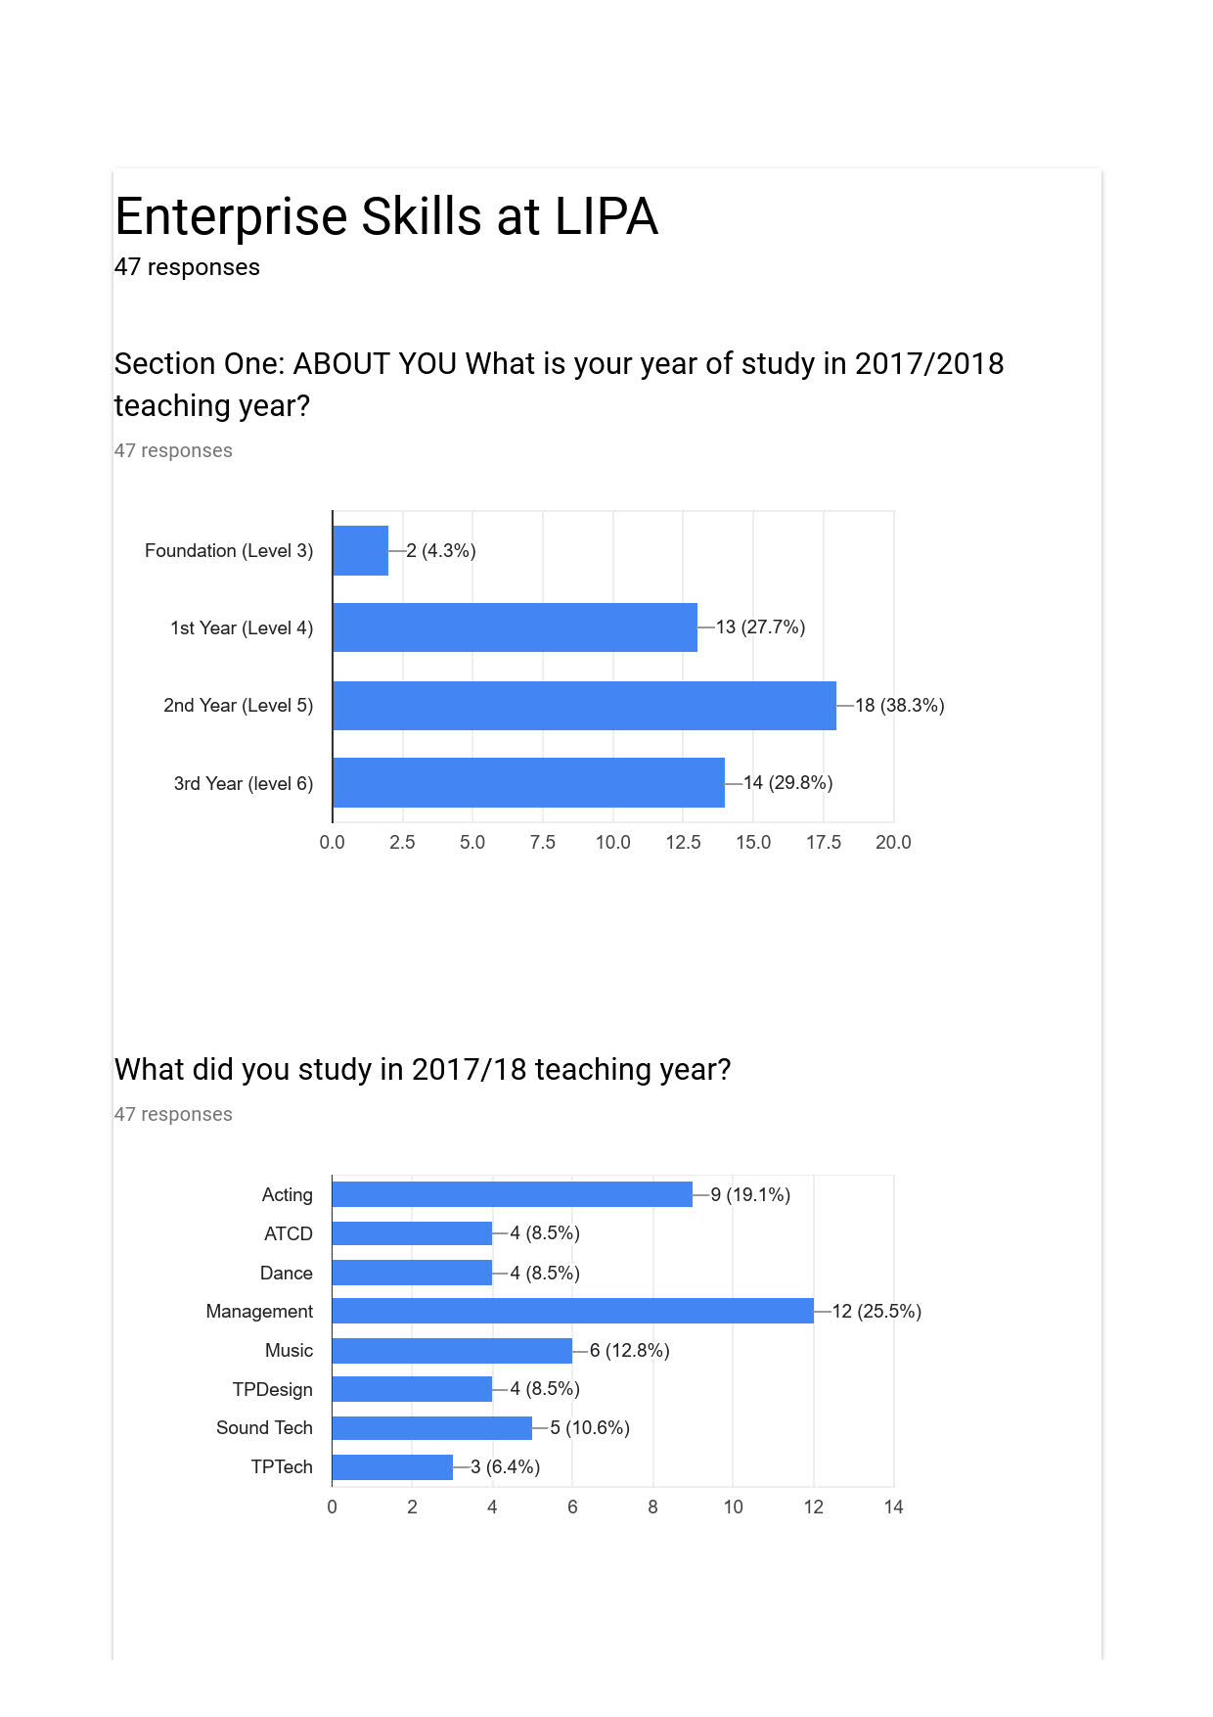

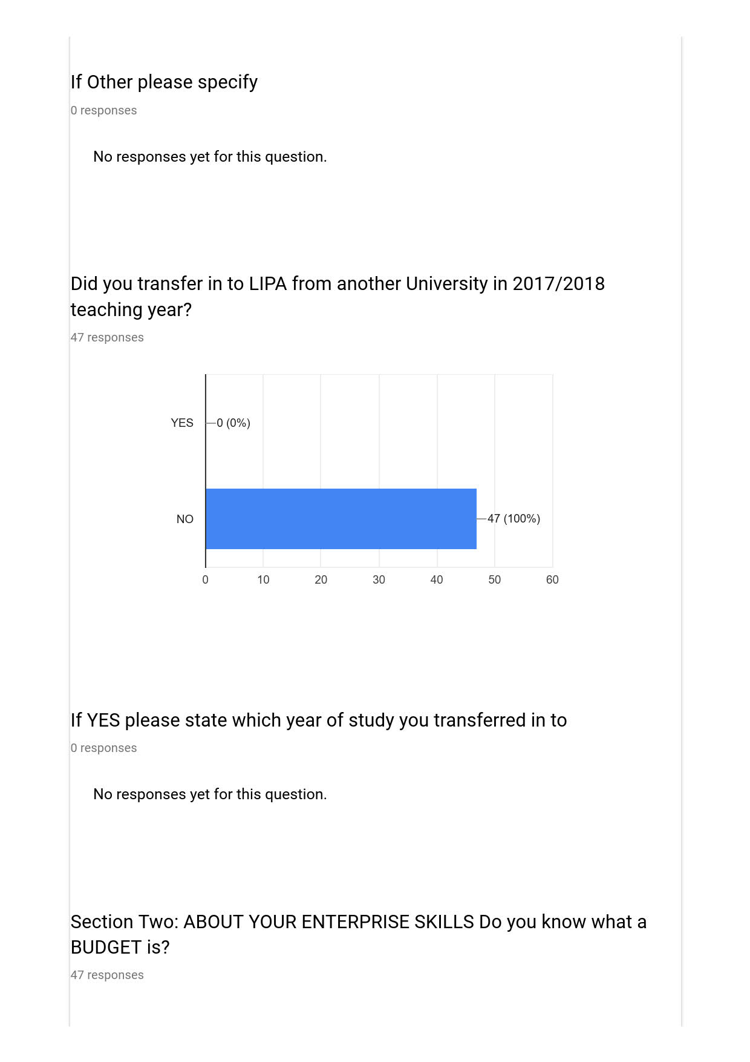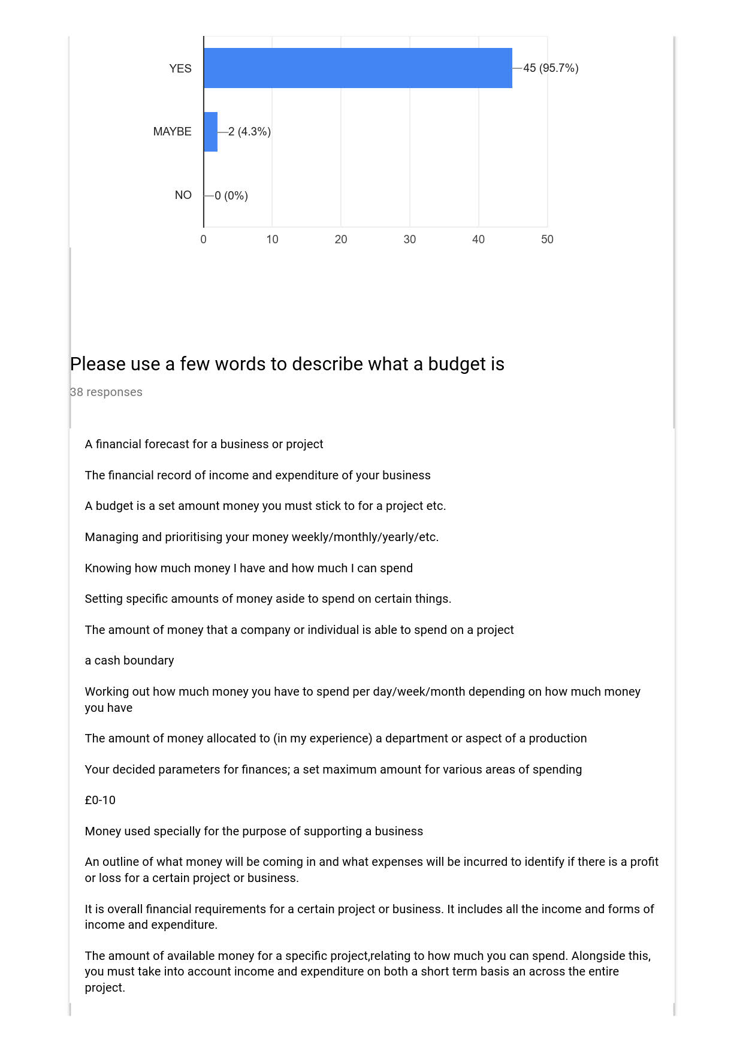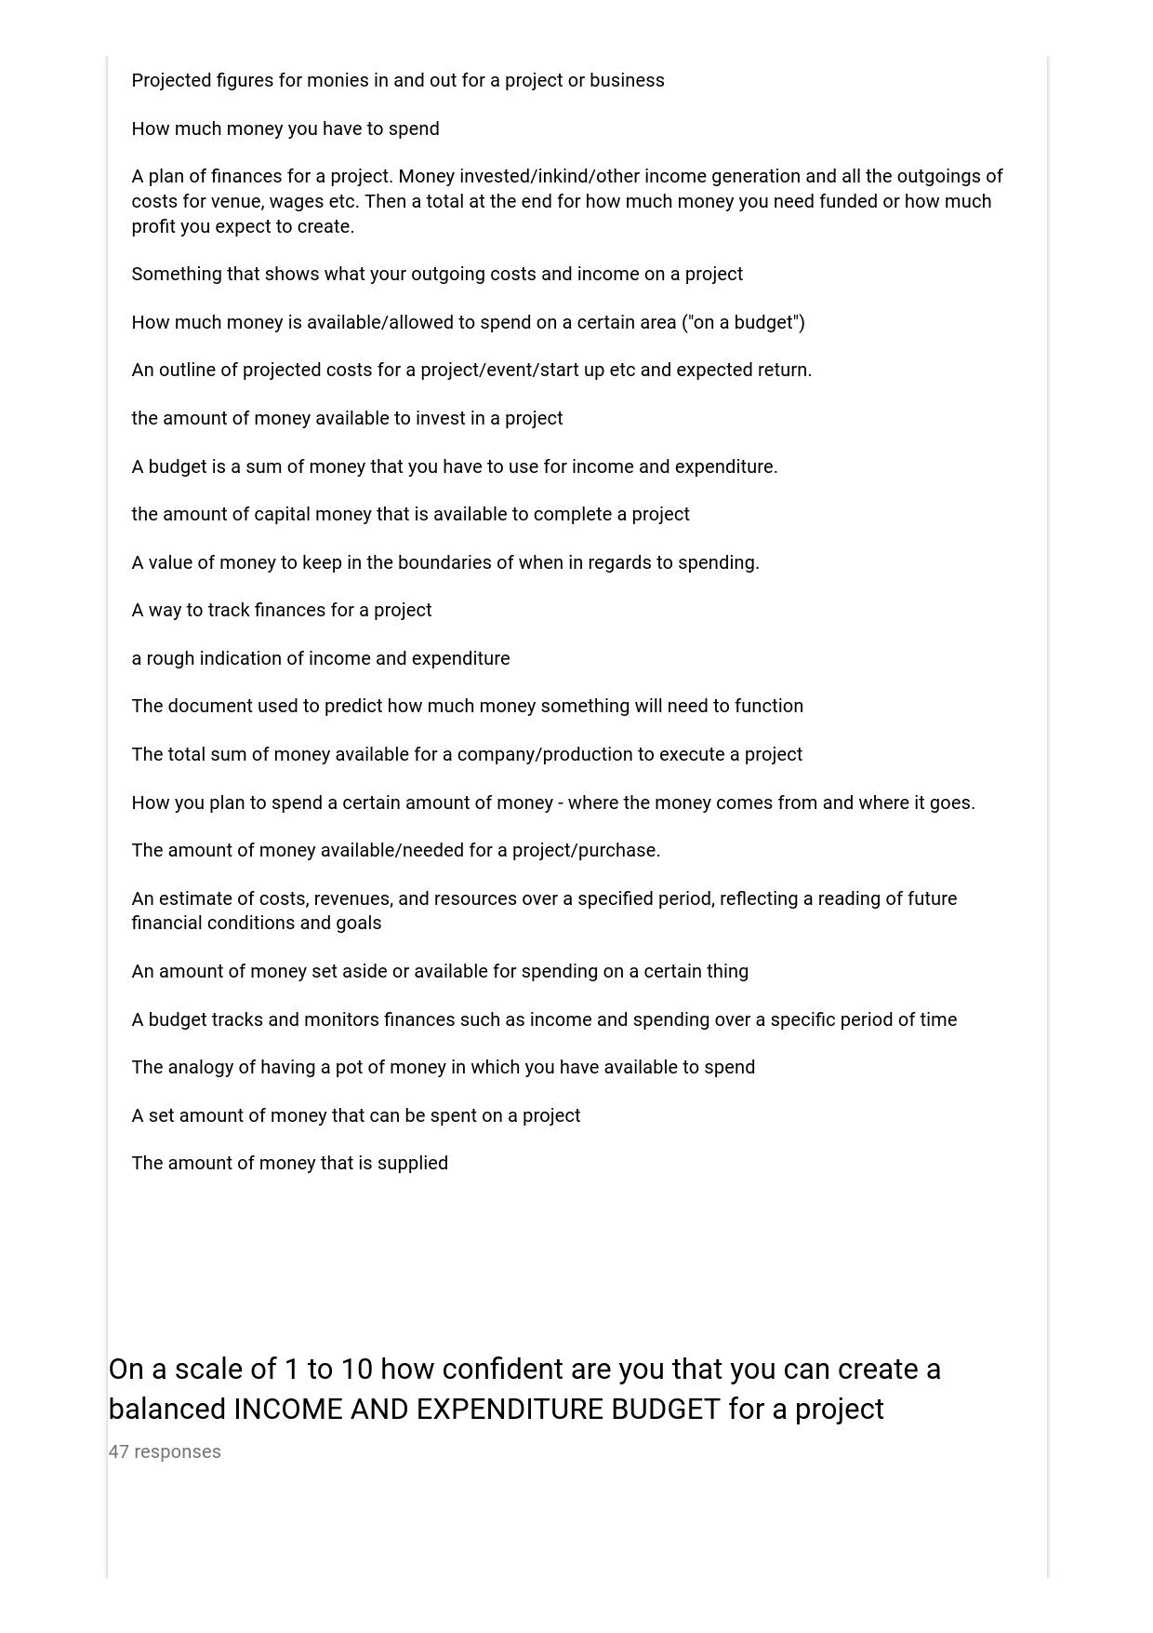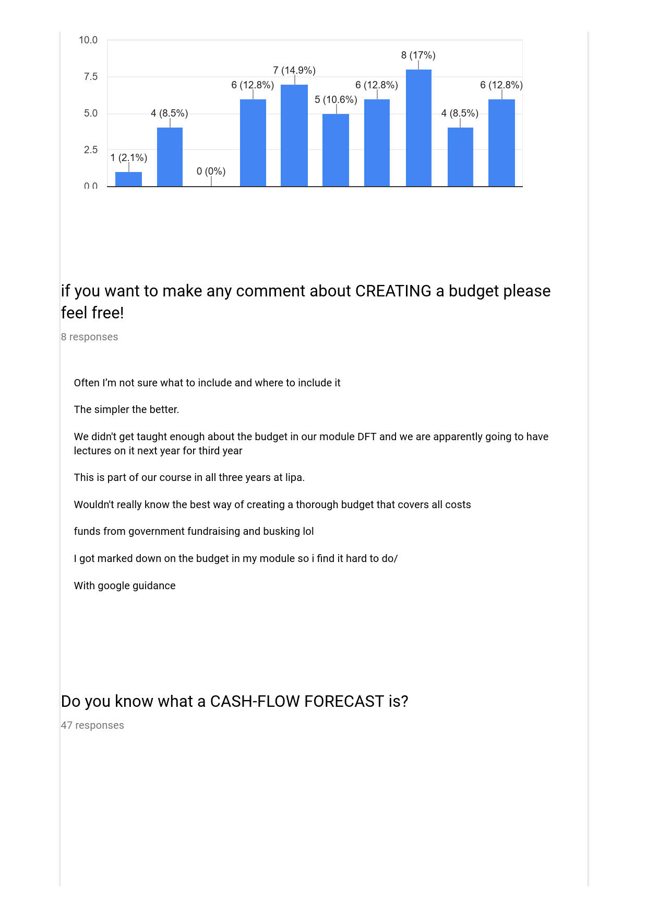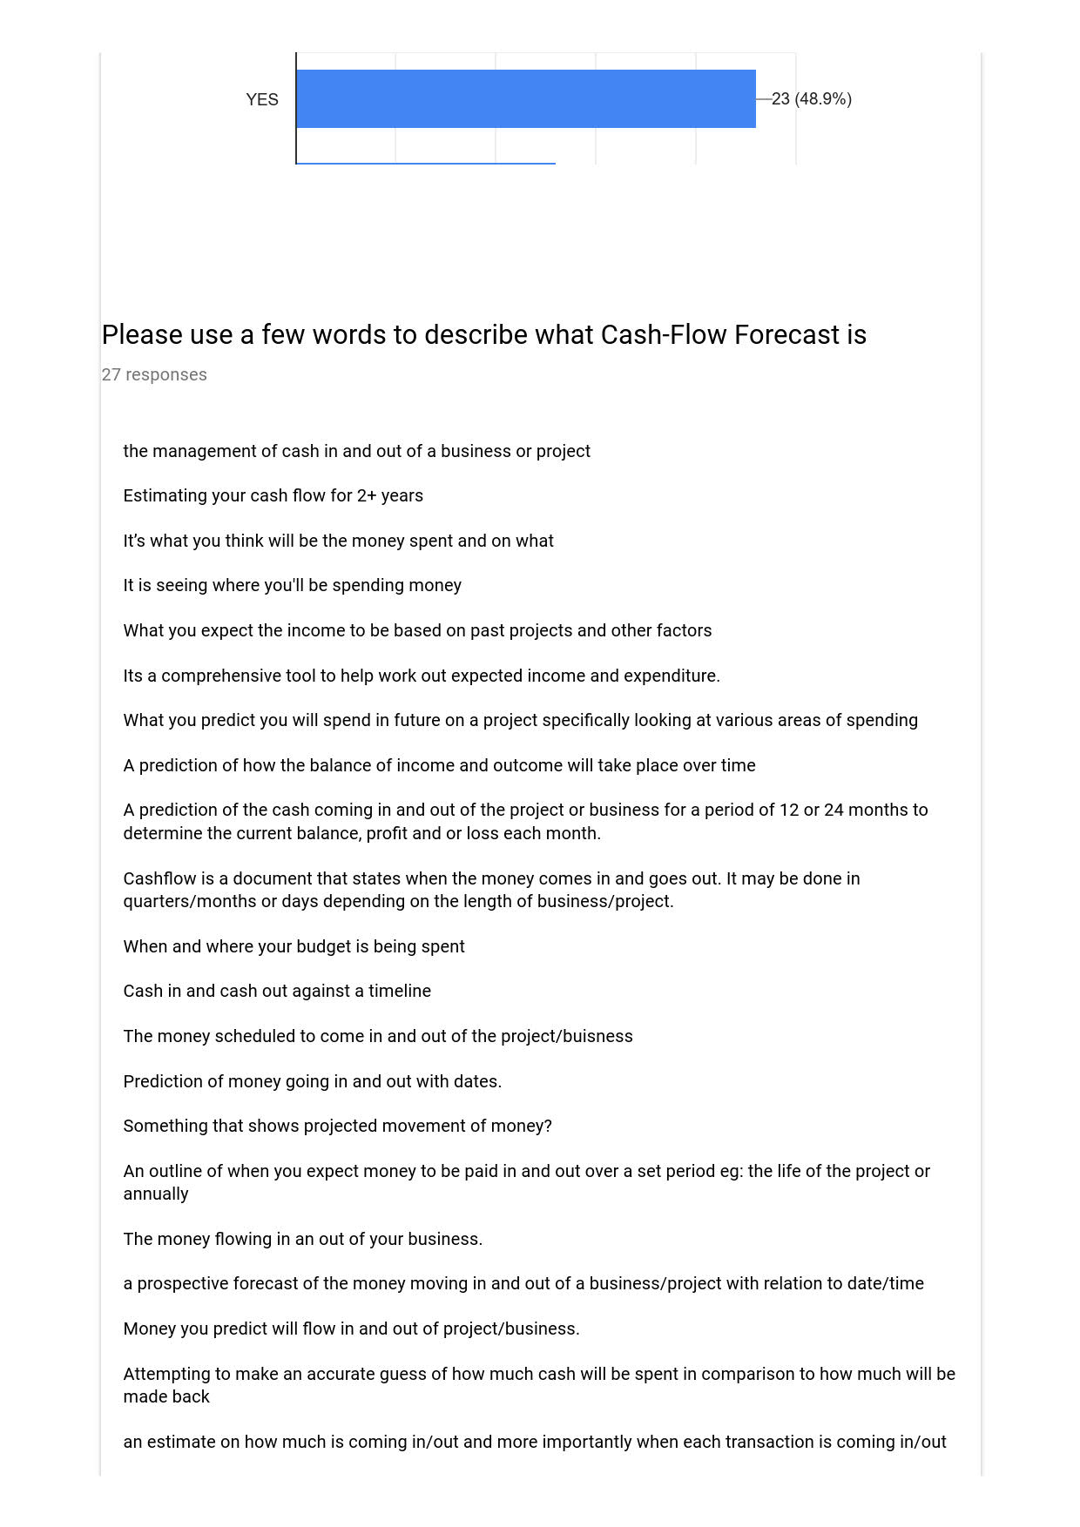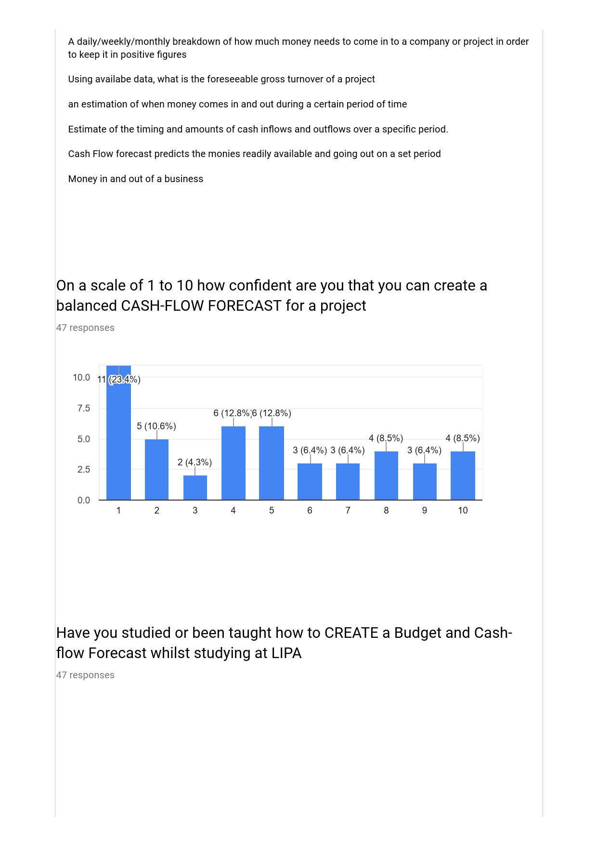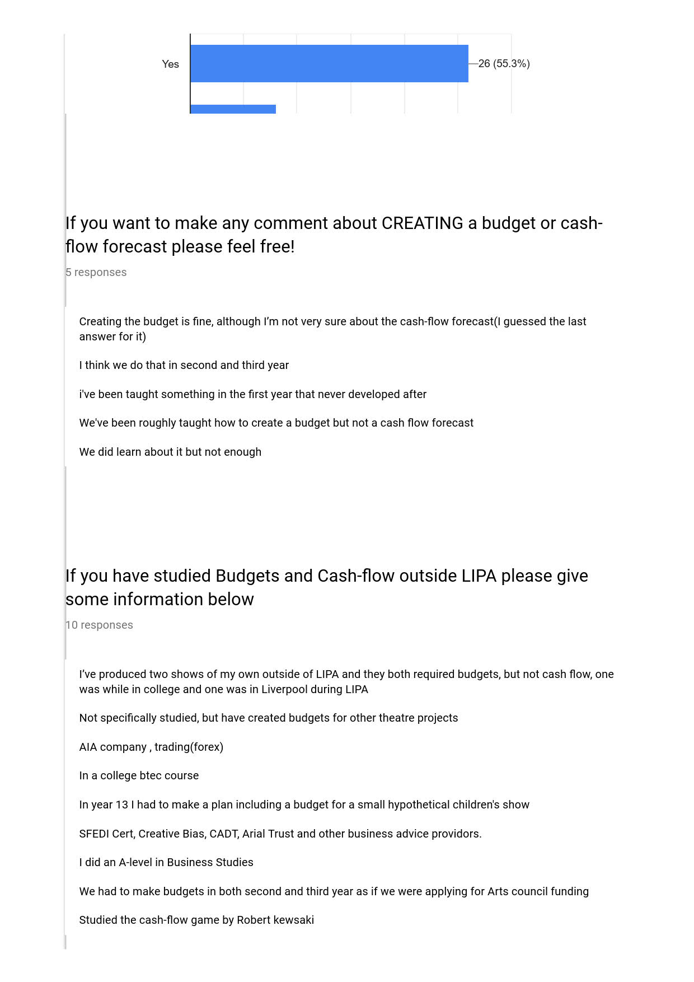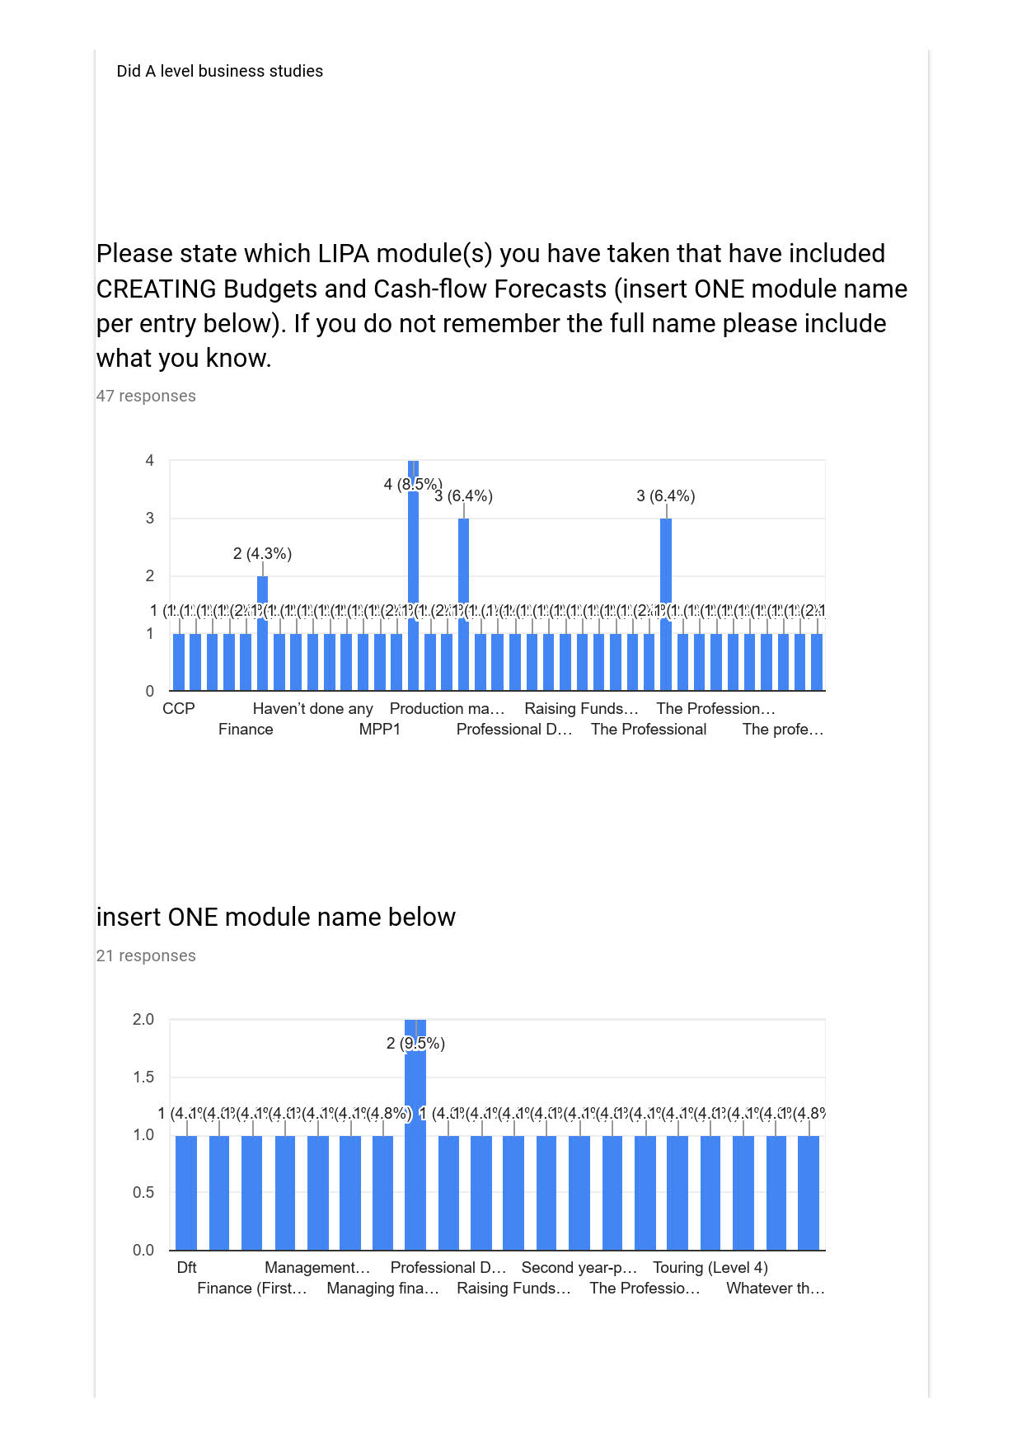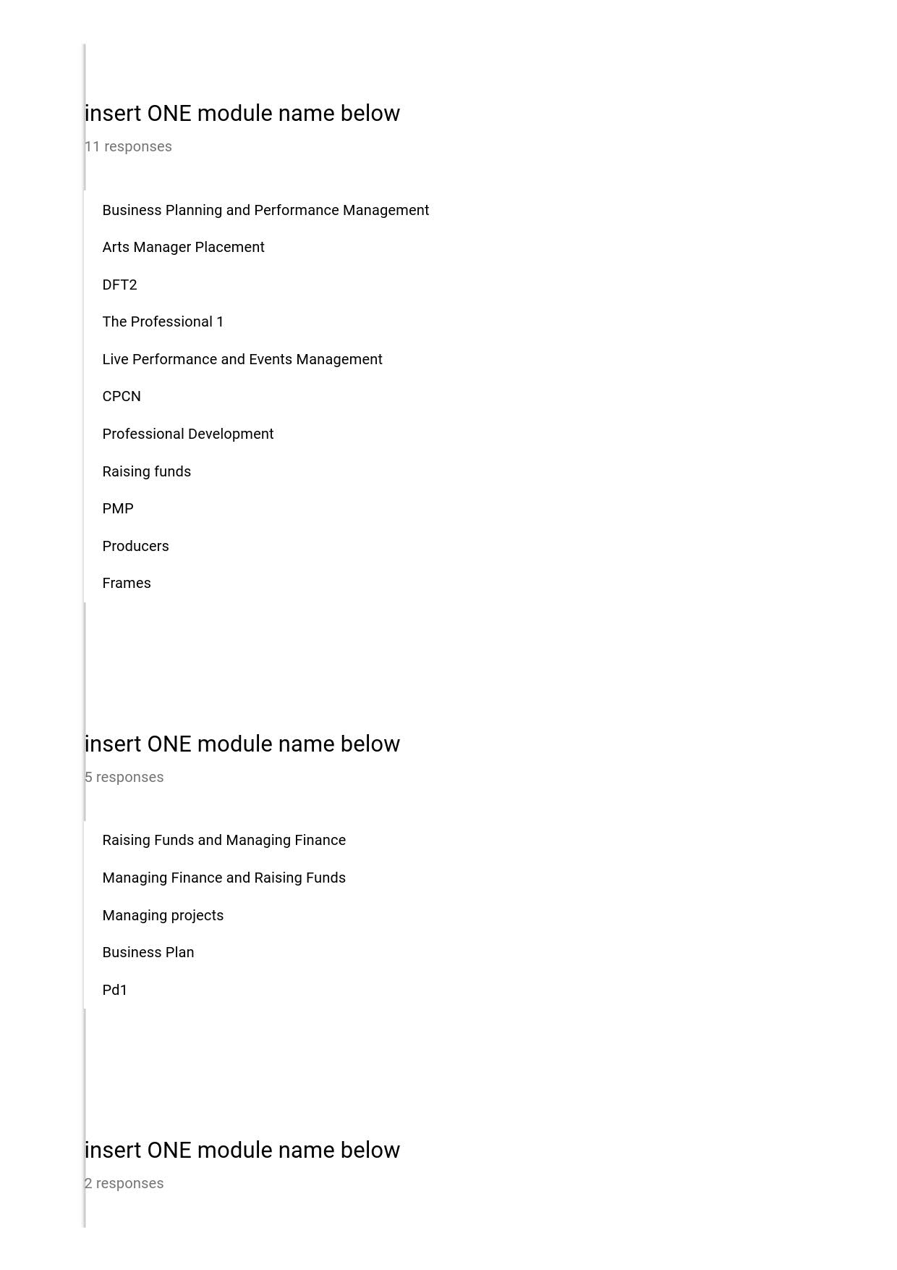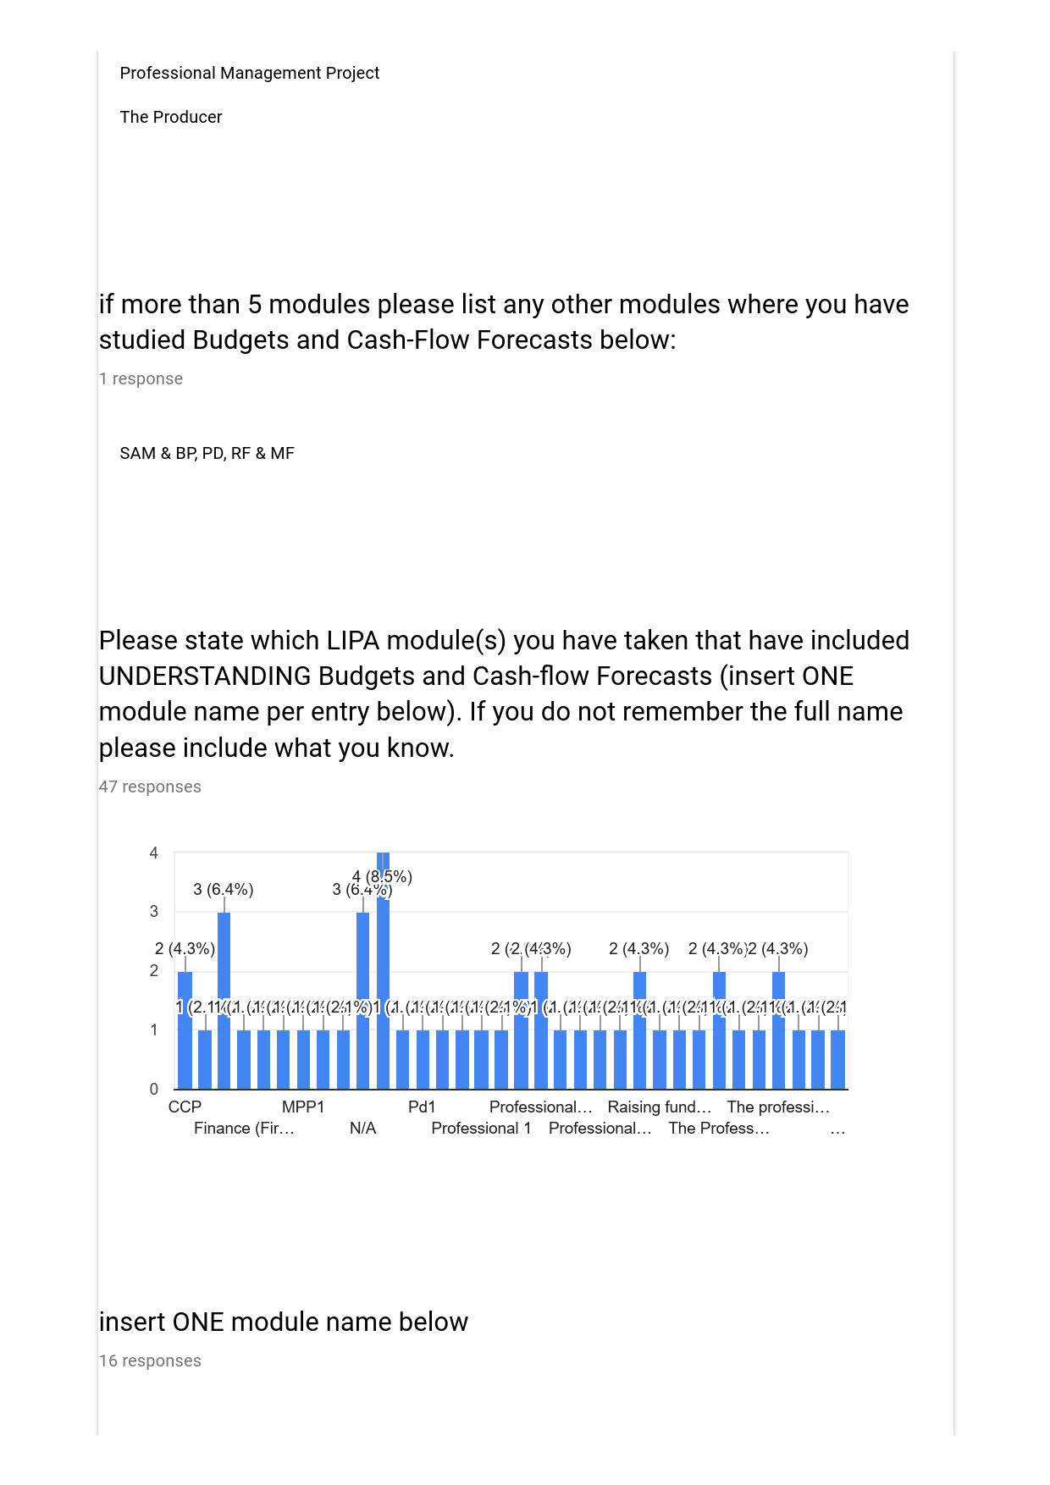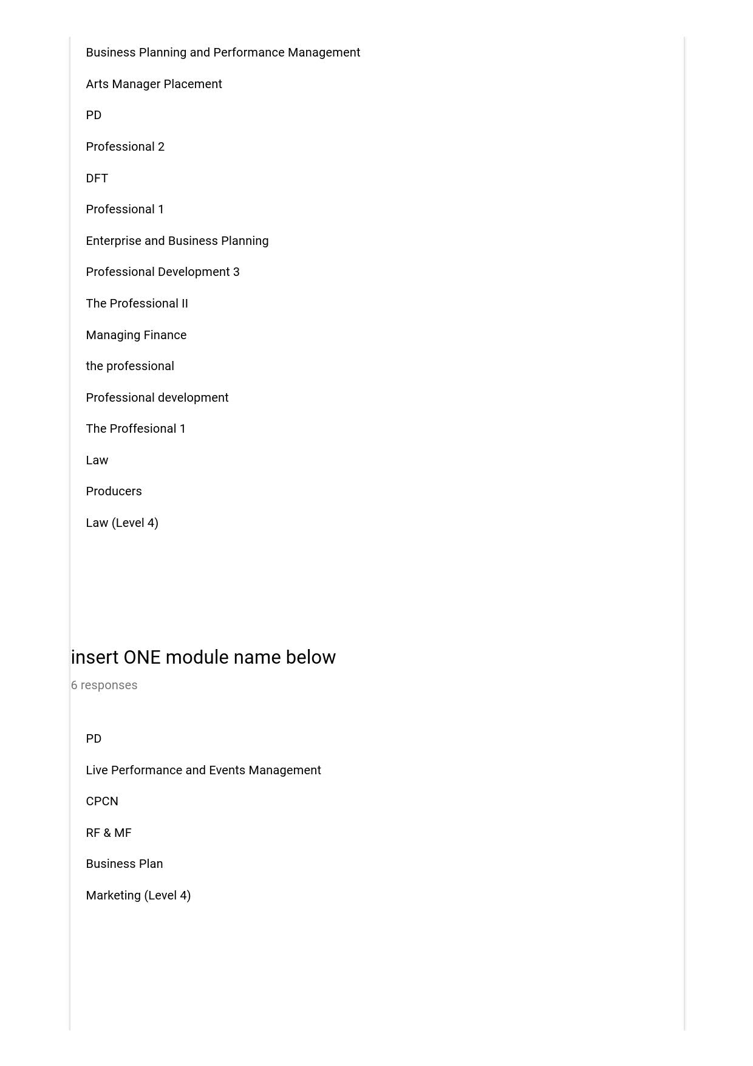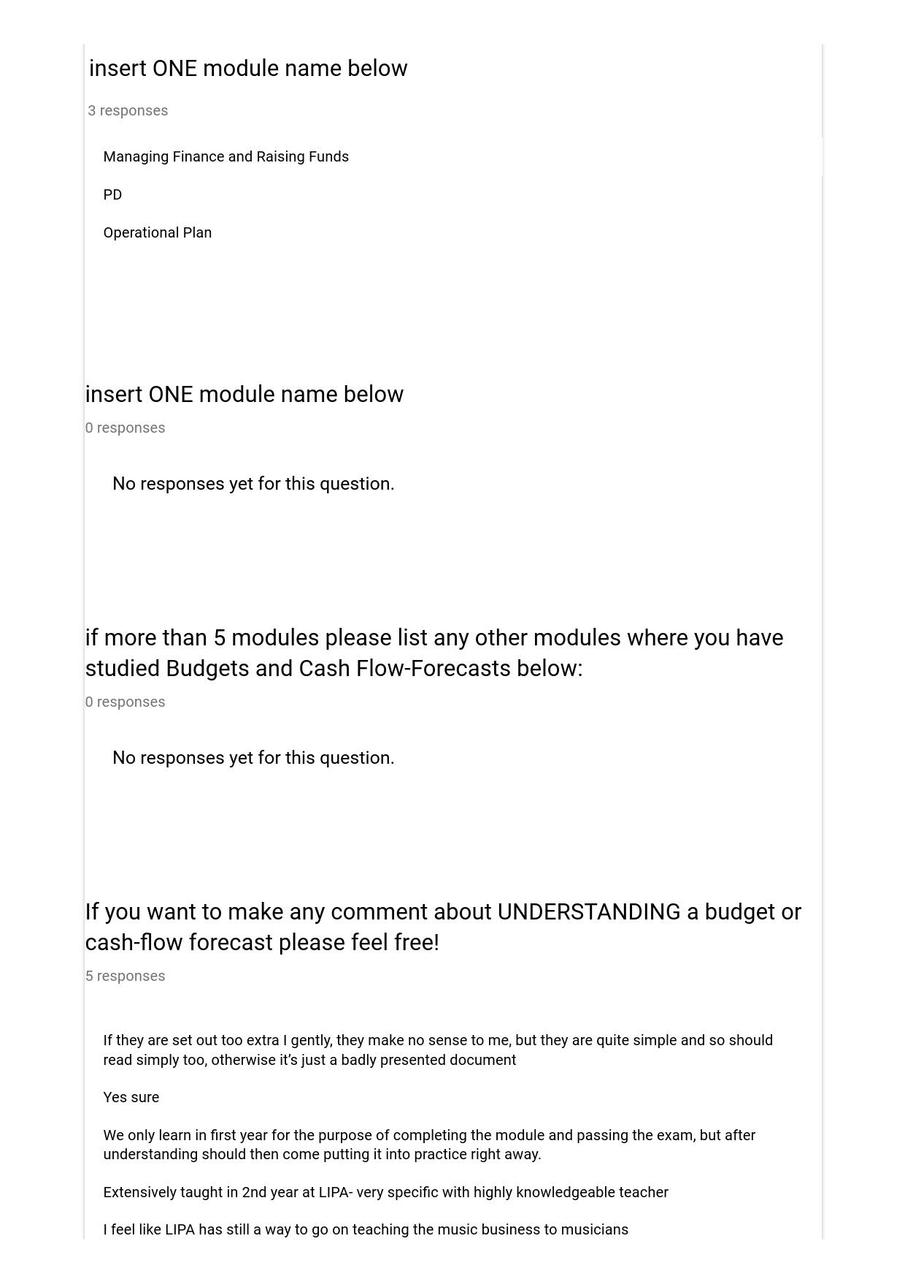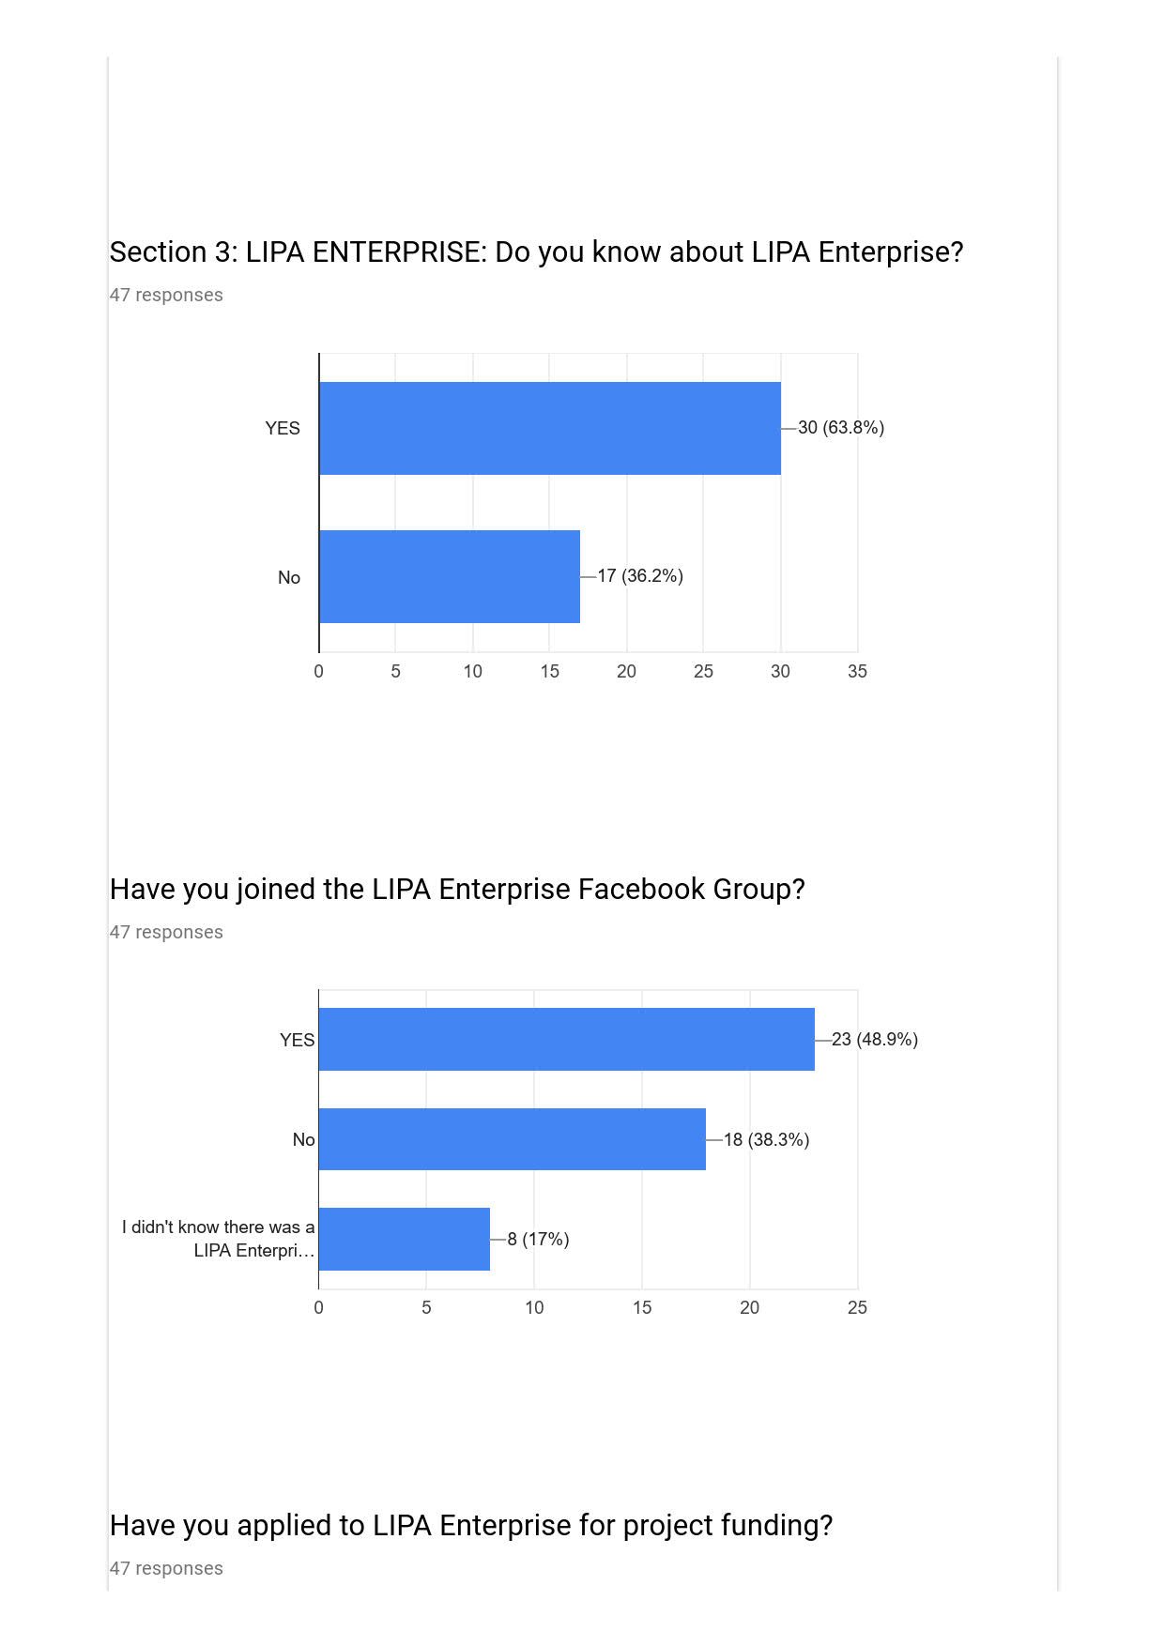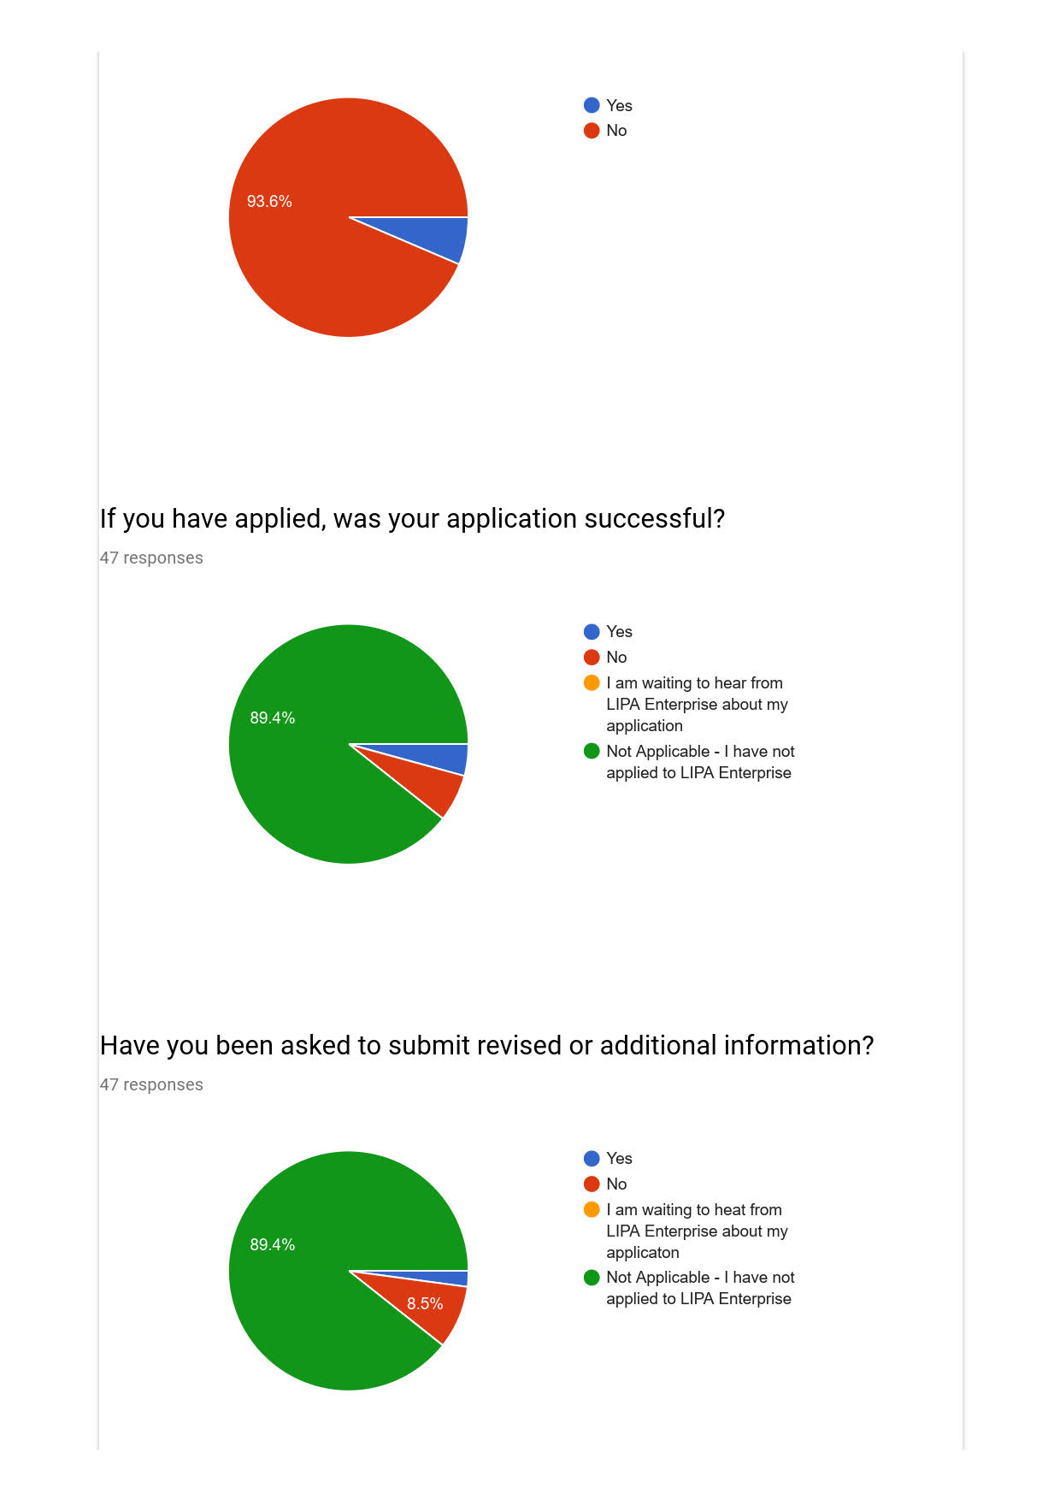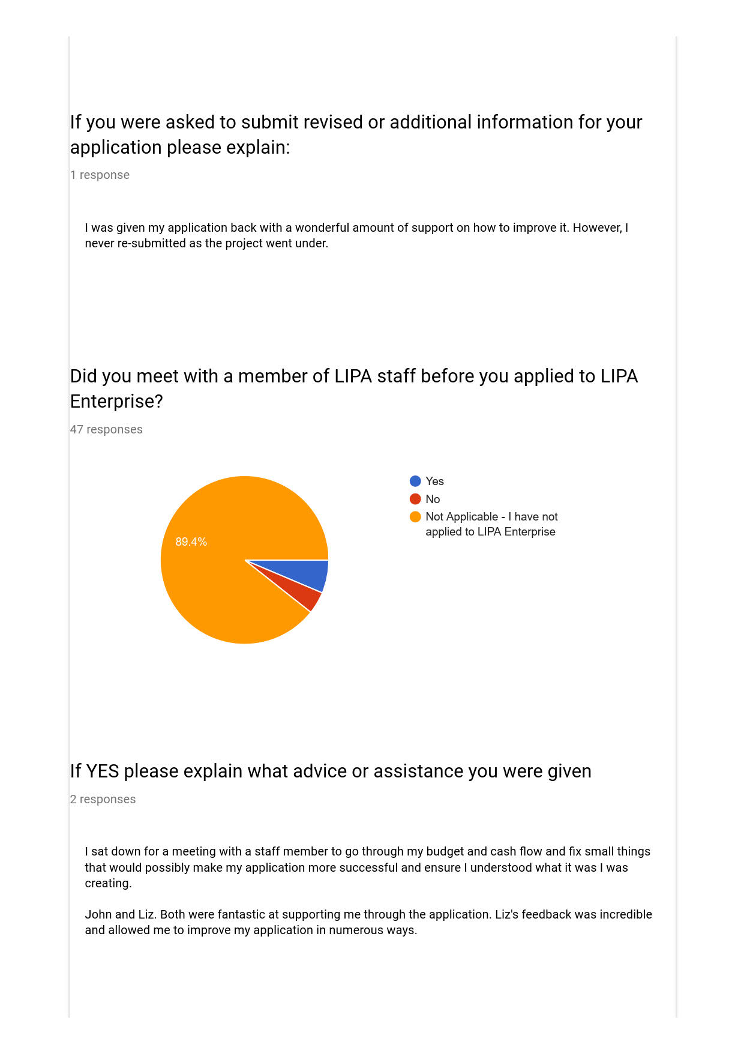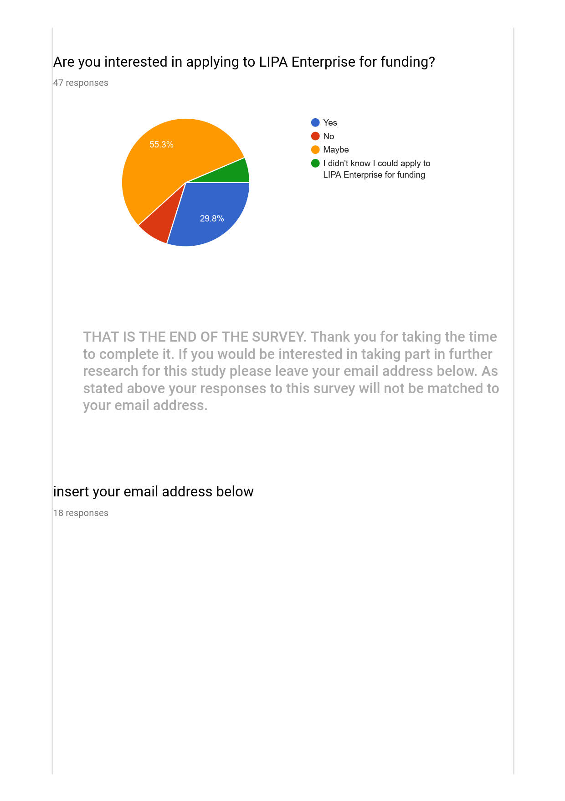

***Email addresses redacted by researcher***

**Appendix 4 Free Text Responses to Describe a Budget**

|  |  |  |  |
| --- | --- | --- | --- |
| **What is your year of study** | **What did you study?** |  | **Please use a few words to describe what a budget is** |
| 3rd Year (level 6) | Management |  | A financial forecast for a business or project |
| 3rd Year (level 6) | Management |  | The financial record of income and expenditure of your business |
| 3rd Year (level 6) | Management |  | A budget is a set amount money you must stick to for a project etc. |
| 3rd Year (level 6) | Acting |  | Managing and prioritising your money weekly/monthly/yearly/etc. |
| 3rd Year (level 6) | Dance |  | Knowing how much money I have and how much I can spend |
| 1st Year (Level 4) | Dance |  | Setting specific amounts of money aside to spend on certain things. |
| 2nd Year (Level 5) | Acting |  | The amount of money that a company or individual is able to spend on a project |
| 2nd Year (Level 5) | Sound Tech |  | a cash boundary |
| 2nd Year (Level 5) | TPTech |  |  |
| 1st Year (Level 4) | TPTech |  | Working out how much money you have to spend per day/week/month depending on how much money you have |
| 2nd Year (Level 5) | TPDesign |  | The amount of money allocated to (in my experience) a department or aspect of a production |
| 2nd Year (Level 5) | Music |  |  |
| 1st Year (Level 4) | Acting |  | Your decided parameters for finances; a set maximum amount for various areas of spending |
| 2nd Year (Level 5) | Music |  |  |
| 2nd Year (Level 5) | Sound Tech |  | £0-10 |
| 2nd Year (Level 5) | Dance |  | Money used specially for the purpose of supporting a business |
| 2nd Year (Level 5) | Management |  | An outline of what money will be coming in and what expenses will be incurred to identify if there is a profit or loss for a certain project or business. |
| 2nd Year (Level 5) | Management |  | It is overall financial requirements for a certain project or business. It includes all the income and forms of income and expenditure. |
| 3rd Year (level 6) | ATCD |  | The amount of available money for a specific project,relating to how much you can spend. Alongside this, you must take into account income and expenditure on both a short term basis an across the entire project. |
| 1st Year (Level 4) | Management |  | Projected figures for monies in and out for a project or business |
| 1st Year (Level 4) | Management |  |  |
| 2nd Year (Level 5) | Acting |  | How much money you have to spend |
| 1st Year (Level 4) | Acting |  |  |
| 2nd Year (Level 5) | Acting |  | A plan of finances for a project. Money invested/inkind/other income generation and all the outgoings of costs for venue, wages etc. Then a total at the end for how much money you need funded or how much profit you expect to create. |
| 2nd Year (Level 5) | TPDesign |  | Something that shows what your outgoing costs and income on a project |
| 1st Year (Level 4) | ATCD |  | How much money is available/allowed to spend on a certain area ("on a budget") |
| 1st Year (Level 4) | Management |  | An outline of projected costs for a project/event/start up etc and expected return. |
| 2nd Year (Level 5) | Music |  | the amount of money available to invest in a project |
| 1st Year (Level 4) | Management |  | A budget is a sum of money that you have to use for income and expenditure. |
| 3rd Year (level 6) | Sound Tech |  | the amount of capital money that is available to complete a project |
| 3rd Year (level 6) | Acting |  |  |
| 1st Year (Level 4) | ATCD |  | A value of money to keep in the boundaries of when in regards to spending. |
| 2nd Year (Level 5) | Acting |  | A way to track finances for a project |
| 1st Year (Level 4) | Music |  | a rough indication of income and expenditure |
| 3rd Year (level 6) | Sound Tech |  |  |
| 3rd Year (level 6) | ATCD |  | The document used to predict how much money something will need to function |
| 3rd Year (level 6) | Music |  | The total sum of money available for a company/production to execute a project |
| 3rd Year (level 6) | Acting |  | How you plan to spend a certain amount of money - where the money comes from and where it goes. |
| 3rd Year (level 6) | Management |  | The amount of money available/needed for a project/purchase. |
| Foundation (Level 3) | Music |  |  |
| 1st Year (Level 4) | Sound Tech |  |  |
| 2nd Year (Level 5) | Management |  | An estimate of costs, revenues, and resources over a specified period, reflecting a reading of future financial conditions and goals |
| 1st Year (Level 4) | TPTech |  | An amount of money set aside or available for spending on a certain thing |
| 3rd Year (level 6) | Management |  | A budget tracks and monitors finances such as income and spending over a specific period of time |
| Foundation (Level 3) | Dance |  | The analogy of having a pot of money in which you have available to spend |
| 2nd Year (Level 5) | TPDesign |  | A set amount of money that can be spent on a project |
| 2nd Year (Level 5) | TPDesign |  | The amount of money that is supplied |

**Appendix 5 Free Text Responses to Describe a Cashflow**

|  |  |  |  |
| --- | --- | --- | --- |
| **What is your year of study?** | **What did you study?** |  | **Please use a few words to describe what Cash-Flow Forecast is** |
| 3rd Year (level 6) | Management |  | the management of cash in and out of a business or project |
| 3rd Year (level 6) | Management |  | Estimating your cash flow for 2+ years |
| 3rd Year (level 6) | Management |  | It's what you think will be the money spent and on what |
| 3rd Year (level 6) | Acting |  |  |
| 3rd Year (level 6) | Dance |  | It is seeing where you'll be spending money |
| 1st Year (Level 4) | Dance |  |  |
| 2nd Year (Level 5) | Acting |  | What you expect the income to be based on past projects and other factors |
| 2nd Year (Level 5) | Sound Tech |  | Its a comprehensive tool to help work out expected income and expenditure. |
| 2nd Year (Level 5) | TPTech |  |  |
| 1st Year (Level 4) | TPTech |  |  |
| 2nd Year (Level 5) | TPDesign |  |  |
| 2nd Year (Level 5) | Music |  |  |
| 1st Year (Level 4) | Acting |  | What you predict you will spend in future on a project specifically looking at various areas of spending |
| 2nd Year (Level 5) | Music |  |  |
| 2nd Year (Level 5) | Sound Tech |  |  |
| 2nd Year (Level 5) | Dance |  | A prediction of how the balance of income and outcome will take place over time |
| 2nd Year (Level 5) | Management |  | A prediction of the cash coming in and out of the project or business for a period of 12 or 24 months to determine the current balance, profit and or loss each month. |
| 2nd Year (Level 5) | Management |  | Cashflow is a document that states when the money comes in and goes out. It may be done in quarters/months or days depending on the length of business/project. |
| 3rd Year (level 6) | ATCD |  | When and where your budget is being spent |
| 1st Year (Level 4) | Management |  | Cash in and cash out against a timeline |
| 1st Year (Level 4) | Management |  |  |
| 2nd Year (Level 5) | Acting |  | The money scheduled to come in and out of the project/buisness |
| 1st Year (Level 4) | Acting |  |  |
| 2nd Year (Level 5) | Acting |  | Prediction of money going in and out with dates. |
| 2nd Year (Level 5) | TPDesign |  | Something that shows projected movement of money? |
| 1st Year (Level 4) | ATCD |  |  |
| 1st Year (Level 4) | Management |  | An outline of when you expect money to be paid in and out over a set period eg: the life of the project or annually |
| 2nd Year (Level 5) | Music |  |  |
| 1st Year (Level 4) | Management |  | The money flowing in an out of your business. |
| 3rd Year (level 6) | Sound Tech |  | a prospective forecast of the money moving in and out of a business/project with relation to date/time |
| 3rd Year (level 6) | Acting |  |  |
| 1st Year (Level 4) | ATCD |  | Money you predict will flow in and out of project/business. |
| 2nd Year (Level 5) | Acting |  | Attempting to make an accurate guess of how much cash will be spent in comparison to how much will be made back |
| 1st Year (Level 4) | Music |  | an estimate on how much is coming in/out and more importantly when each transaction is coming in/out |
| 3rd Year (level 6) | Sound Tech |  |  |
| 3rd Year (level 6) | ATCD |  | A daily/weekly/monthly breakdown of how much money needs to come in to a company or project in order to keep it in positive figures |
| 3rd Year (level 6) | Music |  | Using availabe data, what is the foreseeable gross turnover of a project |
| 3rd Year (level 6) | Acting |  |  |
| 3rd Year (level 6) | Management |  | an estimation of when money comes in and out during a certain period of time |
| Foundation (Level 3) | Music |  |  |
| 1st Year (Level 4) | Sound Tech |  |  |
| 2nd Year (Level 5) | Management |  | Estimate of the timing and amounts of cash inflows and outflows over a specific period. |
| 1st Year (Level 4) | TPTech |  |  |
| 3rd Year (level 6) | Management |  | Cash Flow forecast predicts the monies readily available and going out on a set period |
| Foundation (Level 3) | Dance |  | Money in and out of a business |
| 2nd Year (Level 5) | TPDesign |  |  |
| 2nd Year (Level 5) | TPDesign |  |  |

**Appendix 6 Free Text Responses to Comments on Creating Budget and Cashflow**

|  |  |  |  |
| --- | --- | --- | --- |
| **What is your year of study?** | **What did you study?** |  | **If you want to make any comment about CREATING a budget or cash-flow forecast please feel free!** |
| 2nd Year (Level 5) | Acting |  | Creating the budget is fine, although I'm not very sure about the cash-flow forecast (I guessed the last answer for it) |
| 1st Year (Level 4) | Acting |  | I think we do that in second and third year |
| 2nd Year (Level 5) | Music |  | i've been taught something in the first year that never developed after |
| 2nd Year (Level 5) | Acting |  | We've been roughly taught how to create a budget but not a cash flow forecast |
| 3rd Year (level 6) | Music |  | We did learn about it but not enough |

**Appendix 7 Free Text Responses to Comments on Understanding Budget and Cashflow**

|  |  |  |  |
| --- | --- | --- | --- |
| **year of study in 2017/2018** | **What did you study** |  | **If you want to make any comment about UNDERSTANDING a budget or cash-flow forecast please feel free!** |
| 2nd Year (Level 5) | Acting |  | If they are set out too extra I gently, they make no sense to me, but they are quite simple and so should read simply too, otherwise it's just a badly presented document |
| 2nd Year (Level 5) | Sound Tech |  | Yes sure |
| 2nd Year (Level 5) | Acting |  | Extensively taught in 2nd year at LIPA- very specific with highly knowledgeable teacher |
| 3rd Year (level 6) | Music |  | I feel like LIPA has still a way to go on teaching the music business to musicians |

**Appendix 8 Modules identified by students for creating Budgets and Cashflow Forecasts**

|  |  |  |  |  |
| --- | --- | --- | --- | --- |
| **Modules including creating Budget & Cash Flow** | | | | |
|  |  | **L4** | **L5** | **L6** |
| The Professional | | 10 | 16 | 11 |
| Raising Funds & Man Fin | | 6 | 3 | 8 |
| Music Professional Practice | | 1 |  |  |
| Music Business | | 1 |  |  |
| Design From Text | | 1 | 3 |  |
| Introduction to Professional Practice | | 1 |  |  |
| Mpdp | |  | 1 |  |
| The Producer | |  | 1 |  |
| Frames (Vocational Skills) | |  | 1 |  |
| Production Management | |  | 1 |  |
| Live Performance and Events | |  | 3 | 2 |
| Enterprise & Business Planning | |  | 3 | 2 |
| The Producers | |  | 1 | 1 |
| Practical Management Project | |  | 1 | 4 |
| Strategic Arts Manager | |  |  | 1 |
| Creation & Collaboration | |  |  | 2 |
| Community Performance as Counter Narrative | |  |  | 1 |
| Arts Manager Placement | |  |  | 1 |
|  | | **20** | **34** | **33** |