Action Research Report

How can learning experiences for academic writing be provided within a practical unit?

Module 2: Evaluation and Enhancement

Megan Purdie - 498301

PGCLTHE

6 October 2018

Word Count: 4705

Post Graduate Certificate in Learning and Teaching in Higher Education: Theatre and Performing Arts
Plagiarism Declaration
I hereby declare that this work contains no plagiarised materials as defined in the college academic regulations.
I confirm that I have properly acknowledged all references and quotations from both primary and secondary sources in this submission.
Please note by typing/writing your name below you are agreeing to the Plagiarism Declaration above.
NAME: Megan Purdie - 498301
DATE: Saturday 6 October 2018
MODULE NUMBER: 2
MODULE NAME: Evaluation and Enhancement
ASSIGNMENT NUMBER / TITLE: Action Research Report
For all assignments, please type/write the title in full at the top of your work.

CONTENTS PAGE

Literature Report……………………………………………………………..p.4
Context and Aims……………………………………………………………p.8
Methodology………………………………………………………………….p.10
Evaluation…………………………………………………………………….p.13
Conclusion……………………………………………………………………p.17
References…………………………………………………………………...p.18
Appendices…………………………………………………………………..p.20
Appendix 1. Agreement for participants………………………….p.20
Appendix 2. Questions and responses for survey 1…………….p.21
Appendix 3. Questions and responses for survey 2…………….p.32
Appendix 4. Marks comparison……………………………………p.40

LITERATURE REPORT
In this section I will review the pedagogical theories which informed the design of my action research project: action research, constructive alignment and the flipped classroom.
Action Research:
McNiff (2018) states that ‘Action research is a term which refers to a practical way of looking at your own work to check that it is as you would like it to be’ (jeanmcniff.com, 2018). As a result, McNiff goes on to discuss, it becomes a self-reflective practice. There is therefore a danger that the process can become solely about the self and the individual’s development, rather than contributing to the work of others.

Within the realm of Higher Education teaching and learning, ‘others’ can refer to colleagues, but also to students. Cowan (1998) considers teaching to be ‘the purposeful creation of situations from which motivated learners should not be able to escape without learning or developing’ (Cowan, 1998, p.47) which implies that within education there is a relationship between teacher and student, without which the work of teaching does not exist. Within this context the researcher cannot be separated from this relationship and so the research must be concerned with the self in relation to others.

Whitehead (2011) suggests the following process for identifying an area for and engaging in action research:
  - I experience a concern when some of my educational values are denied in my practice.
  - I imagine a solution to the concern.
  - I act in the direction of the imagined solution.
  - I evaluate the outcome of the solution.
  - I modify my practice, plans and ideas in the light of the evaluation.
(McNiff & Whitehead, 2011, p.90)
This process requires the researcher, and in this case teacher, to first recognise a current problem within their teaching practice and then consider what they may be able to do to change the situation. Those plans are then put into action; the research does not remain theoretical but is applied in a real-life situation, evaluated and adapted. This encourages the practitioner to remain reflective and continue to improve and develop their teaching practice, and therefore the learning experience of their students, through the action research cycle.
Through reflecting on their interactions with students, lecturers refine their teaching processes. Students also give specific feedback, formally and informally, on their learning experience, thereby providing valuable information that can be used to make teaching more effective. (Tong et al. (Ed), 2018, p.3)
Therefore, the identification of a concern or problem, and evaluation of the subsequent actions, can come through self-reflection and dialogue with students as well as research into theoretical frameworks.

Constructive Alignment:
As Bryan (2015) states, constructive alignment (Biggs & Tang, 2011) is now used worldwide as a framework for course design regarding outcomes-based learning. This style of learning is concerned with what graduates are supposed to be able to do having studied on a given course, focusing on how the assessments can illustrate the graduating students’ ability to meet the intended learning outcomes. However, ‘Constructive alignment goes one step further than most outcomes-based approaches, in that, as well as assessment tasks, teaching and learning activities are also aligned to the outcomes, in order that students are helped to achieve those outcomes more effectively’ (Biggs & Tang, 2011, p.14).

This is a student-centred approach which has grown out of the research into constructivism, performed by Vygotsky amongst others. Constructivism begins with the idea that prior knowledge creates the foundation from which further learning can then occur. Vygotsky (1978) terms this potential for learning the Zone of Proximal Development (ZPD). Learning occurs through supported progression through the ZPD from assisted to unassisted performance. This model encourages the teacher to only provide support when it is required, through what Wood (1991) would term a scaffolding approach. And, whilst student-centred learning occurs in a broad range of educational processes, the following set of common characteristics reflect the development of the focus on active learning on behalf of the student:
student-centred learning embodies the following tenets: reliance upon active rather than passive learning, an emphasis on deep learning and understanding, increased responsibility and accountability on the part of the student, an increased sense of autonomy in the learner, an interdependence between teacher and learner ... mutual respect within the learner–teacher relationship, and a reflexive approach to the learning and teaching process on the part of both teacher and learner. Implicit within this approach is the principle that students should be consulted about the learning and teaching process; that is, that it is student- rather than teacher-centred. (Lea. Et. Al, 2003, p.322)
This emphasis on active learning and consultation is important to remember when designing content within the constructive alignment model, and when considering an action research project – especially when it is to form a part of the content.

Cowan (1998), describes his process of formative evaluation of teaching as ‘an investigation of learning and of the learning experience … with the express purpose of obtaining data which will tell me where there is a need or scope for improvement in what I do’ (Cowan, 1998, p.153). This for me represents the starting point for an action research project (and Cowan himself recognises the grey area from one activity to the other). In the developmental stages of a formative evaluation process Cowan describes how he:
- Concentrated on trying to find out how [his] students learned;
- Kept [his] students fully informed, and carried them with [him];
- Turned [his] students into action-researchers of their own practices;
(Cowan, 1998, p.110)
Therefore Cowan (1998) presents a process which can lead to developing action research projects and content for a given course of study that is student-centred and works alongside the constructive alignment model – which itself provides a useful starting point for evaluation of current practice. One pedagogic method for achieving active learning and autonomy within learners is the flipped classroom.

The Flipped Classroom:
Brame (2013) considers the key elements of the flipped classroom to be to:
- Provide an opportunity for students to gain first exposure prior to class.
- Provide an incentive for students to prepare for class.
- Provide a mechanism to assess student understanding.
- Provide in-class activities that focus on higher level cognitive activities.
(Brame, 2013, n.p.)
According to Bloom’s (n.d.) revised taxonomy the lower order learning processes are to remember, understand and apply. In the flipped classroom model the student would be asked to engage with these processes outside of the classroom as they engage in first exposure to the subject matter through, for example, set reading or research tasks. This leaves class time available to deepen knowledge, with support from a teacher, through the higher order learning processes: analyse, evaluate, create. This works alongside Vygotsky’s (1978) ZPD, where the work prior to class provides prior knowledge, and is then built upon within class time as the teacher facilitates the students’ journeys through the ZPD.

The flipped classroom is also compatible with the constructive alignment model and student-centred learning as, ‘one of the core objectives of flipped learning is to move students away from passive learning and towards active learning where students engage in collaborative activity, peer learning and problem-based learning’ (heacademy.ac.uk, 2018, n.p.)

As a result of the research into the above areas I recognised that they each link together towards a common aim of enabling students to develop their learning skills alongside subject knowledge; and that this can be achieved through course content which supports them towards the intended learning outcomes through the teaching and learning activities as well as the assessment tasks. Therefore, I used these theories to evaluate my own practice and engage in a short action research project.

CONTEXT AND AIMS
The Level 4, Acting 2 unit on the BA(Hons) Acting course at Arts University Bournemouth (AUB) has the following learning outcomes:
- LO1 Demonstrate the development of your imaginative, intellectual, professional, innovative and technical skills in the investigation of the artistic challenges presented by the text and performance in a realist/naturalist context.
- LO2 Demonstrate the development of your research and critical reflection, articulated in discussion and your evaluation using accurate academic protocols.
(AUB, 2017)
The development referred to above is in relation to the work explored in Acting 1 (including Stanislavski and Uta Hagen techniques) which preceeds this unit. Both units are taught through practical classes four times a week and I, as a lecturer on both, taught two groups for each unit.

In response to the National Student Survey results in 2017 an action plan had been created to improve the student experience in relation to assessment and feedback and in particular that ‘the criteria used in marking is clear in advance’ (NSS, 2017). In order to work towards this I allocated time within my first Acting 2 class to discuss the learning outcomes and assessment methods for the unit and allow space for any questions, with the aim of increasing the students’ understanding of how they were to be assessed.

Through this dialogue it became clear that the students’ main concerns lay with Learning Outcome 2 (LO2) which is assessed through a written evaluation. Following feedback on their Acting 1 evaluations there was some confusion on what the content and structure of an evaluation could be, and how they could improve. It was also highlighted that very little, or no time was allocated to this area within the Acting 1 contact time.

This lead me to reflect upon my teaching in the previous unit, and to recognise that within the contact time I had failed to fully meet one of the aims of the unit: ‘To promote the use of the analytical, investigative and reflective skills of the actor through research, practical exploration and written evaluation’ (AUB, 2017). Through applying Biggs and Tang’s (2011) constructive alignment model it was apparent that I had not facilitated learning and teaching experiences which clearly and specifically focused on this aim or LO2. Therefore, this was an area for improvement within my teaching practice which could be explored through dialogue and applying different pedagogies with my students for Acting 2. This is what formed the basis for my action research project.

The intention to focus on the written assessment was further validated through it’s potential benefits for the teaching team and students across the course; as our external examiner had highlighted that the quality of our students’ written work could be improved; leaving the question of, how? Currently there is a provision of academic writing workshops throughout the term which all our students can attend. However, only two of these addressed evaluations and they are generic in terms of content as they are designed for any student from any course to attend. Any student can also request an academic tutorial from student services. However, this relies upon the student organising the tutorial, and neither of these options are compulsory.

At the beginning of the PGCLTHE course I completed the Teaching Perspectives Inventory (Pratt & Collins, n.p., 2014) questionnaire, and discovered that my dominant characteristics were Nurturing and Developmental. In reflection upon this at the time I recognised a belief that students should be challenged but provided with the teaching and learning experiences that they need in order to meet those challenges. It is clear that this belief is part of the reason why I became concerned about the imbalance between the assessment and teaching and learning elements of Acting 2 with regards to the written assessment.

Therefore, I designed an action research project to increase the teaching and learning time with regards to LO2, which my students would receive as part of the contact time for Acting 2; with the subsequent aims of increasing their understanding of the mode of assessment, their confidence in approaching it and their final marks for LO2. As the amount of contact time for the unit is fixed this would require having less time for practical work and rehearsals. As a personal aim for the project was for it to be student-centred and collaborative, I discussed this with my students and agreed the terms of the action research project through dialogue and a written agreement (see appendix 1).

METHODOLOGY
McNiff and Whitehead (2011) state that action research is about asking a range of questions, such as ‘What is my concern? Why am I concerned?’ (McNiff & Whitehead, 2011, p.3), which I focus upon in the Aims and Context section of this report. I shall now go on to show my response to questions such as ‘How do I gather evidence to show reasons for my concern? What do I do about the situation?’ (McNiff & Whitehead, 2011, p.3), through describing the methods implemented for my action research project.

In order to gather further evidence I designed a survey for my Acting 2 classes to complete with regards to their experience of approaching the written assessment for Acting 1 and how they felt about the written assessment for Acting 2. The full set of questions and responses can be found in Appendix 2, for which there was an 87% response rate.

Key areas of interest which came out of survey 1 were:
- A strong recognition of the value of self-reflection through the evaluation and how it helps them to ‘understand [their] weaknesses and develop them into strengths’ (Participant, Survey 1, 2018)
- A shared struggle with connecting personal experience to theory and communicating this effectively through a structure which follows academic protocols and is critically evaluative.
- 89% of respondents considered themselves to have received between none and a small amount of contact time focused on the written assessment during Acting 1, with 75% wanting more (and the remaining quarter wanting the same amount, no one wanted less).
- A broad range of recognition for the academic support available/provided both in and out of class time - from none to ‘lots of scheduled lectures explaining how to write essays … [however] most of these lectures were very similar to each other’ (Participant, Survey 1, 2018).
- An average confidence rating of 57% regarding approaching the written assignment for Acting 2.
Therefore, I chose to focus my action research on the application of theory to personal experience for evaluation and the communication of the results of this.

The ‘doing’ of my action research project took the form of three, weekly group plenaries of thirty minutes. For each plenary the students were asked to complete a task beforehand and be able to share and discuss the outcome with the group – following the flipped classroom structure. The content of each session and preparatory activity was as follows:

Plenary 1
In preparation for this plenary the students were asked to select a short reflective section from their journals that they would be happy to share with the group. This could be in response to anything they had experienced within class time. Within the plenary all the reflections were shared and I then facilitated a discussion to support students to further reflect in response to their peers contributions, and also to see if they could connect their experiences to theory. Overall the students were unable to provide detailed knowledge of theory, or therefore evaluate their personal experience in comparison. This informed the content of the next plenary.

Plenary 2
In preparation for this plenary the students were each given the name of a technique which was relevant to their studies over the first 5 weeks of the unit. They were asked to research the technique and be able to speak about it for two minutes to the group, providing a clear definition and how and why it may be applied for performance – along with a reference to support their findings. Within the plenary time, after each two-minute sharing, the group were supported to discuss where they could relate to this theory through their own experience and whether they felt it worked for them and why. The aim for the next plenary was to formalise this discussion into an academic structure and language.

Plenary 3
In preparation for this plenary the students were asked to prepare a two minute presentation including at least two references from different types of sources, supported by one or two powerpoint slides. The presentation had to include theory connected to personal practice for reflection. They were asked to use appropriate academic protocols with regards to language and citations. In the plenary time, after each presentation, the presenter would receive peer and tutor feedback on how it could be improved or needed to be changed to adhere to academic conventions and the requirements of the written assignment. The groups were also able to ask questions of one another with regards to the theories being used. After this plenary the slides were collected and shared amongst all the students.

The design of this series of plenaries was informed by the pedagogic theories explored in the literature review. As McNiff (2013) states, in doing your action research ‘you need to check that you are acting honestly and from a context where you can help others to help themselves, rather than do things for them’ (McNiff, 2013, p.96). I believe that I achieved this through following the flipped classroom model – providing the students with tasks to perform independently and encouraging their participation through clear expectations for the following class time. This meant that through facilitating and observing discussion I could check on their learning and therefore their progression through the ZPD. Vygotsky (1978) also states that every function in the learner’s development appears twice, ‘first, between people (interpsychological), and then inside the [learner]’ (Vygotsky, 1978, p.57). As Wertsch (1985) describes, Vygotsky would argue that this requires social interaction, dialogue and mediated activity between learners, as well as with their teachers. By integrating these methods into my teaching practice, the students and I were able to construct a mutual understanding of acting techniques, and what the written evaluation is, together. Therefore, this process can be described as student-centred and constructivist in nature. It also lead to my meeting the aim of increasing the learning and teaching time directly associated with the written assignment, and therefore achieving a more balanced constructive alignment (Biggs & Tang, 2011).

EVALUATION
‘Doing action research means you consciously hope that something is going to change.’ (McNiff 2013, p.96). I had changed my teaching practice and the learning content of the unit, however, in order to see whether anything had changed for my students I needed to gather further data. I did this firstly through a second survey, this time focusing on their experience of approaching and completing the written assignment for Acting 2. The questions and full set of responses can be seen in Appendix 3. Secondly, I also made comparison between marks for the written assignment for the Acting 1 unit and the Acting 2 unit, both for my students and samples from the rest of level 4 in order to see where any patterns or differences lay. The full marks comparison can be seen in Appendix 4.

Key points from the second survey include:
- The main difficulties focused around structuring the essay and staying within the word limit, with less comments about content and academic protocols.
- 91% of respondents felt that they had received more learning time specific to the written assignment and that this made up between a little and a large amount of time. All respondents also made clear recognition and descriptions of the types of learning activities that they had engaged in, no one felt that they had received no, or less, time.
- All the respondents felt that the process had had a positive effect on their written work and approach to it: ‘I was much more prepared and relaxed when it came to writing this essay, I understood the structure more and had lots more terminology to refer to when doing independent research’ (Participant, Survey 2, 2018)
- The average confidence rating in approaching the written assignment was 64%, an increase of 8%.
- All respondents felt that this process would be of benefit to future level 4 students.
Overall the responses were very positive and encouraging, whilst also shedding light on areas that could be improved – for example also including some teaching regarding structuring the content. This could be achieved by making the course of plenaries longer by one or two weeks.

However, there are some problematics which should be highlighted with regards to this survey and respondents. For the second survey there was only a response rate of 52% - significantly lower than the response rate to the first survey of 87%, and only just enough, as considered by Richardson (in Nulty, 2008), to be an adequate response rate. However, many would want it to be higher than this. Nulty (2008) suggests that there are two key ways to increase participation in online surveys firstly through reminder emails and secondly through the form of an incentive. It is the incentive which I suspect was missing from the second survey. As, through completing the first survey, the students had the opportunity to shape the teaching and learning experience that they would receive, in order to improve their understanding, breadth of knowledge and final marks. However, with the assignment having been handed in, and therefore the action research project being finished from the student point of view, there was no longer this incentive. One way to address this in the future would be to include the second survey within a final plenary which happened after the assignment had been completed. In Nulty’s (2008) research ‘the data clearly shows that face to face administration results in higher response rates’ (Nulty, 2008, p.303), and this would give me more confidence in the results from the project not being swayed by a sample bias.

However, as I was also collating marks based data, it was possible that the marks and survey responses combined may lead to a more fair and accurate conclusion.

From the marks comparison (Appendix 4) we can see that students in my groups achieved, on average, a 1.8 mark increase for their written work. This is above the average from the other group samples (a decrease of 1.6) and the average from the year sample (an increase of 0.2). This is a result of 48% of my students increasing their marks, 26% decreasing and 26% staying the same. Whereas across the year 37% increased and decreased with 25% staying the same. This data can be seen more clearly in the table below:
 | My groups | Other groups | 80% sample of year
Average change in Marks | +1.8 | -1.6 | +0.2
Percentage of students with a mark increase | 48% | 28% | 37%
Percentage of students with a mark decrease | 26% | 46% | 37%

From these results it could be argued that the plenary process had a positive effect upon the marks within the participating groups – as more students improved their marks and by a larger increment than the average of the year sample. And this is certainly supported through the positive experiential responses communicated in the surveys. However, once more, there are problematics that need to be addressed:

Samples
Initially my aim was to collect data for the whole year group regarding numerical results for their written assignments in Acting 1 and Acting 2. However, I had to remove students who had not passed LO2 for Acting 1 due to non-submission, as this could lead to artificially high improvement rates. Also, some of the results for LO2 in Acting 1 were unavailable at the time of writing due to a colleague taking sick leave before this information was moved on to the server. Therefore, whilst I have the grading band for each student I do not have the specific mark. This leaves me with a sample size from the non-participating groups of 70% and across the whole year group of 80%, with 12 students out of 63 being excluded.

The ideal would be to have a sample of 100%, however as the samples represent the majority of the level 4 students I can still use the data to evaluate the process and consider future steps, as I shall discuss in the conclusion.

Anonymity
The surveys were completed anonymously by the participating students. The benefit of this, as Nulty (2008) discusses, is that is encourages more participation in the survey and honest responses as the students have no fear of recrimination. However, this does cause a problem when it comes to comparing all the data in order to draw conclusions. As I do not know who completed which surveys I cannot make comparisons between qualitative remarks, the increase in confidence and the change in their written assignment marks. This would have made a stronger connection between the numeric and survey data and lead to more justified conclusions.

Breadth of Data
This action research project is a starting point, and as such only focuses on numerical data from the level 4 students in the 2017-2018 academic year. To identify any patterns in mark change between the two units I will need to collate data from previous year groups. By doing this I will be able to get a greater sense of whether the plenary process had a clear effect by changing the trend, or whether there have always been similar changes, which may be the result of other variables outside of my control.

Other Variables
There are several factors that could have affected any of the students’ marks, regardless of their participation in the action research project. For example, this does not account for natural progression between Acting 1 and Acting 2 – something which could be clarified through broadening the range of the data collected, as described above. Also, based on the information I have gathered here, there is no way of knowing how much time each student spent upon their essay, or whether they proof-read it and followed other hints and tips provided – or whether any of these would have a positive or negative effect. These are areas that I would include in a survey or group discussion, potentially after the students had received their feedback, to see what they would identify as the main factors which affected the change, or lack thereof, in their mark.

CONCLUSION
From the process of the action research project and the data collected I would argue that the plenary process had a positive effect on the participating students; both in terms of their feelings towards the written assignment and in their marks which increased over the average for the year. However, I recognise that due to the problematics described in the evaluation above, these results are not conclusive.

By referring back to the action-reflection cycle described by McNiff and Whitehead (2011) I can see that this places me at the point of asking ‘how do I modify my practice in light of my evaluation?’ (McNiff & Whitehead, 2011, p.3). In response to this I would make the following suggestions for my own practice and to my peers:
- Introduce the LO2 plenaries in Acting 1, at the very beginning of the students experience of writing at university level.
- Include more than three plenaries, so that time can be spent on structuring the essay, once they have explored content based on experience and theory.
- Include plenaries in future units, perhaps in a different structure, to continue developing the students’ learning in this area.
In regards to the last point I presented my findings to my colleagues and as a result I have already introduced this work into the Level 5 unit Applied Theatre Practices, where a written evaluation is also required. A colleague and I used similar tasks, but over one day rather than split into smaller weekly plenaries. The overall results for this unit had improved over previous years and, where some students had failed their written assignment on a previous unit, no one did so in this unit – which has given me further confidence that this process holds benefits for students. I will now be working with other members of the team to discover how this work may be adapted for other units too.

Therefore, whilst I would say that there is not enough evidence to say that the process explored in my action research project holds benefits for everyone, there is enough to encourage me to make further changes to my practice in pursuit of this. And so, I shall continue through the action-reflection cycle.

REFERENCES

AUB. (2017) Acting 2 Unit Handbook Available at: https://sharepoint.aub.ac.uk/docs/mycourse/UnitInformation/ACT456.pdf (Accessed 14 August 2018)

Biggs, J. & Tang, C. (2011) Teaching for Quality Learning at University. Maidenhead: Open University Press
Bloom’s Taxonomy Plus Depth of Knowledge (no date) Available at: http://selectedreads.com/ wp-content/uploads/2014/12/b2cad8ba86b240e09515201b65a5f957.jpg (Accessed: 13 August 2013)
Brame, C., (2013). Flipping the classroom. Available at: http://cft.vanderbilt.edu/guides-sub-pages/flipping-the-classroom/ (Accessed: 13 August 2018)
Bryan, C. Enhancing Student Learning, (2015) in Lea, J. (Ed) Enhancing Learning and Teaching in Higher Education: Engaging with the Dimensions of Practice. Milton Keynes: Open University Publishing
Cowan, J. (1998) On Becoming an Innovative University Teacher: Reflection in Action. Buckingham: Open University press
Higher Education Academy (2018) Flipped Learning. Available at: https://www.heacademy.ac.uk/knowledge-hub/flipped-learning-0 (Accessed: 13 August 2018)
Lea, S., Stephenson, D. & Troy, J. (2003) Higher Education Students' Attitudes to Student-centred Learning: Beyond 'educational bulimia'? Studies in Higher Education, 28:3, 321-334.
McNiff, J. (2018) Action Research for Professional Development. Available at: http://www.jeanmcniff.com/ar-booklet.asp (Accessed: 10 August 2018)
McNiff, J. (2013) Action Research: principles and practice. Abingdon: Routledge
McNiff, J. & Whitehead, A. (2011) All You Need To Know About Action Research. London: Sage publications Ltd.
NSS. (2017) National Student Survet 2017 – Core Questionnaire. Available at: https://www.thestudentsurvey.com/content/NSS2017_Core_Questionnaire.pdf (Accessed 14 August 2018)
Nulty, D. (2008) The adequacy of response rates to online and paper surveys: what can be done? Assessment & Evaluation in Higher Education, 33:3, 301-314
Pratt, D. & Collins, J. (2014) Teaching Perspectives Inventory. Available at: http://www.teachingperspectives.com/tpi/ (Accessed: 14 August 2018)
Tong, V., Standen, A. & Sotiriou, M. (Eds) (2018) Shaping Higher Education with Students: Ways to connect research and teaching. London: UCL Press
Vygotsky, L. (1978) Mind in society: the development of higher psychological processes. London: Harvard University Press
Wertsch, J. (1985) Vygotsky and the social formation of Mind. USA: Harvard College
Wood, D. (1991) ‘Aspects of Teaching and Learning’ in Sheldon, S. and Light, P. Learning To Think. London: Routledge pp.97-120

APPENDICES
APPENDIX 1 – Agreement for Participants


APPENDIX 2 – Questions and Responses from Survey 1
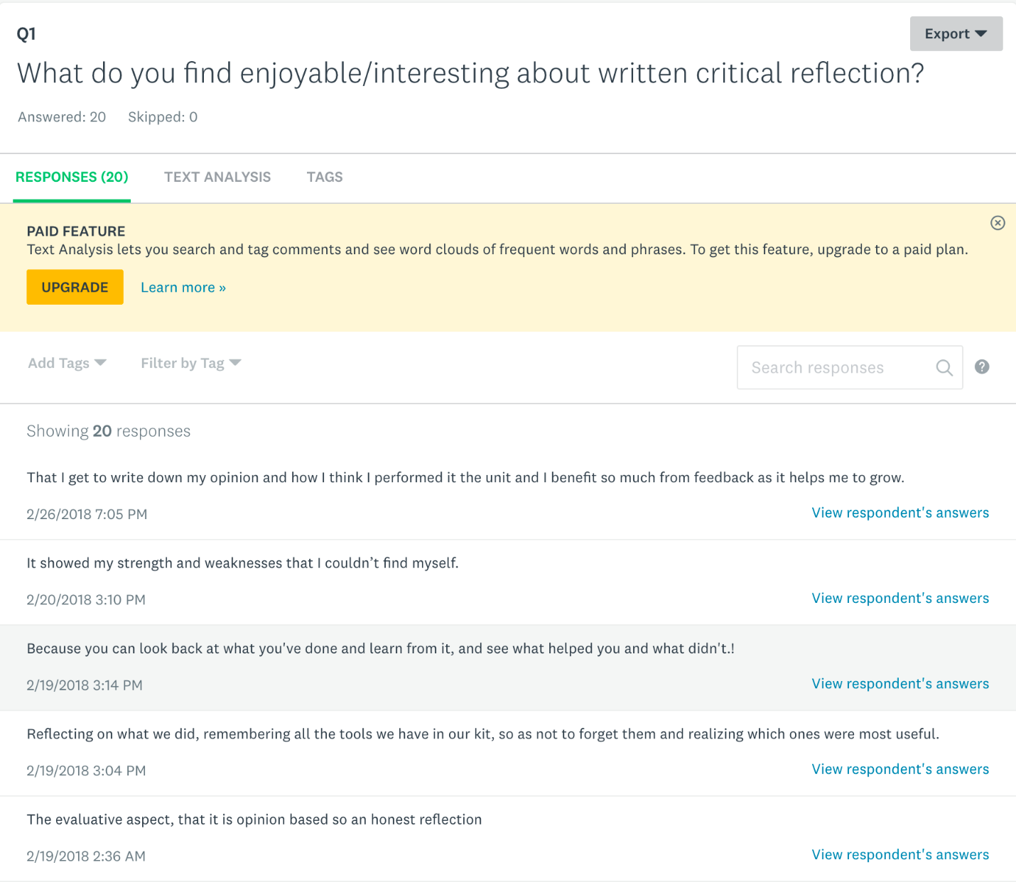
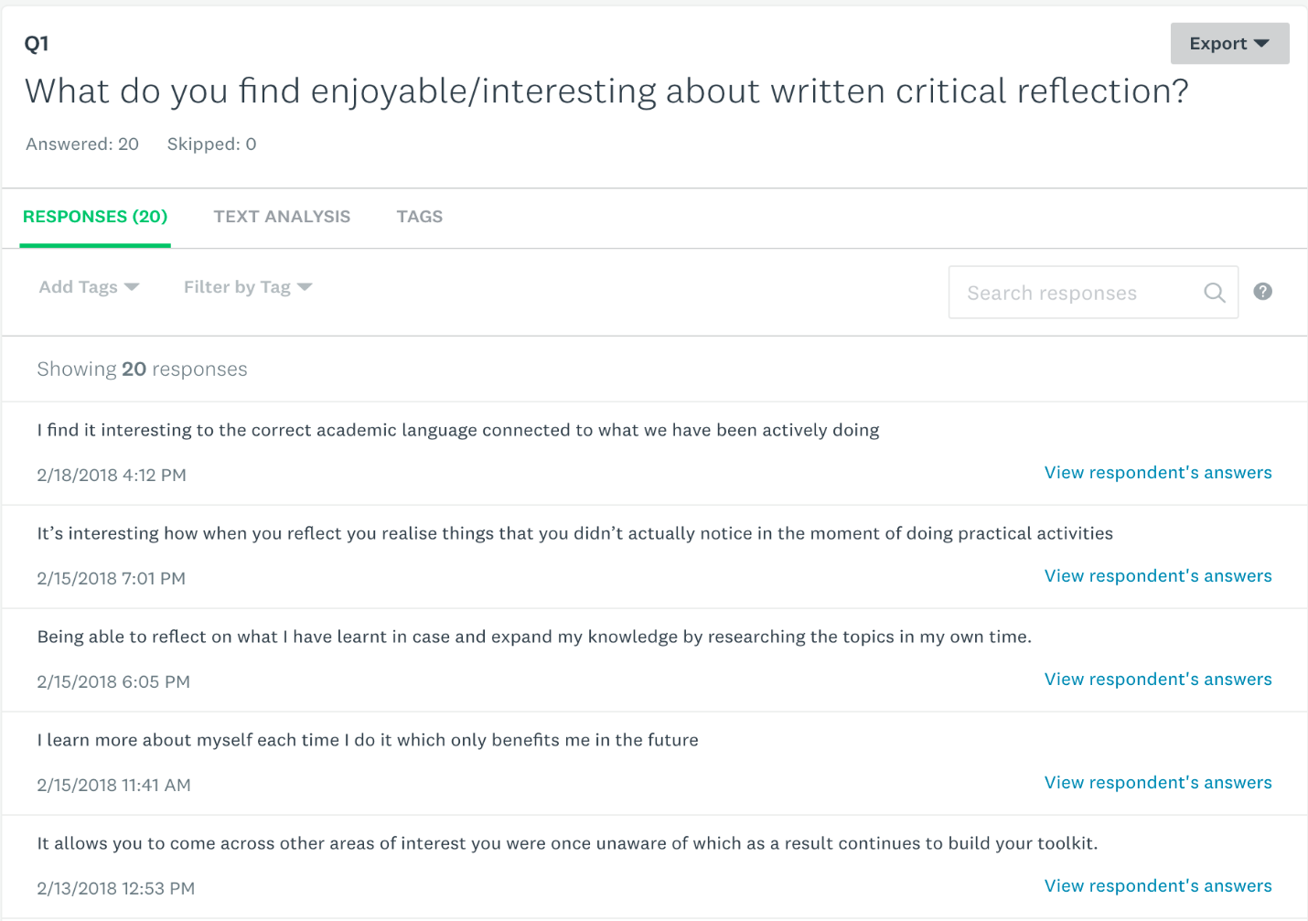
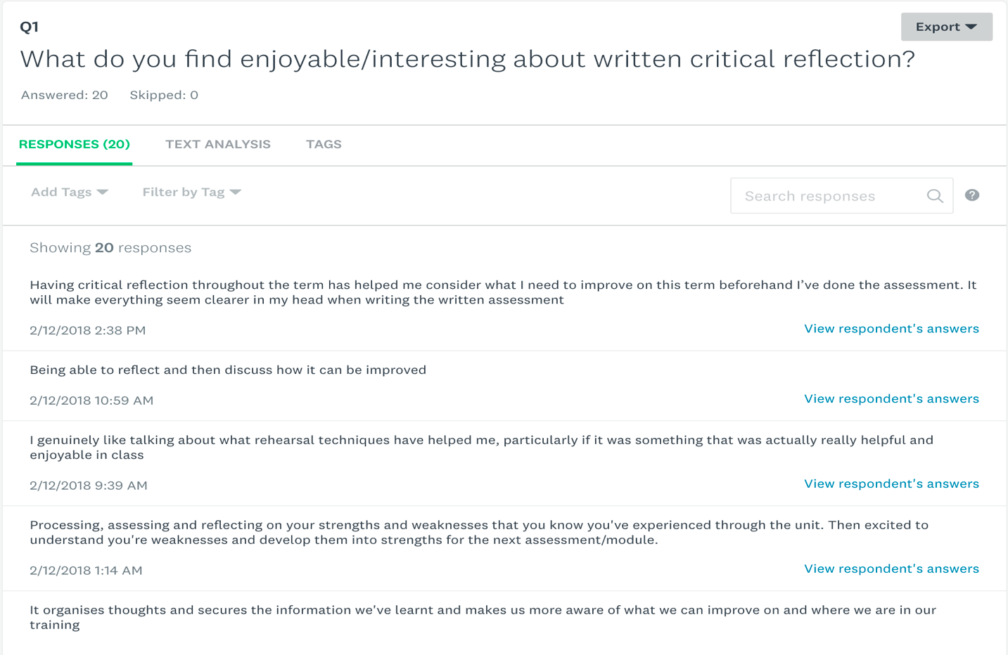
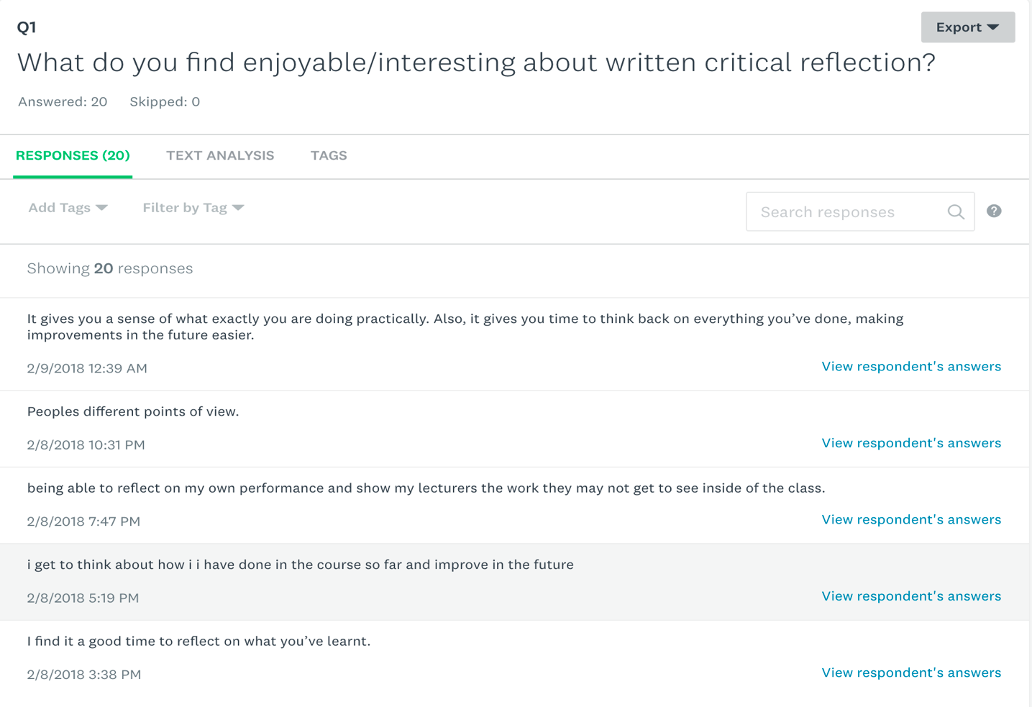
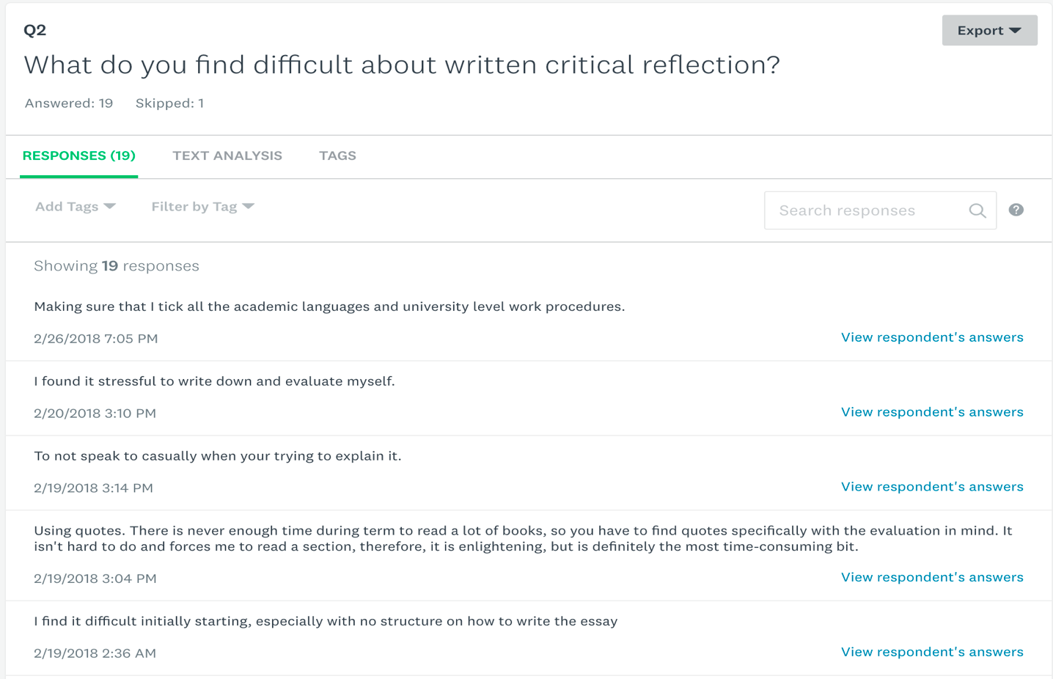
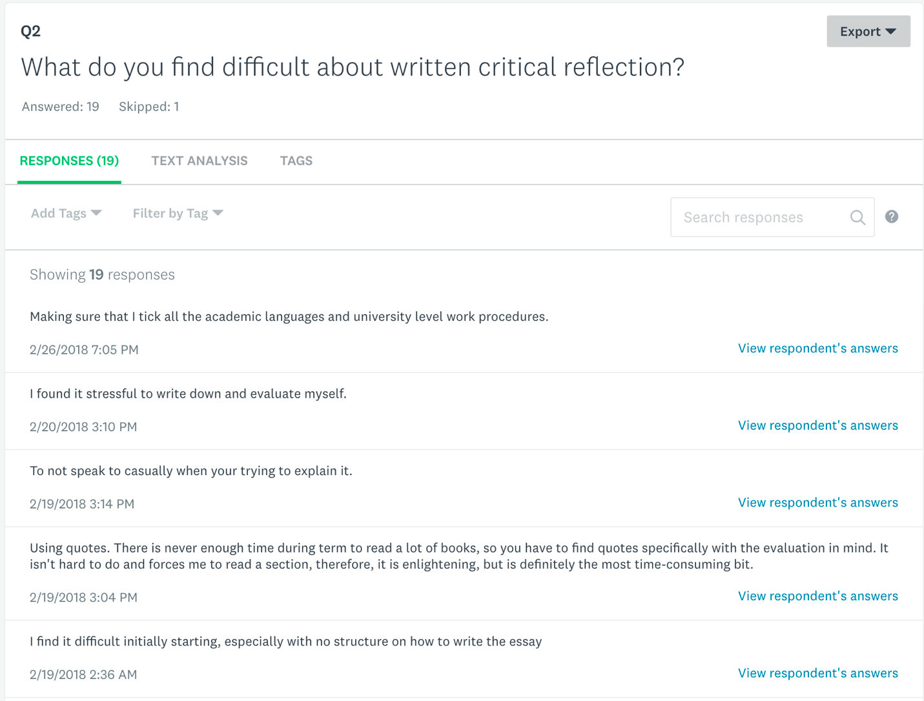
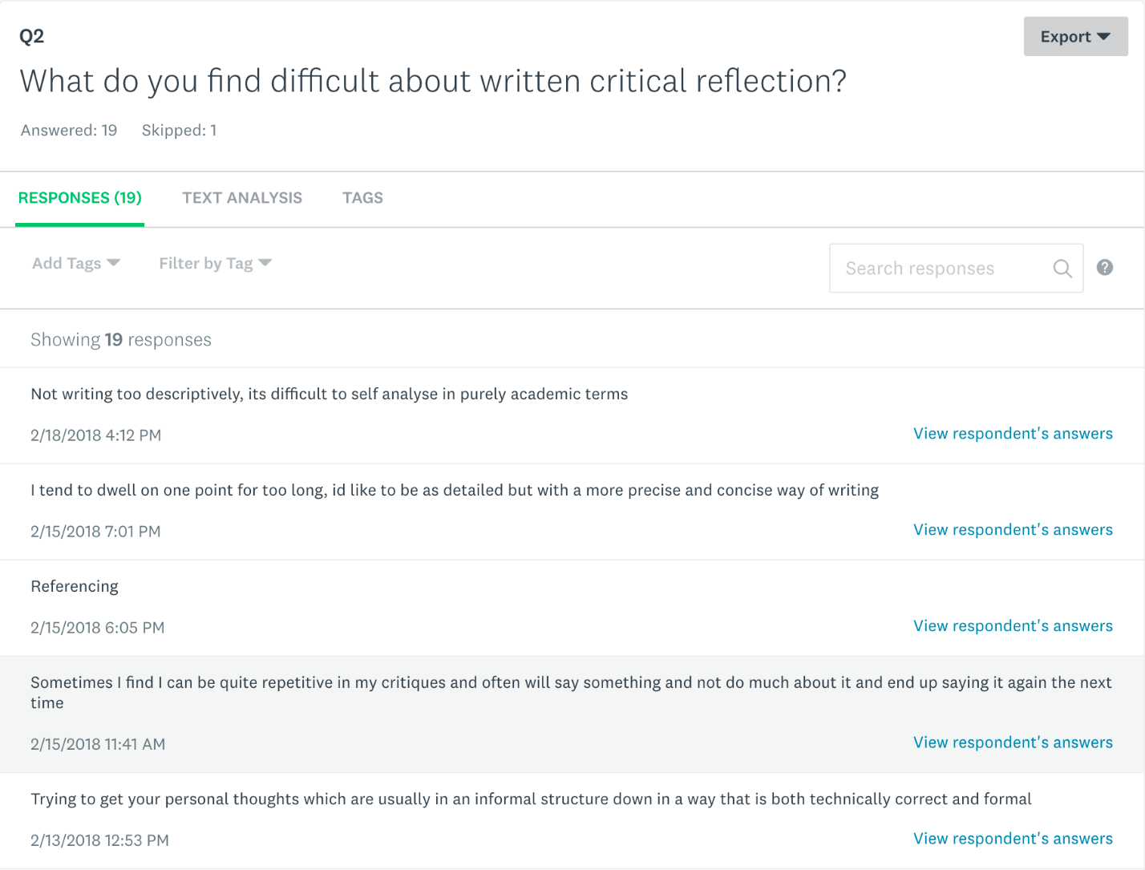
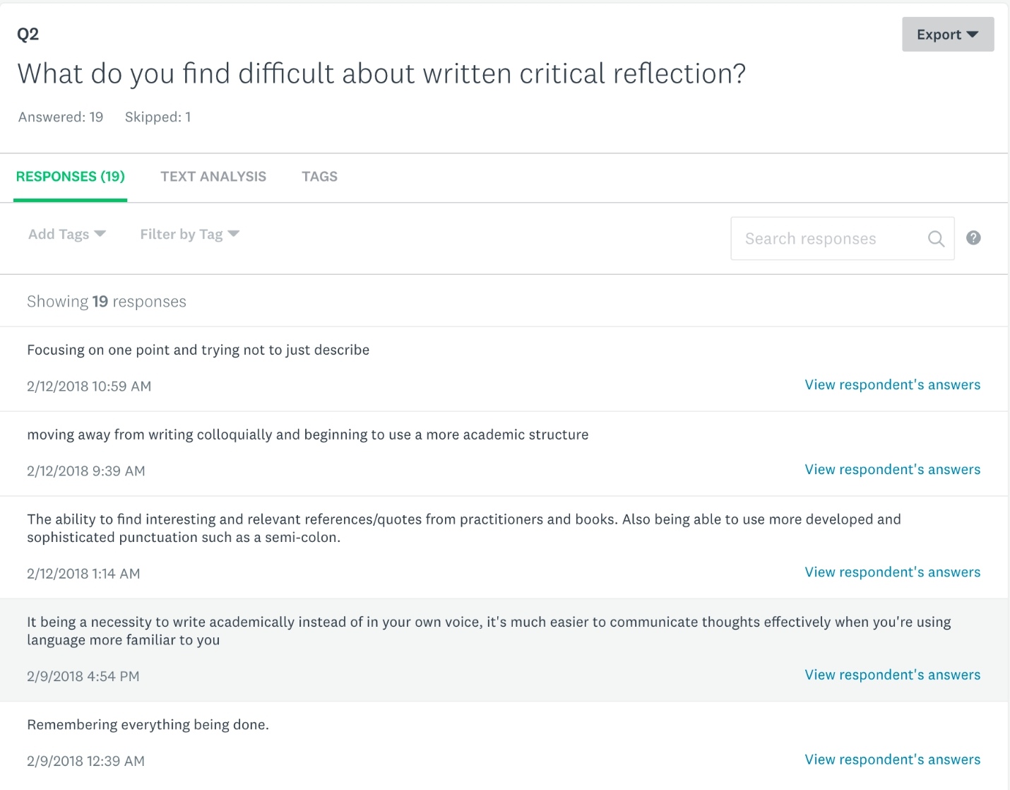
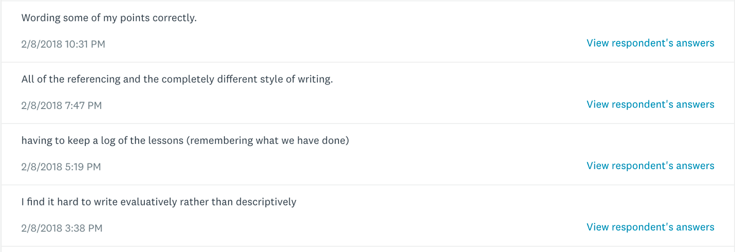

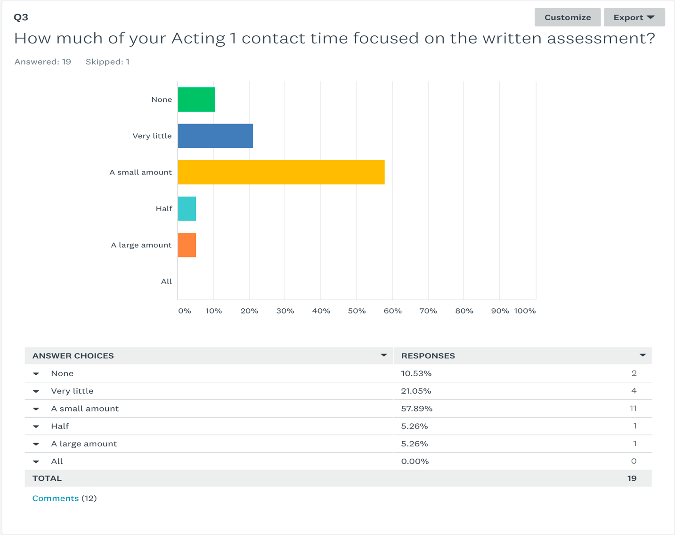
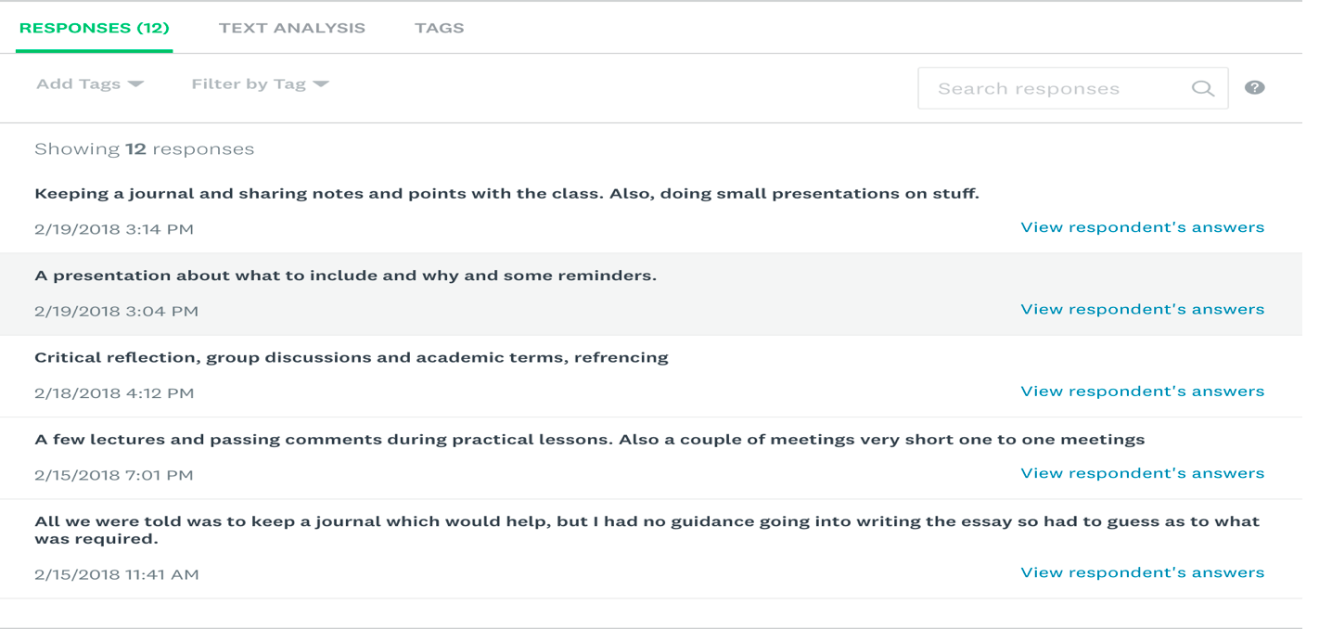

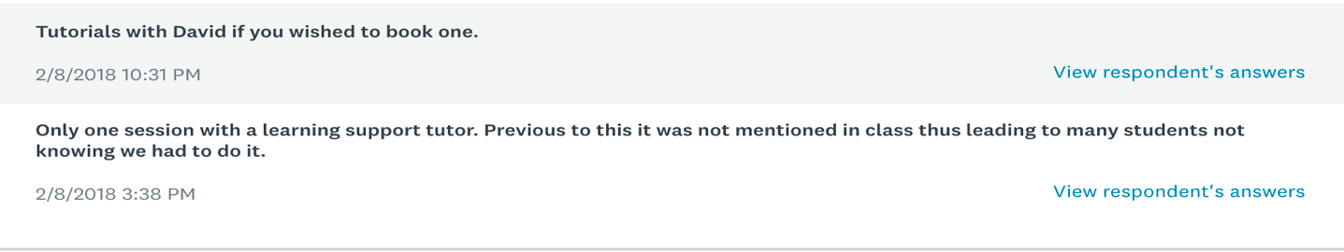
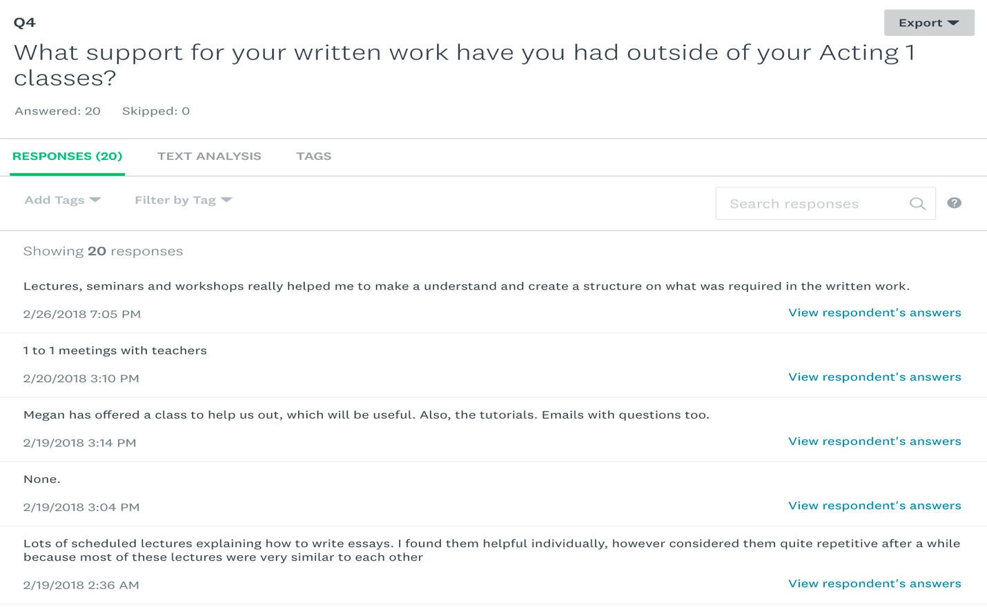

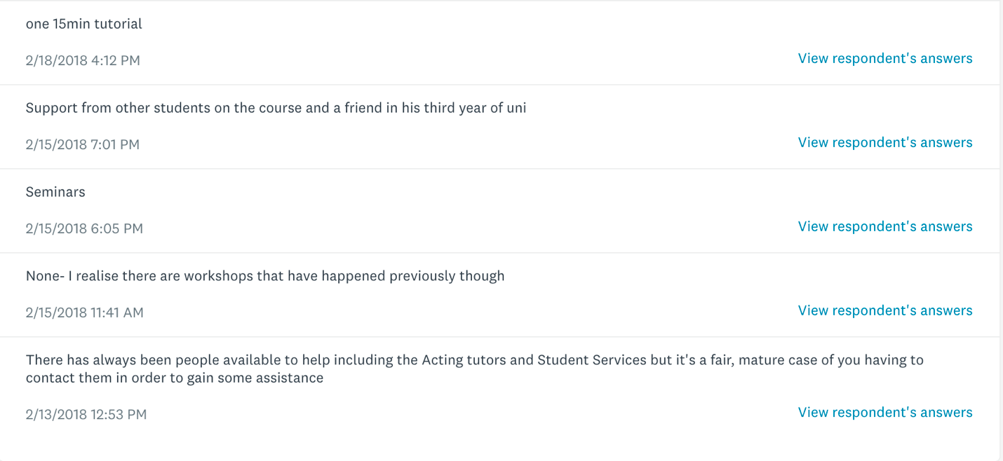
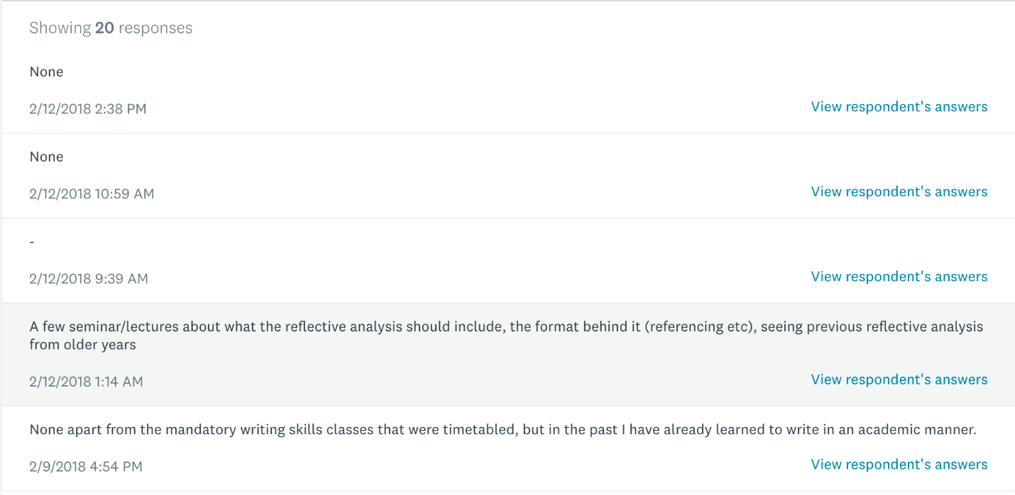
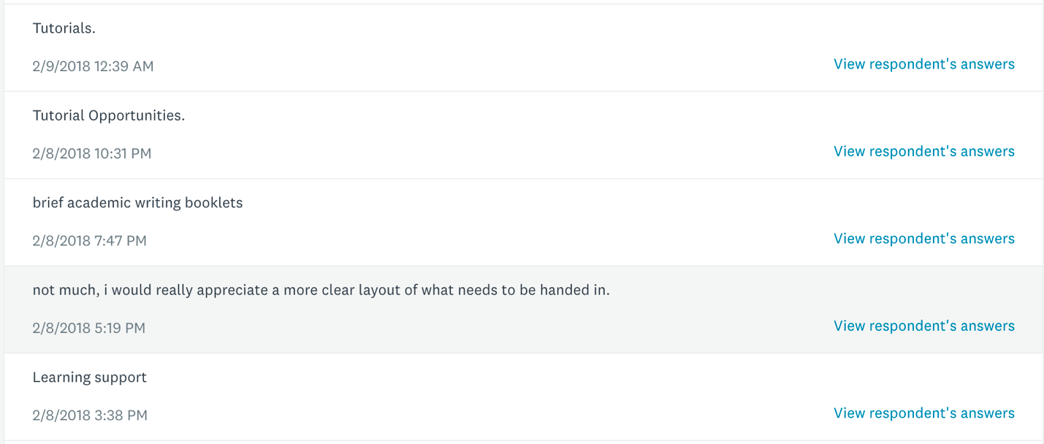
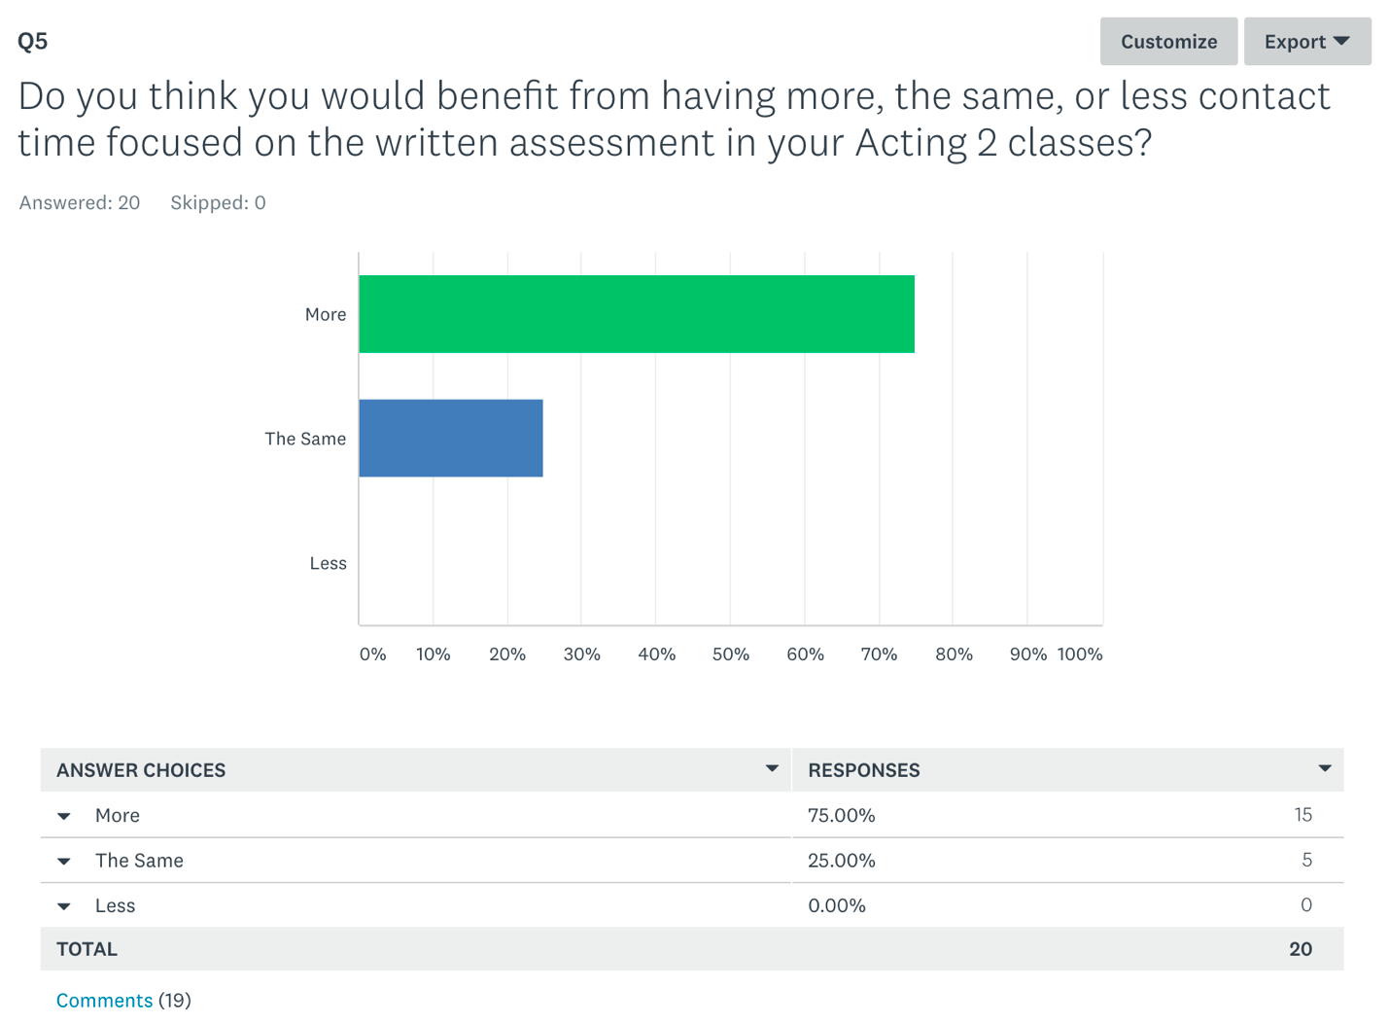
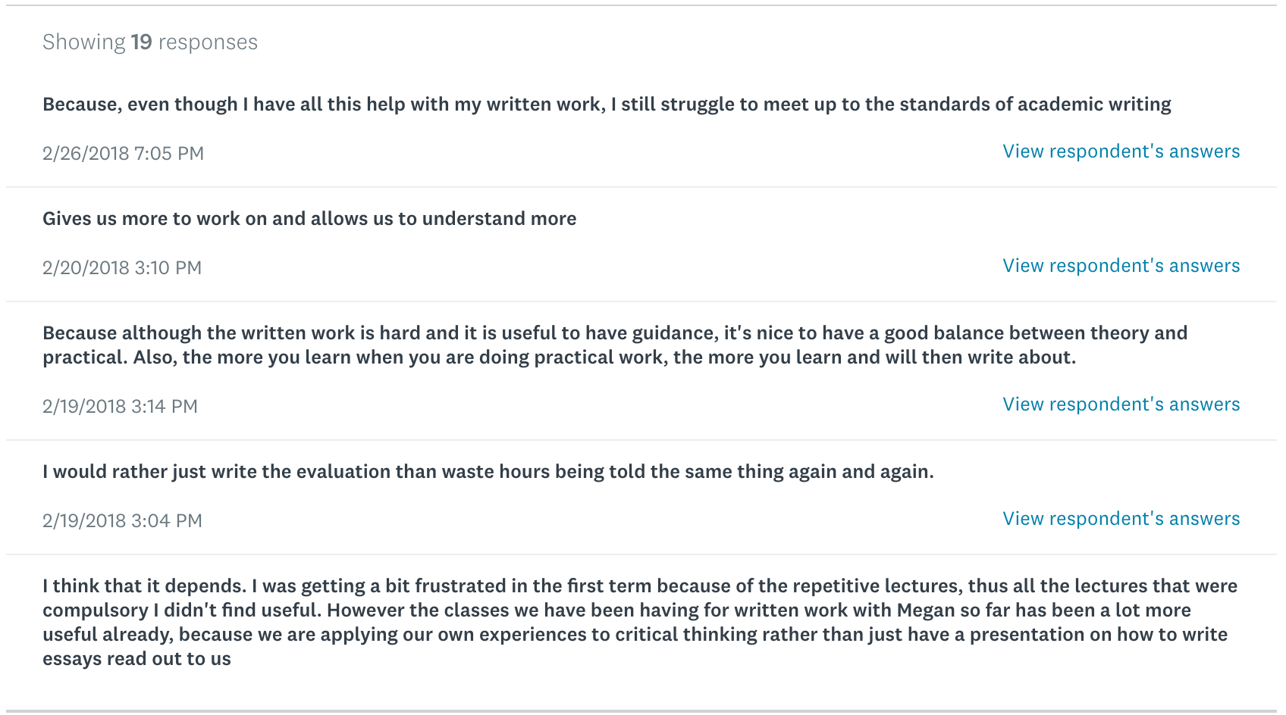

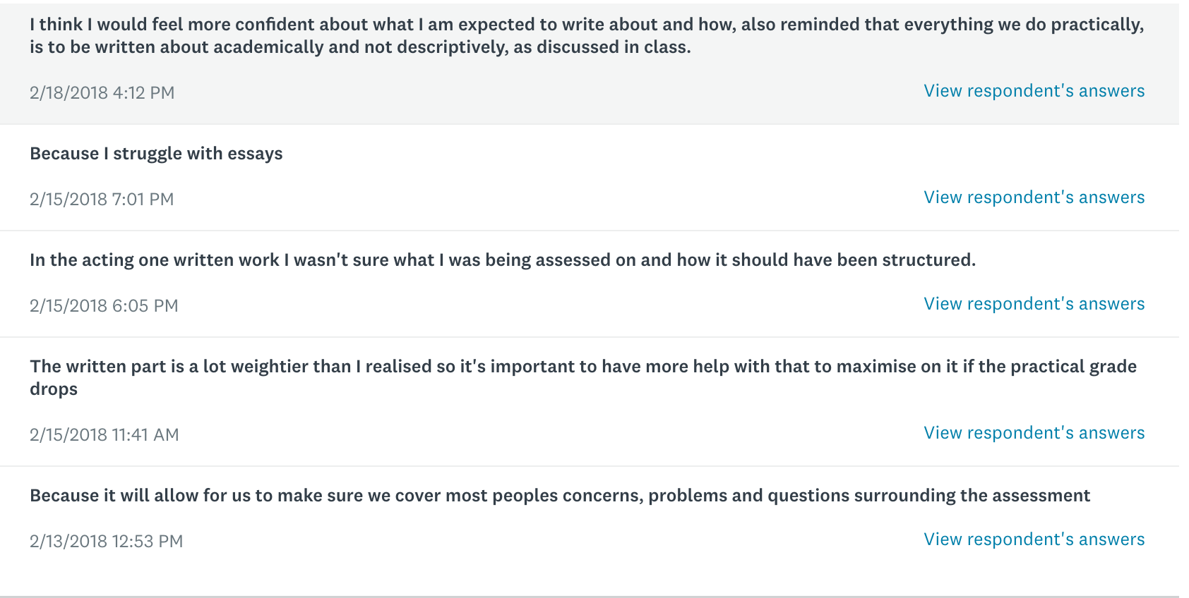
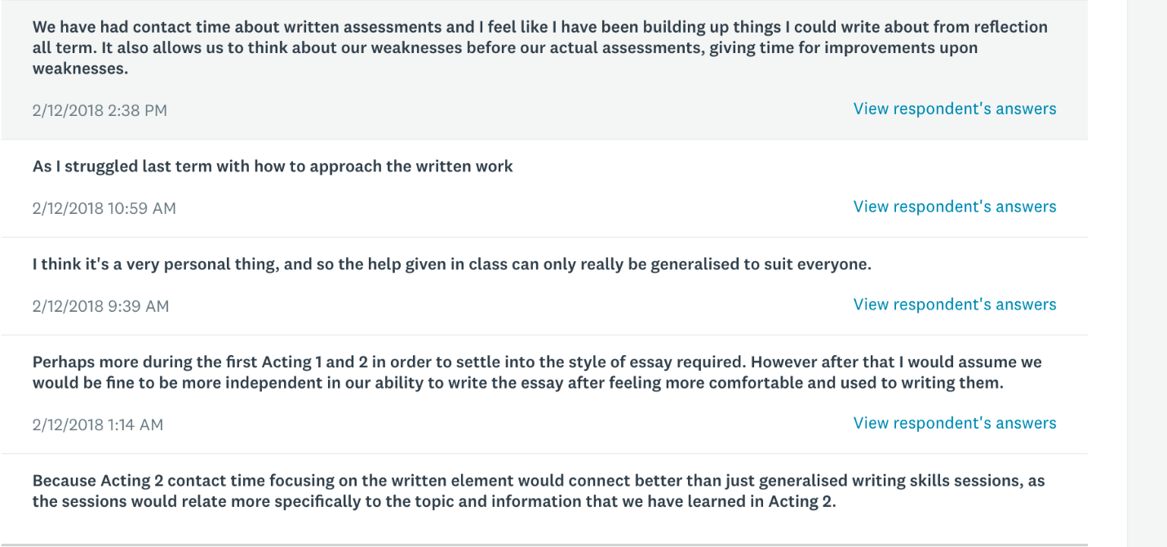
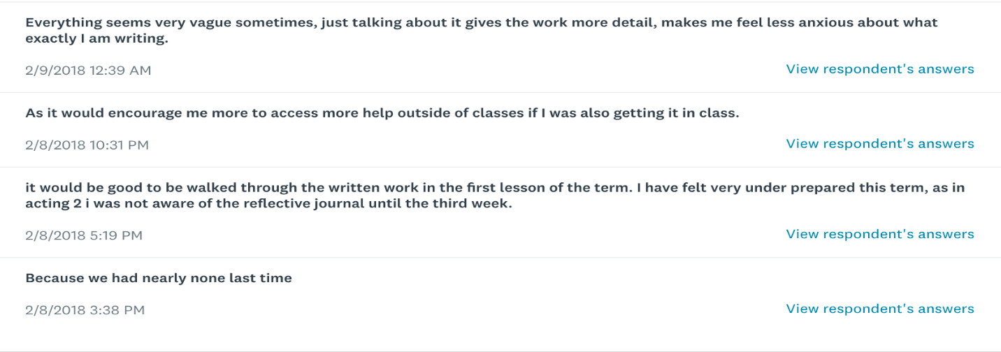
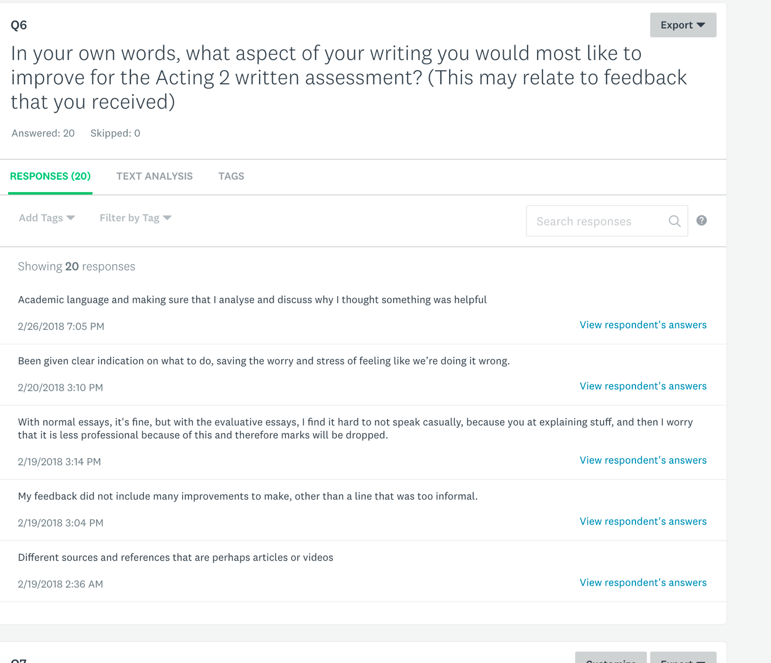
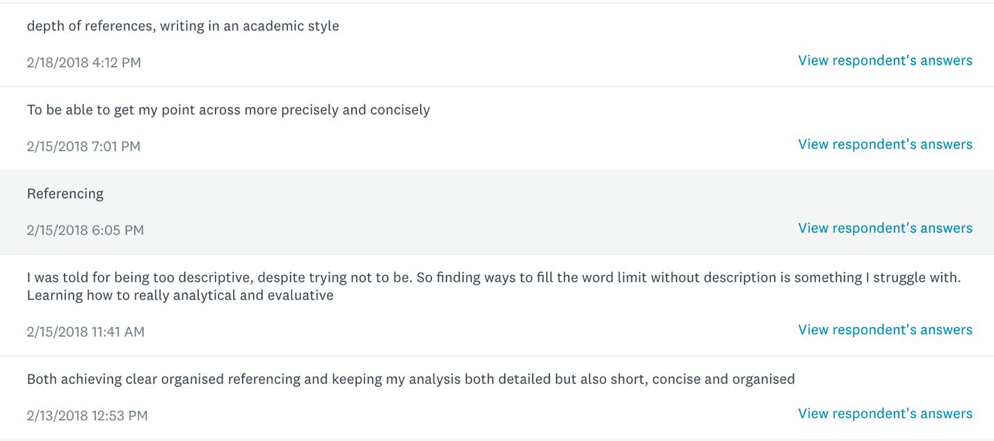

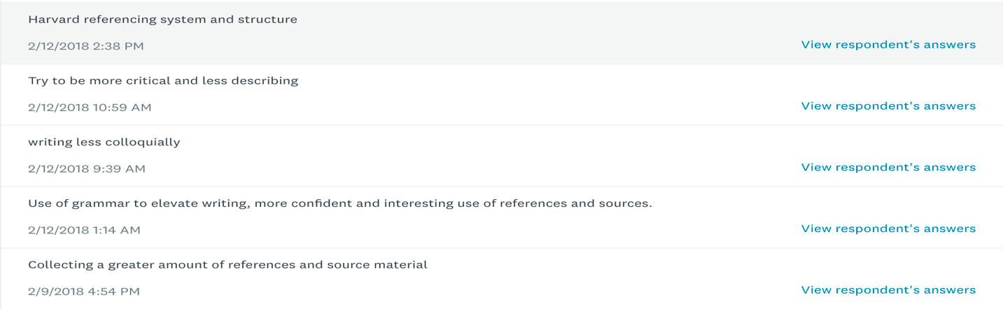
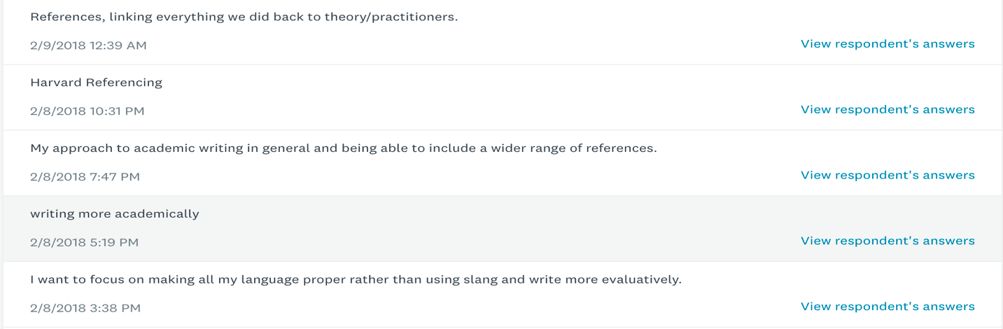
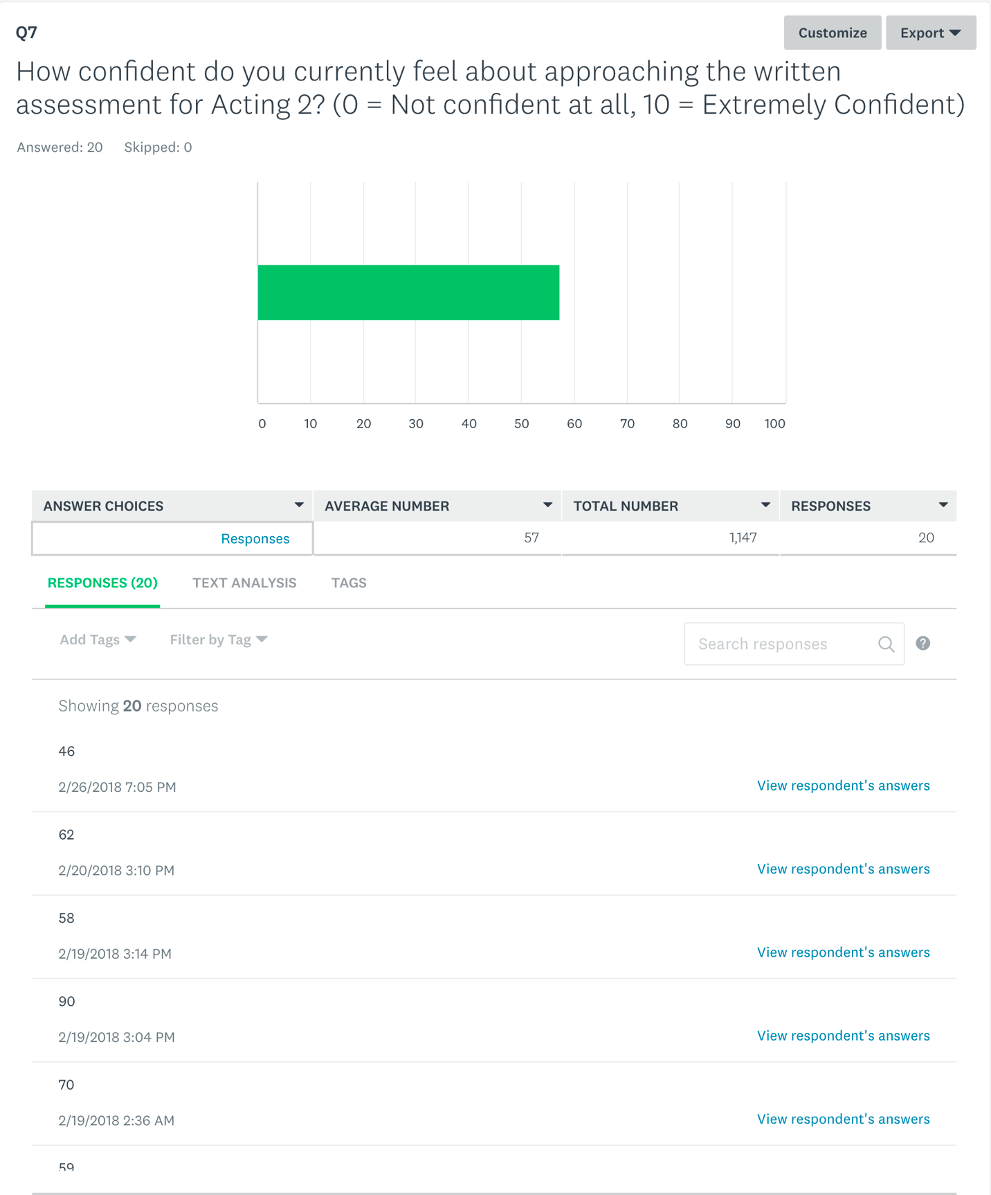

APPENDIX 3 – Questions and Responses from Survey 2

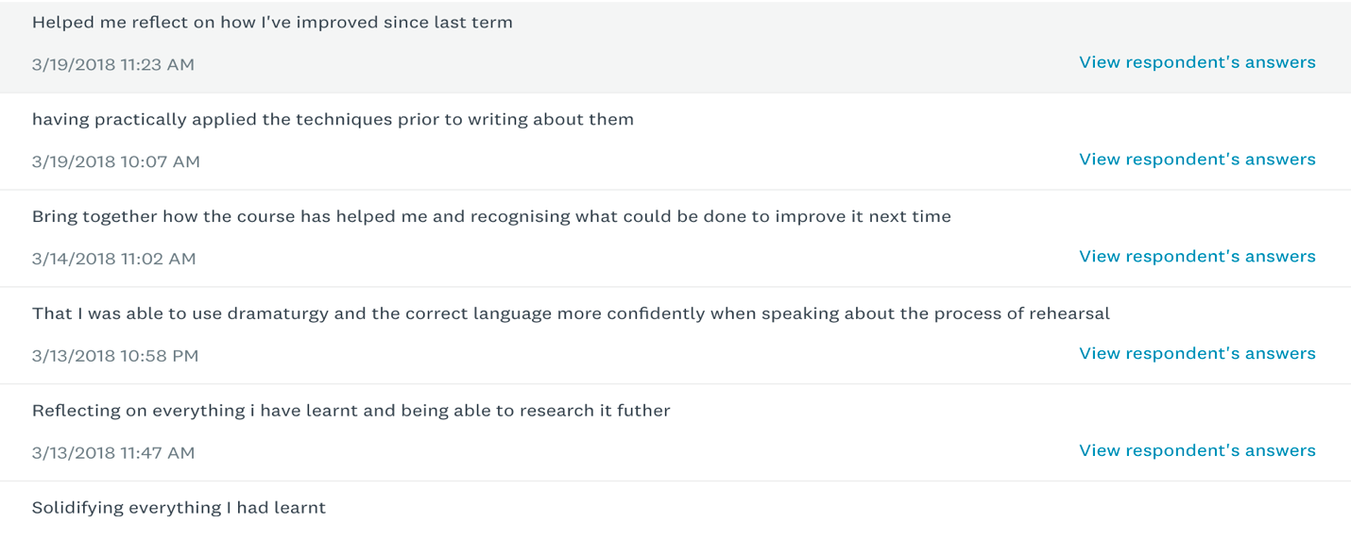


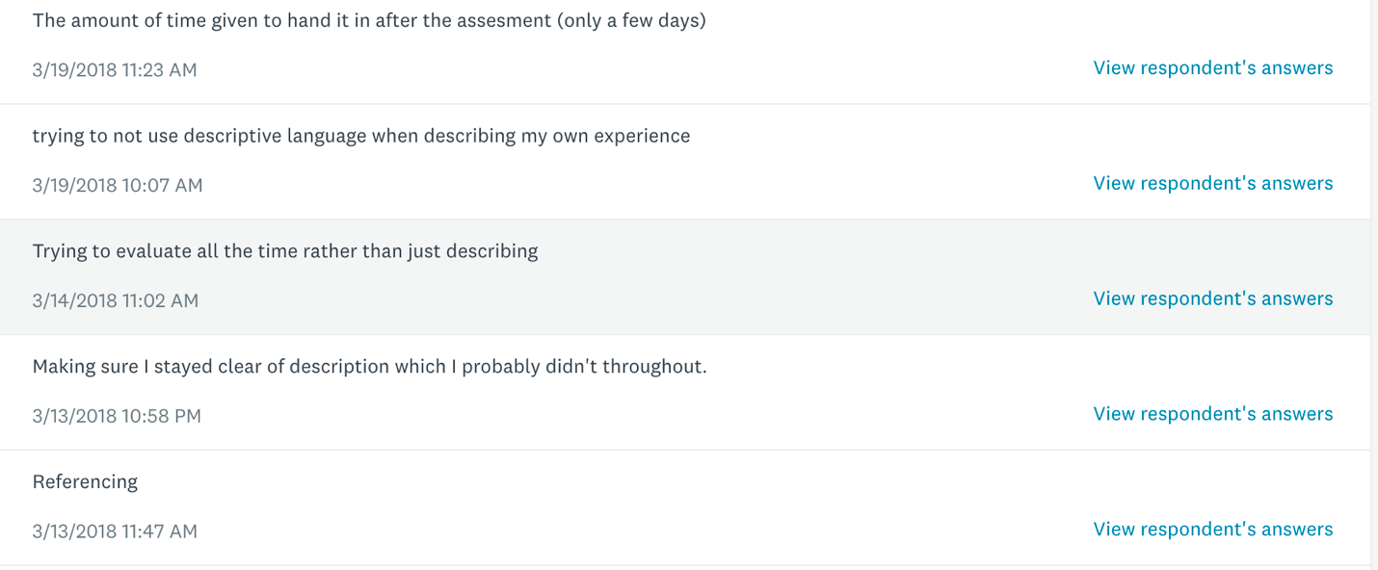
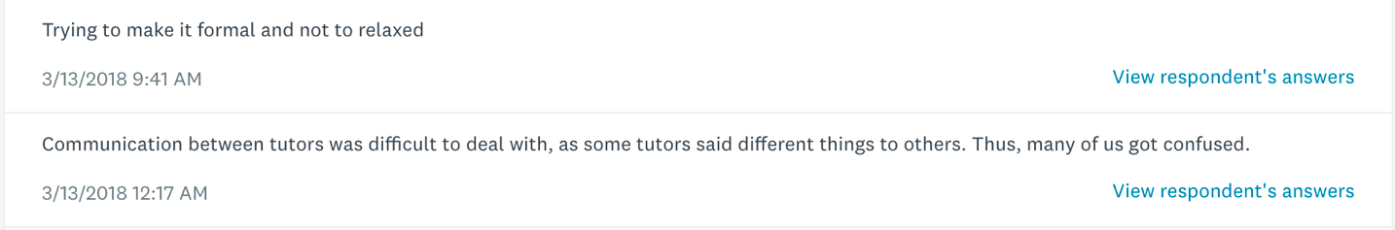
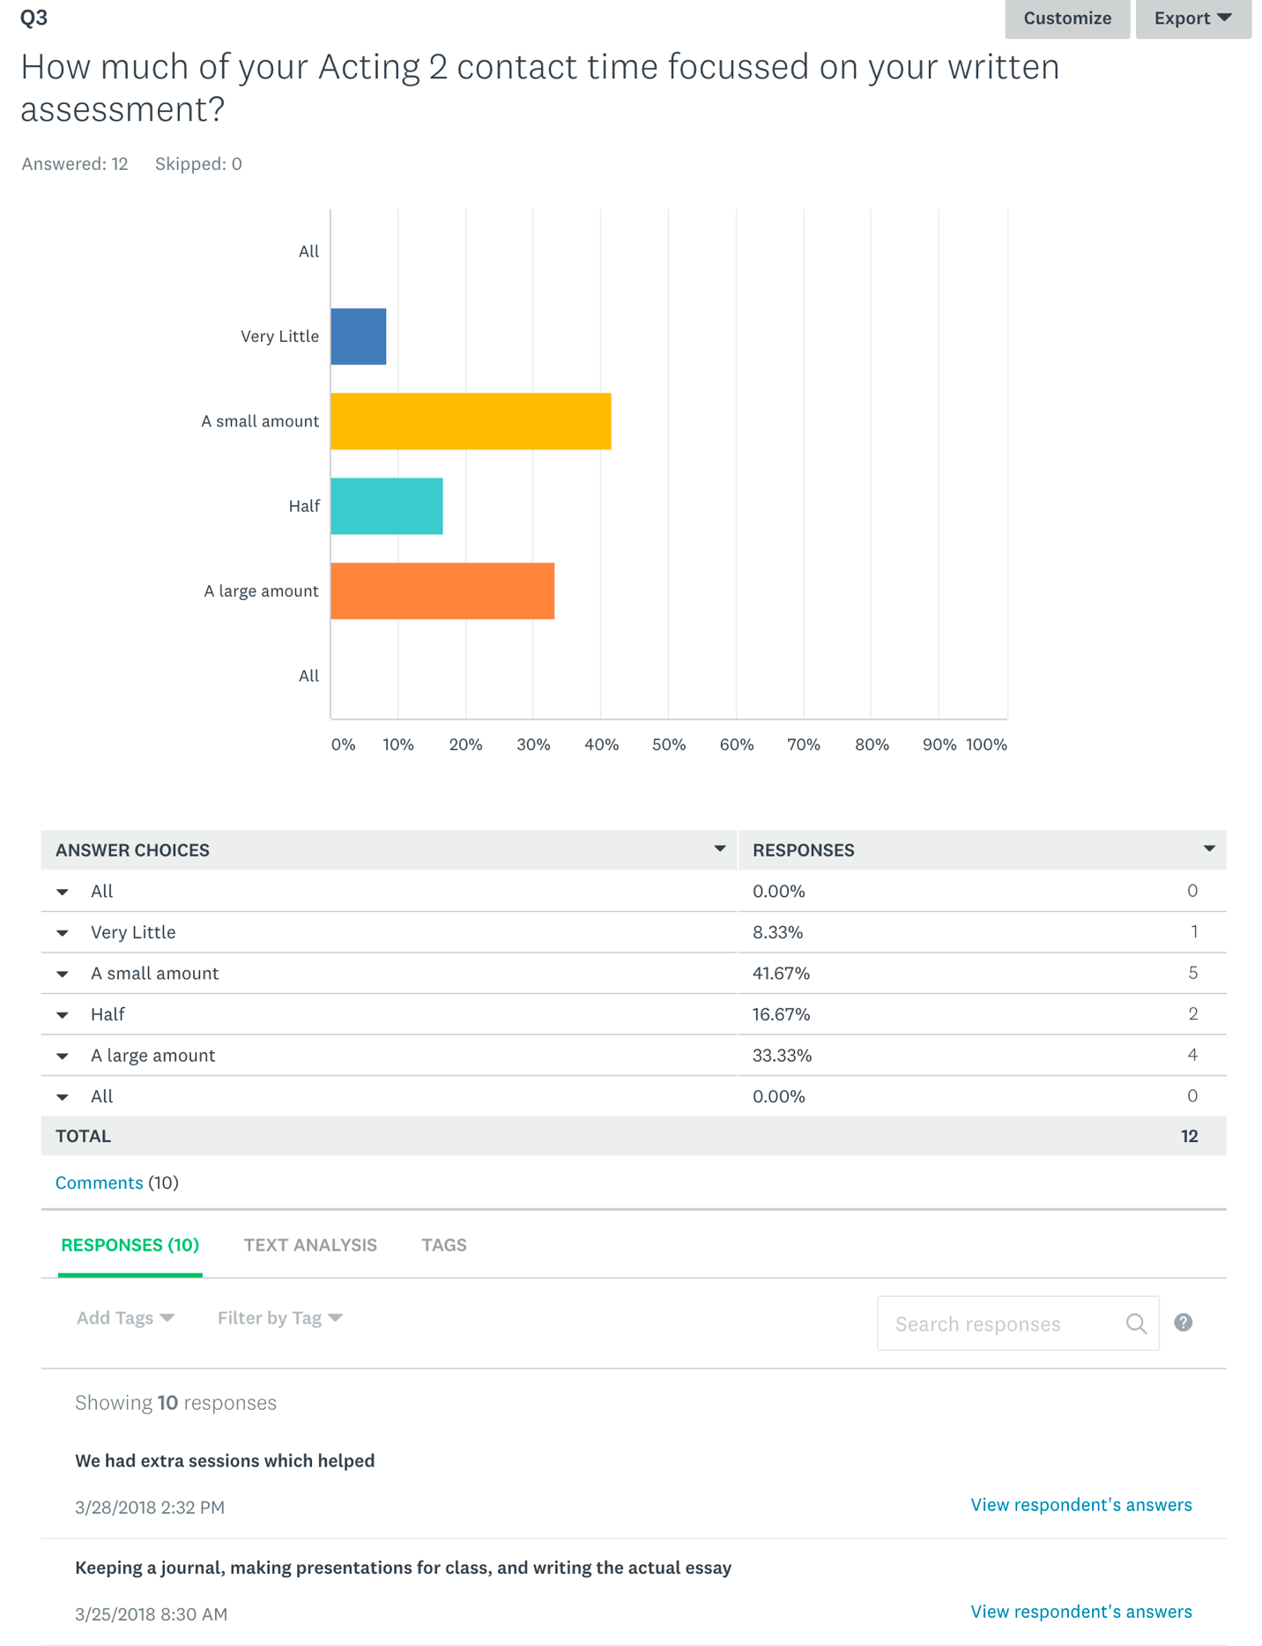
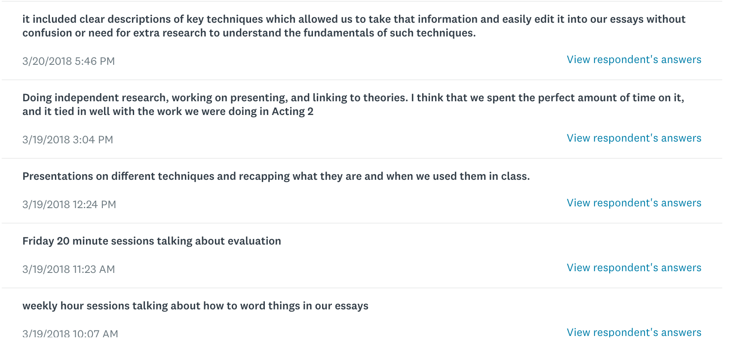
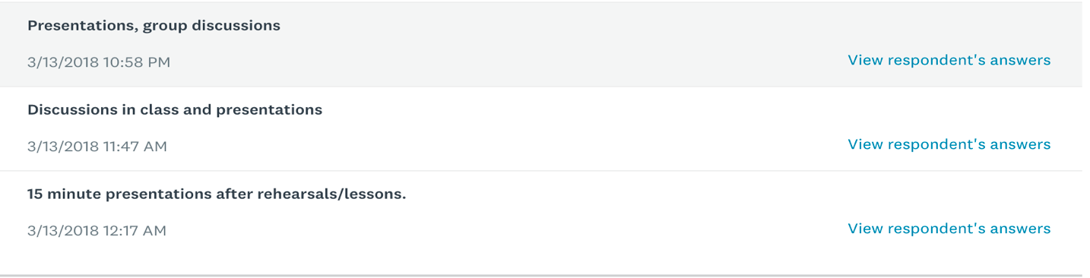
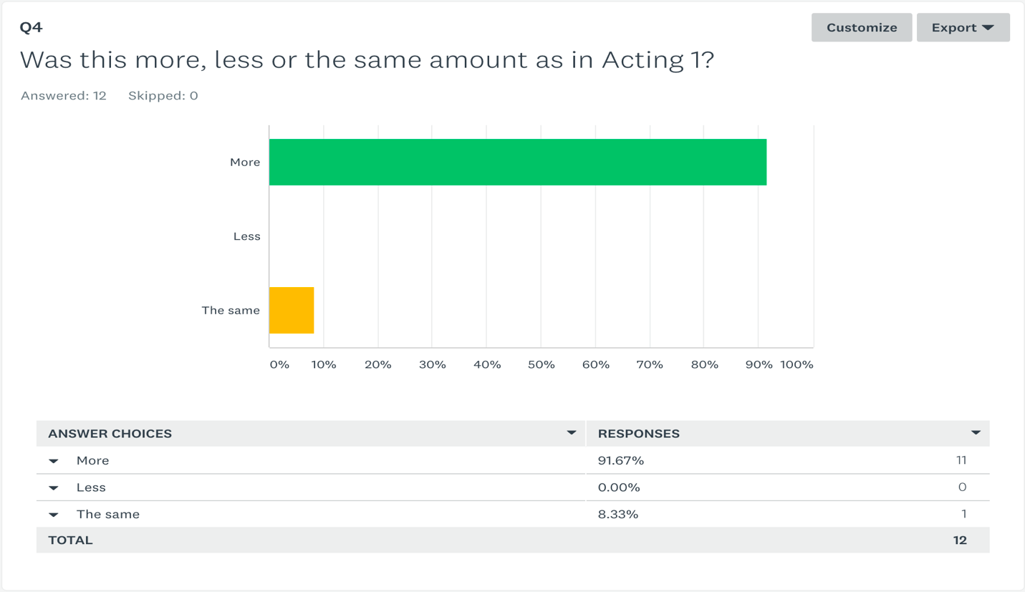
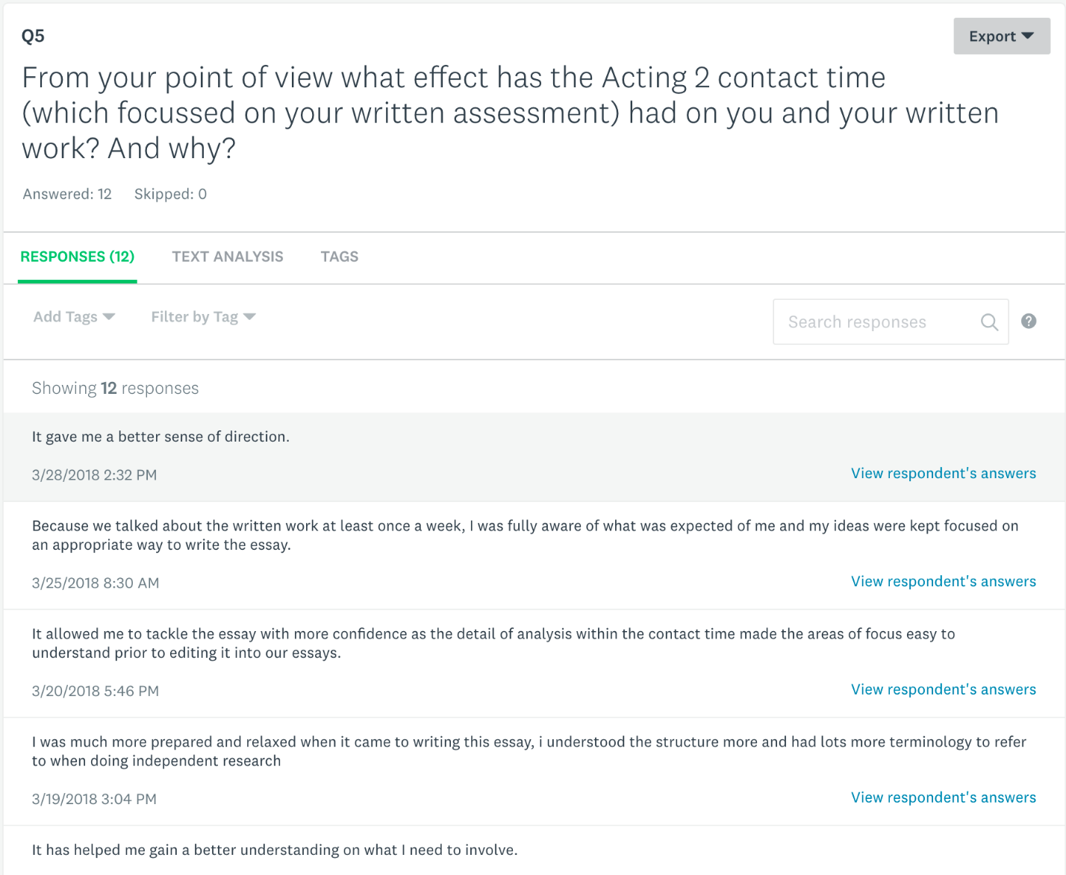
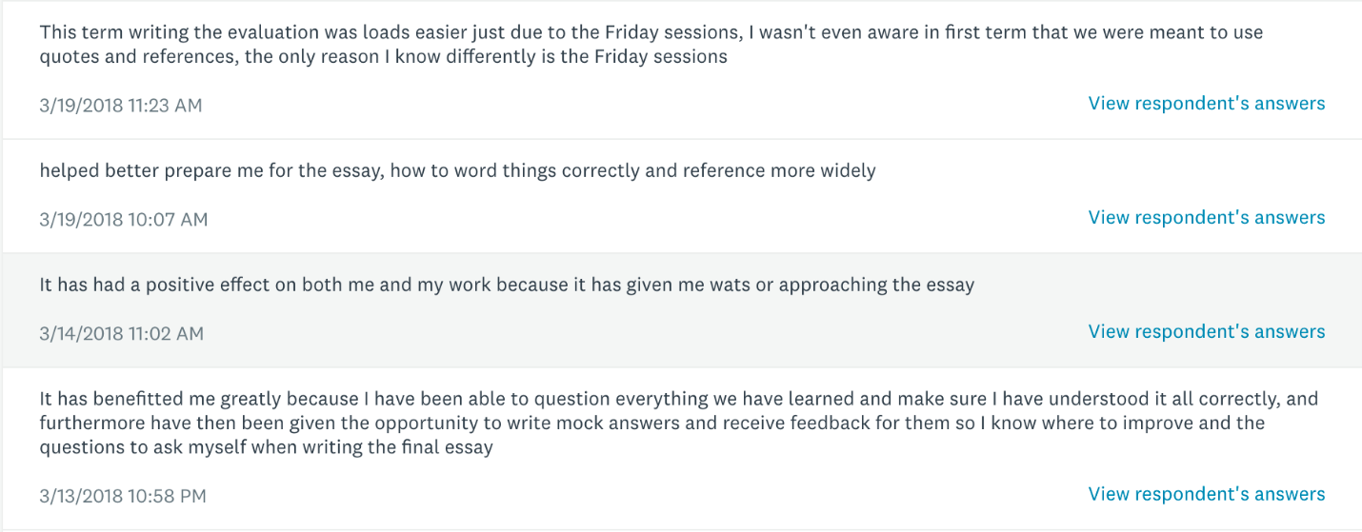
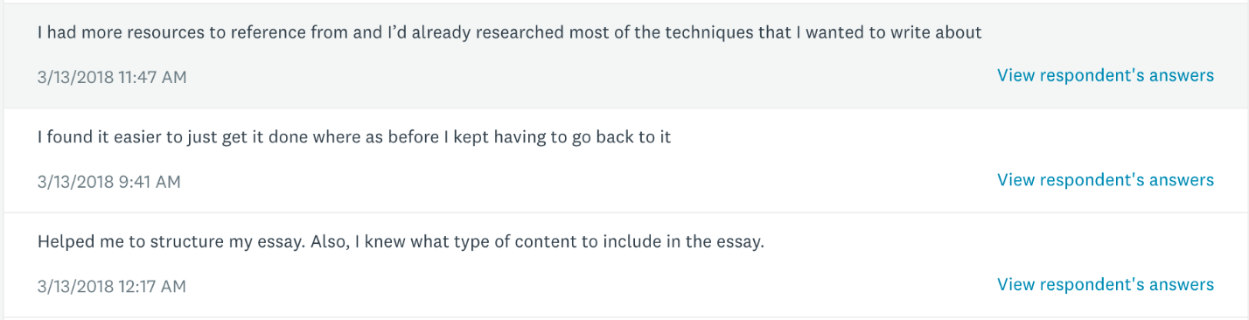
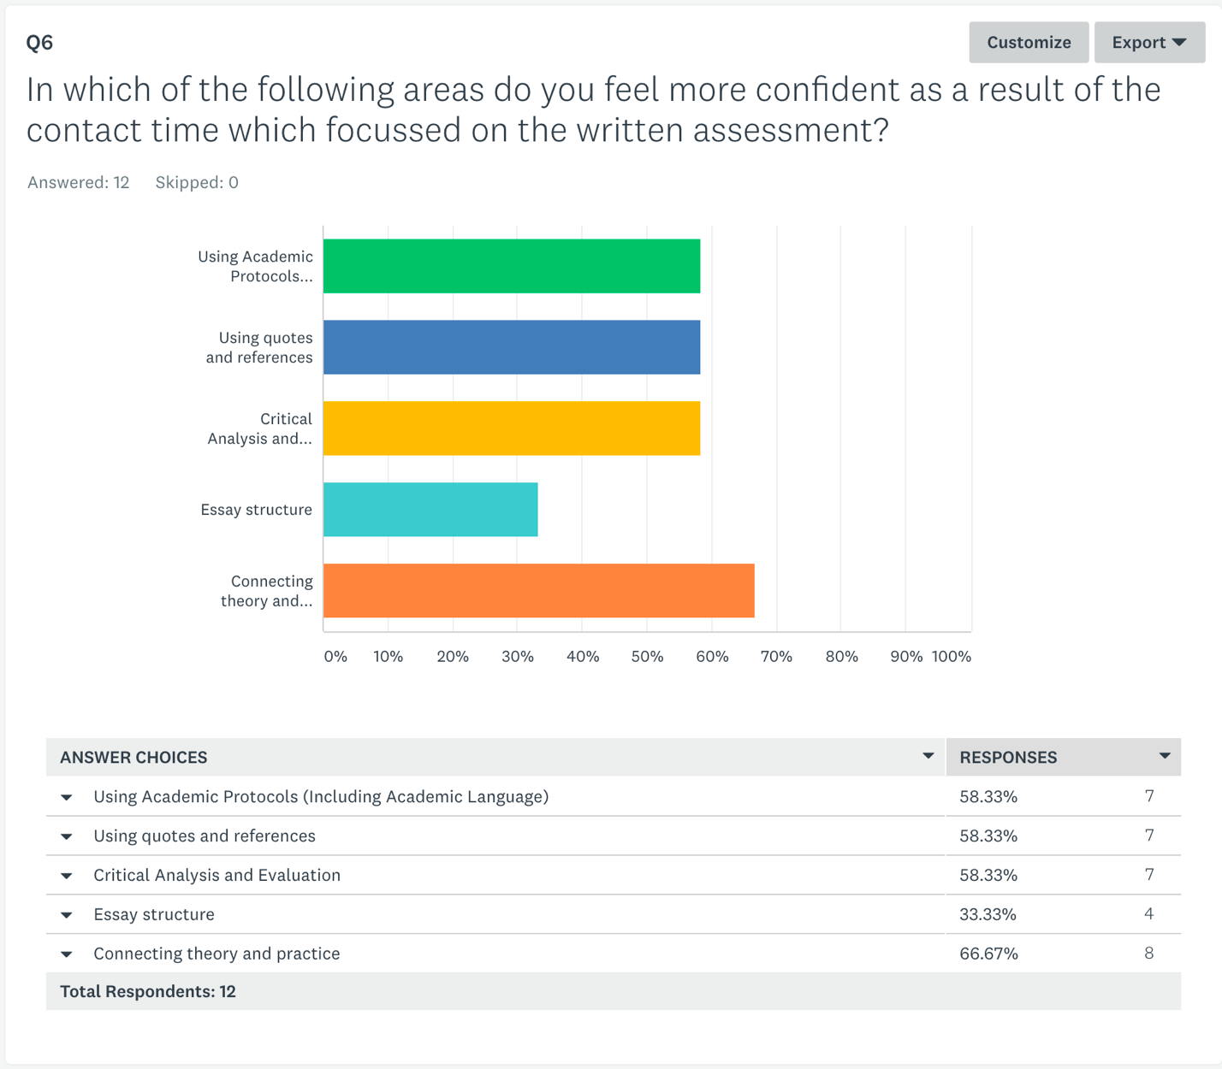
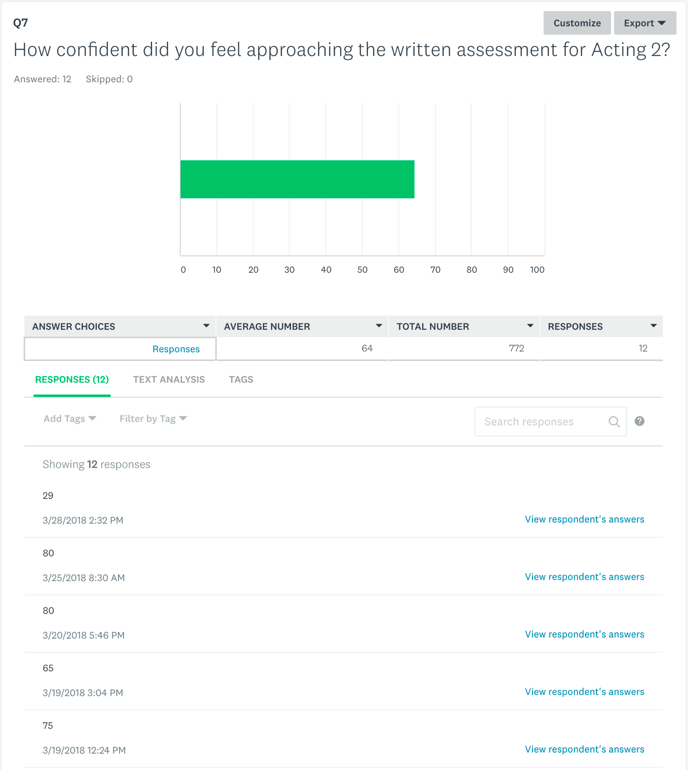
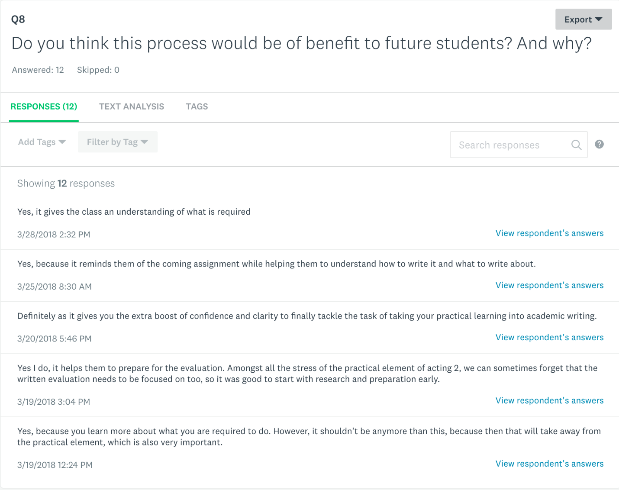
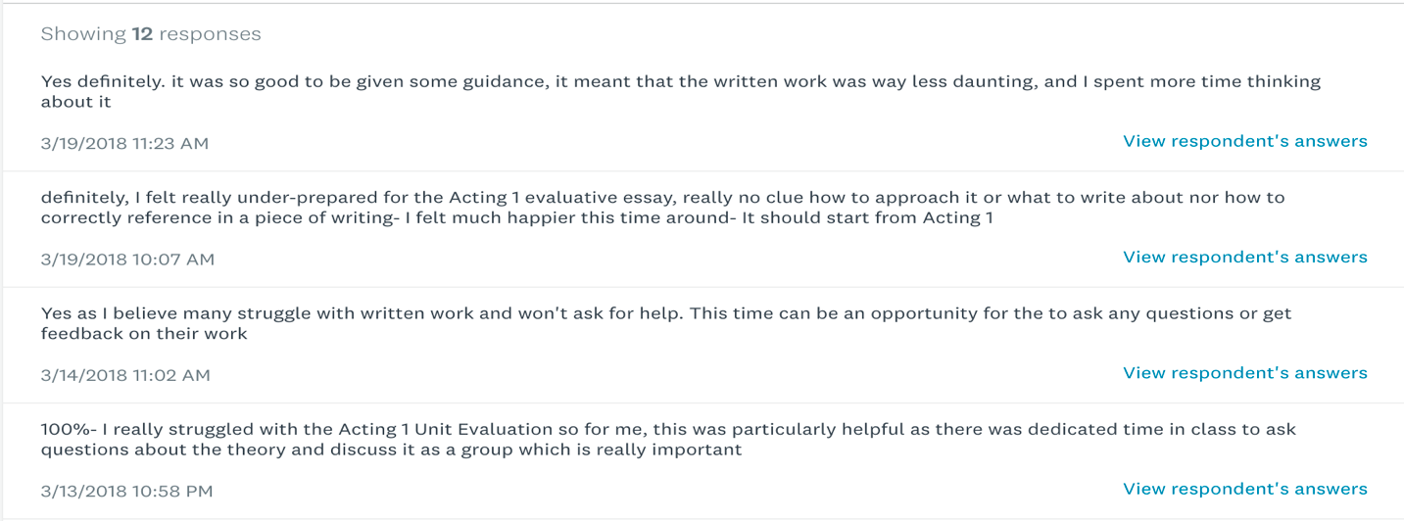
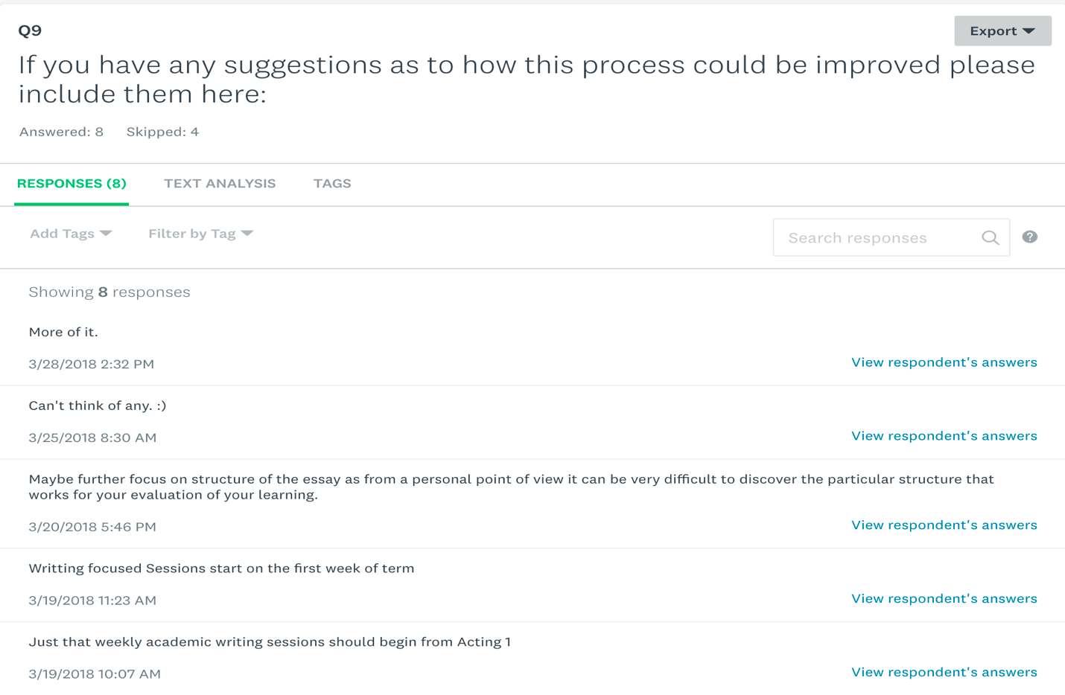
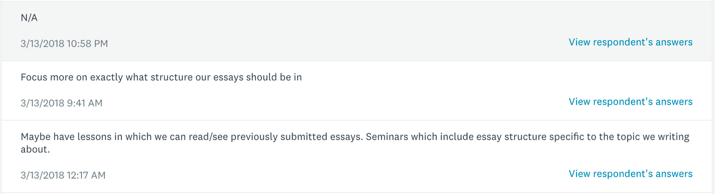

APPENDIX 4 – Marks comparison

