Sylwia Dobkowska

Student Number: 1800096

**Action Research Report**

*Postgraduate Certificate in Learning and Teaching*

*in Higher Education*, Rose Bruford College

Table of Contents

Self-assessment Grid **3**

action Research Report **6**

**project objectives 9**

**methodology 14**

**project schedule and observation 19**

**conclusion 21**

references **22**

**Self-assessment Grid**

*The grid should be completed at the beginning and end of Module 1. It should be used as a final check list again at the end of module 2.*

*This grid enables you to track your own progress and to provide evidence for meeting the course learning outcomes whilst also demonstrating your commitment to and active engagement with the UK Professional Standards Framework (UKPSF).*

*The first time you complete the grid it will be used as a diagnostic tool to enable you to take stock of your current learning and teaching situation. You will use the same grid at the end of Module 1 when it acts as part of your summative assessment. To indicate your progress from the beginning to the end of module 1, please use a different colour or symbol in the appropriate column.*

*Complete the grid below using the key to determine your own professional context for each category. The grid is based on the UK Professional Standards Framework which underpins the whole programme. The UKPSF may be seen at:* <https://www.heacademy.ac.uk/>

*Once you have completed the grid, write a short* ***Reflective Statement*** *(1000 – 1,500 words when enrolling) explaining why you have positioned yourself as you have and describing how you see your current context and yourself as a supporter of learning.*

Key:

0 I have not really considered how to do this; nor do I have any direct experience to reflect upon. I can thus produce no evidence of engaging in the activity/achieving the required learning outcome.

1 I have started to think about this; I have only limited experience to draw upon. However, I can produce little or no evidence to demonstrate that I have engaged in the activity/achieved the required learning outcome.

2 I have thought about this; I have had experience of doing it. However, I can produce little or no evidence to demonstrate that I have engaged in the activity/achieved the required learning outcome.

1. I have thought carefully about this; I have had experience of doing it. I can produce evidence that demonstrates that I have engaged in the activity/achieved the required learning outcome.
2. I have thought carefully about this; I have various experiences of doing it. I can produce substantial evidence that demonstrates that I have engaged in the activity/achieved the required learning outcome

X – October 2017

O – March 2018

A – August 2018

|  |  |  |  |  |  |
| --- | --- | --- | --- | --- | --- |
| **Areas of activity, knowledge & values embedded in the learning outcomes for both modules 1 and 2** | 0 | 1 | 2 | 3 | 4 |
| **Areas of Activity** |  |  |  |  |  |
| A1 Design and plan learning activities and/or programmes of study |  |  | x |  | o A |
| A2 Teach and/or support learning |  |  | x |  | o A |
| A3 Assess and give feedback to learners |  |  | x |  | o A |
| A4 Develop effective learning environments and approaches to student support and guidance |  | x |  | o | A |
| A5 Engage in continuing professional development in subjects/disciplines and their pedagogy, incorporating research, scholarship and the evaluation of professional practices |  |  |  | x | o A |
| **Core Knowledge** |  |  |  |  |  |
| K1 The subject material |  |  |  | x | o A |
| K2 Appropriate methods for teaching, learning and assessing in the subject area and at the level of the academic programme |  |  | x |  | o A |
| K3 How students learn, both generally and within their subject/disciplinary area(s) |  | x |  | o | A |
| K4 The use and value of appropriate learning technologies |  | x |  |  | o A |
| K5 Methods for evaluating the effectiveness of teaching |  | x |  |  | o A |
| K6 The implications of quality assurance and quality enhancement for academic and professional practice with a particular focus on teaching |  | x |  |  | o A |
| **Professional Values** |  |  |  |  |  |
| V1 Respect individual learners and diverse learning communities |  |  | x |  | o A |
| V2 Promote participation in higher education and equality of opportunity for learners |  |  |  | x | o A |
| V3 Use evidence-informed approaches and the outcomes from research, scholarship and continuing professional development |  |  |  | x | o A |
| V4 Acknowledge the wider context in which higher education operates recognising the implications for professional practice |  |  |  | x | o A |
| When you **complete** Module **1 Reflecting on Theory and Practice**, tick or cross the appropriate column in the same way. You should now be scoring 3s and 4s and provide evidence for this in your Reflective Statement 2 (1500 - 2000 words). |  |  |  |  |  |
| 1. Critically analyse and evaluate their own practice in relation to contemporary pedagogical theory |  |  |  |  | o A |
| 1. Apply theoretical principles to the development of course design, project planning and assessment |  |  |  |  | o A |
| 1. Reflect on their practice to identify scope for enhancement within the broader context of contemporary pedagogic research |  |  |  |  | o A |
| 1. Use their knowledge of how students learn to inform theoretical debate and approaches to practice-based problems |  |  |  | o | A |
| When you **complete** **Unit 2 Evaluation and Enhancement,** please check that ALL areas are now ticked in the appropriate column including any further evidence provided in your Action Research Report (summative assessment 5000 words). |  |  |  |  |  |
| 1. Make a presentation to peers in a professional context 2. Conduct a small-scale action research project within a particular sphere of professional practice |  |  |  |  | A  A |
| 1. Evaluate the outcomes of your project according to appropriate theoretical principles. |  |  |  |  | A |
| 1. Relate the outcomes of your project to contemporary pedagogic research and principles to inform your current and potential professional responsibilities. |  |  |  |  | A |

***Online Learning with Flipped Classroom***

Action Research Project, PGCLTHE programme requirement at Rose Buford College in the UK, applied to Intercultural Communication project - *Cultural Identity* at Meio University in Japan.

February - August 2018

In this action research project, online learning is introduced to students through flipped teaching strategy. The following action research report refers to the UK Professional Standards Framework, particular areas of activity are indicated as a letter and number (e.g. A1) and can be found in the text. Although those areas can be found in multiple places throughout the research, for clarity purposes each of the UKPSF area will be indicted only once.

This project is the beginning of my journey in online learning and teaching. I participated in the PGCLTHE course as a distance learner. I had experience with learning online and I wanted to develop my knowledge about teaching in this environment. I can recognise the growing significance of online learning, as it offers access to education despite a geographical location, time zones, and physical ability. Those characteristics also resonate with my professional values, as I believe that education should be made accessible to people despite their geographical location, physical ability, or age. Diversity should be appreciated in education and the digital environment gathers diverse learners across the globe. The field of online learning is dynamically changing along the advancement of technology and society.

*Online Learning in Higher Education*

In 2018, the Digital Innovation Prize in *Guardian University Awards* went to Open University (Hall, 2018, online). Open University is the largest university that offers distance learning and online courses in the UK. The award is a sign of the importance of innovation and technology being at the heart of the institution. The more technology develops, the more is available to include students in the learning process, such as the transition from television broadcast to the internet changed the possibility of student active engagement. With online learning constantly changing, many limitations from the previous years have been already addressed. Presently, instant feedback was made possible with the change in technology. The response can be as simple as ‘like’ button or ‘comment’ function. However, tutor attention and individual guidance can be achieved if online courses have between 30 to 40 students. Previous lack of tutorial support could be explained by expenses, as the online courses were free and there was not a recognized institution to support the cost of tutors’ time. Tutor’s engagement makes the learning experience much more enjoyable, which I can confirm from my experience.

Interpersonal relationship and accreditation standards are seen as values of studying in the traditional setting (Coleman, 2014, 2018). Those values are particularly visible in shaping the attitude to online learning. Nancy Coleman, a former director of distance education at Boston University wrote in *The Guardian* about “Online learning: the UK’s scepticism is holding it back” (Coleman, 2014, online), an article about attitude towards online learning as a cultural phenomenon. Coleman compared how online learning has developed in the US and in the UK. According to Coleman, the attitude to online learning can be seen in the example of Columbia University’s online programs, where online leaning offers an excellent academic experience through the support system and technology they offer - “In the US, institutions have been trying to provide a contemporary digital experience for students, looking at the best examples of social networking, remote working and gaming technologies and using them to provide constant engagement and interaction” (Coleman, 2014, online). Despite the initial scepticism, the engagement in technology and keeping academic rigour online is also currently developing in the UK. “Dominic Micklewright, dean of academic partnerships at the University of Essex, believes mixed reality teaching and learning environment (MiRTLEs) - which enable online students to enter a real face-to-face lecture virtually - will become an increasingly popular facet of online degrees” (Jolin, 2015, online). To give an example, Coventry University works together with PlattForm in the US to have two new undergraduate, online degrees in management (Jolin, 2015, online). Each student from the course has assigned from PlattForm a student success adviser for learning support and pastoral care. Student support is one of the key elements of online learning in the US.

In 2016, there was a shift in attitude towards online learning in the UK. Open University and the University of Leeds, which is one of the Russell Group of universities, currently have online courses that count towards a final degree (Weale, 2016, online). This was a familiar structure in the US, but in the UK online learning was only counting towards a certificate of participation. Currently, the platform owned by Open University - FutureLearn, is the place to find online degrees that are credit-based. Online learning can be seen as research based learning, and equally to traditional research based learning, the students must be self-motivated in order to complete the course. Technology, course design and social attitude are significant, but student attitude and autonomous motivation are also important (V4).

*Action Research Project*

This action research project began as an ambitious journey to discover online learning and ended in setting up guides to make a successful project even more effective in the future. The use of technology offers learning opportunity that supports student-centered learning experience. Moreover, it supports diversity of multiple kinds of student-centered education, as every student is different and they do not have one learning experience. The students in my class have never used online learning. To gradually introduce this learning environment, I decided to implement online course as a project component in the Intercultural Communication class. Online courses (K4) with the flipped classroom approach are not my invention, this strategy have been previously successfully explored at larger educational institutions (Hutchings and Quincy, 2015). Moreover, recent research suggests that EFL students prefer the flipped learning strategy than the traditional learning setting (McNally, et al. 2016, p. 297). Learning about a subject before introducing it in the class gave my students time to understand the language, and consider their thoughts and opinions.

In this project, there are couple of difficulties I could foresee at the beginning. There is no virtual learning environment at the institution I work at. Hence, there is no online learning support system established. To solve this problem, together with the helpful staff at Meio University I arranged an online learning support center in the Language Learning Center at Meio University (V2). To motivate my students, I have dedicated a grade of ten points for participation in this project (out of one hundred). I was available for any appointment outside of class and I monitored student participation through the progress in their online learning as a course administrator. Throughout the project I gave formative feedback online, for the final essay students received summative feedback which was written and presented individually, face-to-face (A3). Their reflection notes online gave me understanding of their subject comprehension, which further influenced my in-class teaching.

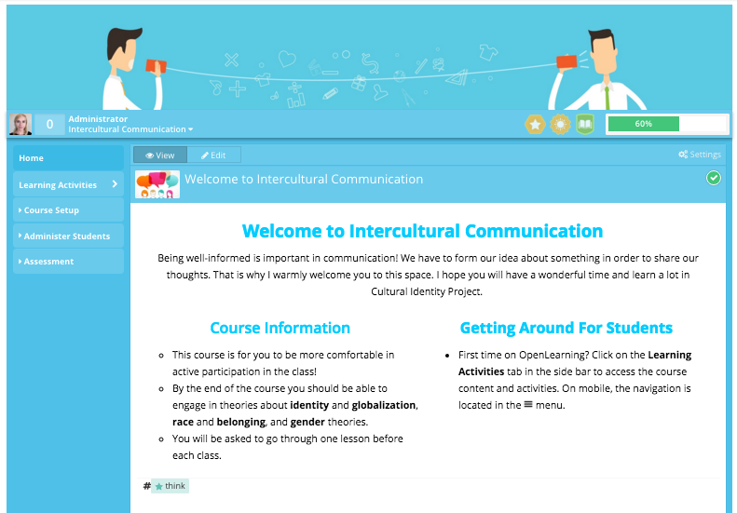Figure 1. *Online Course.* Dobkowska, openlearning.com, 2018.

**Project Objectives**

In the beginning of the process, I imagined that my action research project objectives will be threefold: 1) to develop students confidence in class through the flipped classroom approach, 2) to introduce the online learning environment and develop student interest in lifelong learning, 3) to develop my skills in the area of designing online course with the research in pedagogical theory about online learning, and develop understanding of the role of nonverbal communication in the digital environment. When I began to implement my project, I realised that those aims are already complex in themselves. During the project those components grew into the following interpretation of the objectives:

1. *to develop students confidence in class through the flipped classroom approach*

When I planned my project, I thought it could be an opportunity to support active participation in class, then I noticed that the problem of participation in EFL classroom is not that simple. For all of my 48 Intercultural Communication students, and for myself, English is a foreign language and physically it might take more time to understand a message and form an informed opinion in another system of communication. To actively participate in class, my students would have to have an opinion to share. Therefore, firstly they need to have understanding of the complexity of the concepts studied in class, such as racism, sexuality, identity, or the role of diversity in globalisation (K1). Secondly, after they gather information about the new concepts, they have to think about their own understanding and the way they express their opinion. Finally, the last point is also not straightforward as they have to present their thoughts and their character. Something that comes naturally when we speak our native language, as we practice this language as long as we understand ourselves. In a way language becomes a part of who we are, so expressing the thoughts and identity in a new system of communication takes more time.

The preference for flipped class for students who learn English as a foreign language has also been observed in “Flipped classroom experiences: student preferences and flip strategy in a higher education context” (McNally, et al. 2016), a study conducted with a group of 561 students (K3), “a stronger preference for flipped teaching in students with English as an additional language was found, which may be due to online resources and self-directed learning facilitating the ability to revisit content multiple times (especially with difficult terms or phrases)” (McNally, et al. 2016, p. 297). The popularity of flipped classroom among English learners could be clearly noticed in my classroom. However, except observation and student feedback, my answer can also be visible in statistics. I repeated McNally’s (et al.) survey about flipped classroom with my students (V3). The first table is from McNally (et al.) research and the one below is from the survey with my students.

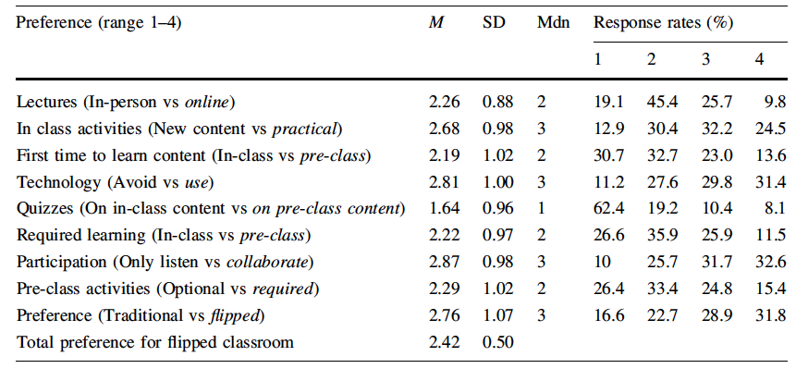**Table 1.** McNally (et al.), percentage responses from a group of 561 students.

**Table 2.** Percentage responses from a group of 40 EFL students.

|  | (*n* = 40) |  | Response rates (%) | | | |
| --- | --- | --- | --- | --- | --- | --- |
|  | Preference (range 1–4) | *Mdn* | 1  (strongly) | 2 (moderately) | 3 (moderately) | 4  (strongly) |
| 1 | Lectures (In-person vs online) | 2 | 7.5 | 55 | 25 | 6.25 |
| 2 | In class activities (New content vs practical) | 2 | 5 | 42.5 | 37.5 | 15 |
| 3 | First time to learn content (In-class vs pre-class) | 2 | 10 | 47.5 | 22.5 | 17.5 |
| 4 | Technology (Avoid vs use) | 3 | 0 | 20 | 47.5 | 35 |
| 5 | Quizzes (On in-class content vs on pre-class content) | 2 | 10 | 37.5 | 35 | 15 |
| 6 | Required learning (In-class vs pre-class) | 3 | 5 | 40 | 45 | 12.5 |
| 7 | Participation (Only listen vs collaborate) | 3 | 5 | 12.5 | 50 | 32.5 |
| 8 | Pre-class activities (Optional vs required) | 2 | 5 | 37.5 | 35 | 22.5 |
| 9 | Preference (Traditional vs flipped) | 3 | 2.5 | 37.5 | 40 | 17.5 |

This table about my students can be interpreted in the following way:

* 1. Lectures (In-person vs online): Students moderately but in majority prefer lectures delivered live and in person.
  2. In class activities (New content vs practical): Students moderately prefer to learn new content in class, rather than deal with practical and applied problems.
  3. First time to learn content (In-class vs pre-class): Students moderately prefer learning about new concepts in class first.
  4. Technology (Avoid vs use): Students moderately but in majority find the use of technology in education desirable.
  5. Quizzes (On in-class content vs on pre-class content): Students moderately prefer being quizzed only after material has been introduced in class.
  6. Required learning (In-class vs pre-class): Students moderately prefer having required learning before they go to class.
  7. Participation (Only listen vs collaborate): Students moderately prefer active and collaborative participation in class.
  8. Pre-class activities (Optional vs required): Students moderately prefer having optional pre-class activities.
  9. Preference (Traditional vs flipped): Students moderately prefer flipped classroom.

The difference between those two tables is in the teaching style area (2), my students are used to the traditional teaching style where the teacher is the centre of knowledge. The other difference is in moderate response to quizzes being assigned only after introducing the material in class (5). There is also preference for required reading done before students come to class (6). To language students, flexible reading time can be more helpful when they learn new vocabulary as well as content, hence they can be more confident in class. This finding supports McNally’s (et al.) research suggesting that EFL students prefer flipped strategy.

*2) to introduce the online learning environment and develop student interest in lifelong learning*

According to the second survey, 94% of students would like to use online learning in the future, the satisfaction rate is extremely high. However, there is evidence that “relying on student perceptions and satisfaction when evaluating flipped classrooms is not indicative of assessing student engagement and academic achievement and that future research in this area should attempt to measure more than student perceptions” (McNally, et al. 2016, p. 294). Additionally to student overall perception, this research gathered specific student academic achievement in the form of reflective statements, which involved deep thinking process (Figure 2). Student engagement could be seen through a feature in the learning platform that life-traced their percentage and time of completion.

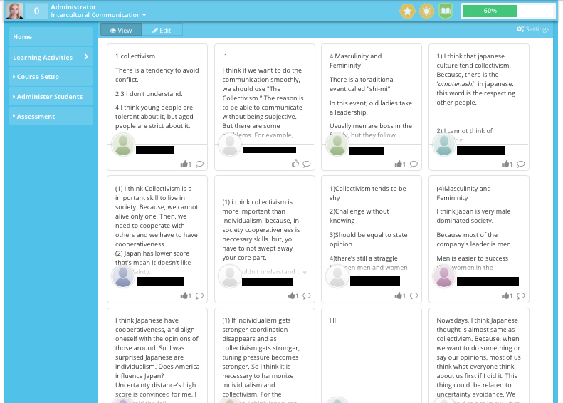Figure 2. *Reflective Statements*. Dobkowska, openlearning.com, 2018.

Although I could design my course, I could not know who in particular will take online lessons. Online teaching has to be flexible enough to accommodate diversity of students. One of the students who is already a lifelong learner was introduced to online learning and the internet in general (V1). The student is a woman in her 70s who used to learn English in the times when Okinawa was occupied by the U.S. after the Second World War and she lives in a small village in the remote coastal area. That was my only student who did not know how to turn on a computer. I scheduled a session with her where we went through opening a laptop, getting to, and navigating through the online learning environment. She is a great example of the power of the right attitude towards learning, regardless of age and language barrier. Despite her initial disadvantage in digital technology, I made sure I expressed my full confidence in her success and with the right support of the LLC tutors she finished the course on time and successfully went through the project. She expressed her interest in learning online from institutions outside of Japan.

*3) to develop my skills in the area of designing online course with the research in pedagogical theory about online learning, and develop understanding of the role of nonverbal communication in the digital environment.*

Throughout the project I had a chance to practice teaching in an online environment and learn about online education. I developed my technical skills in making an online course. I also had a chance to develop my understanding on the role of engagement and behaviour in an online learning environment, and I could promote empathy online by making VLE guidelines to help others in the future.

**Methodology**

This research is set to be participatory and ethnographic. Student participation shaped the learning environment and without their experience the project would not have been successful. It is also ethnographic as I looked at my students as a specific group of language learners. Through their engagement I could reflect on the research project.

In the designing stage, I researched multiple learning platforms and contacted several support assistants to receive information regarding privacy and payment. Eventually, I chose openlearning.com educational platform to host my project without any advertisements while remaining free of charge for all the users. This course can be seen by my students only, as it is safely accessed by invitation.

While I was making the online course I decided to do an initial survey and ask students about their previous experience with online learning. I had 48 registered students in my class. The students used the internet every day, but they did not use any form of online learning. One student did not have any experience with the internet. After receiving this information I decided to research ways to make the project more accessible for them. Assistant Director of the Language Learning Center was extremely supportive and together with the head of International Studies department and Associate Professor from the Language Learning Center (LLC) they accommodated my project. They provided physical space and language tutors for my students who needed more support with online learning. In the Language Learning Center there are English speaking students, who work as language tutors, and they could offer language guidance (A4).

In this project participated Level 3 undergraduate students, who are advanced English learners in International Studies Department and Meio University in Japan (A2). The course content aimed to help my students reflect on their sense of identity. The complex subject about identity and personal values, conducted in a foreign language requires greater attention to detail and student research in theory. The online environment provided flexible time, opportunity to stop and check vocabulary in search for meaning. Multilingual options in subtitles in the *TedEd* videos were also used in certain parts of the course. Students had to reflect on their experience regarding a particular theory, for example when learning about intercultural empathy they had to explain what the term means for them. One student replied poetically that it is “as if the cuddling of minds” (Intercultural Communication student, 2018). As a summative assessment, they had to submit a reflection essay on their own experience in reference to the studied theory. They could select one of seven subjects, or upon approval they could propose their own topic. The online learning project (A1) in flipped classroom was divided into four theoretical lessons with subcomponents:

1. *Belonging and Multilingualism*

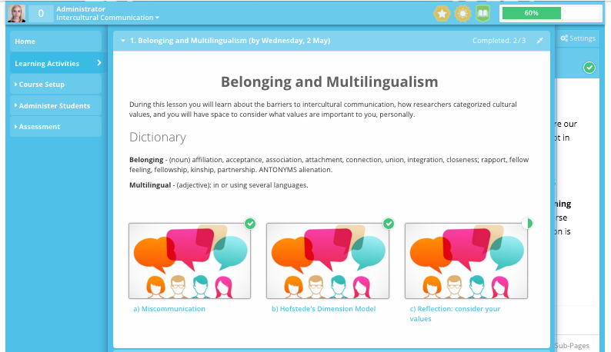Figure 3. *Belonging and Multilingualism*. Dobkowska, openlearning.com, 2018.

* 1. Miscommunication: *Barriers to Communication*, text about anxiety, assuming similarity instead of difference, ethnocentrism, stereotypes and prejudice, with questions suggested in *An introduction to intercultural communication: Identities in a global community* (Jandt, 2017). Students watched a short video (available with Japanese subtitles) from *TedEd* by Katherine Hampsten about *How miscommunication happens (and how to avoid it)*.
  2. Next part introduced Hofstede’s Value Dimensions with simple charts outlining countries and research methods with regards to the following dimensions: individualism - collectivism, uncertainty avoidance, power distance, masculinity and femininity.
  3. Reflection page, students had to use the four dimension model to think about their culture.

1. *Belonging and Globalisation*

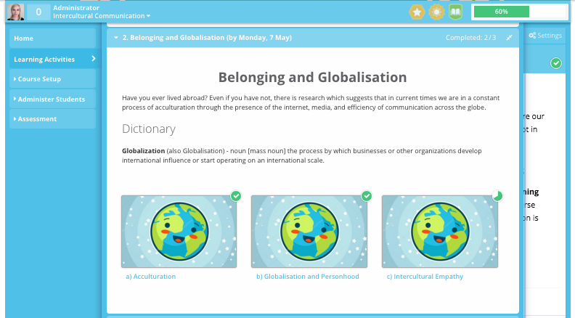Figure 4. *Belonging and Globalisation*. Dobkowska, openlearning.com, 2018.

* 1. Acculturation: video from *Introduction to Intercultural Communication*. (n.d). Shanghai International Studies University.
  2. *Globalization and Intercultural Personhood* by Young Yun Kim, theory about acculturation was presented in form of text and graphics with link to the full academic article presenting the theory.
  3. *Intercultural Empathy*, short video about the difference between empathy and sympathy. After watching the video (available with Japanese subtitles), students had to reflect on the following question: What does it mean to have Intercultural Empathy?

1. *Race and Power*

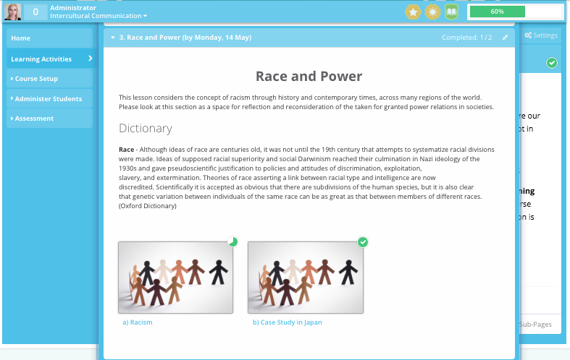

Figure 5. *Race and Power*. Dobkowska, openlearning.com, 2018.

* 1. A short video that describes racial categories as not biological but completely invented as there is nothing in our DNA that stands for the social concept of race, yet the concept affects many people. After watching the video students had to reflect on their thoughts regarding racism in Japan.
  2. Case Study in Japan - Miss Japan 2015 Ariana Miyamoto and the phenomenon of ‘hafu’ in Japan (the word comes from English *half*, the concept refers to the representation of blood as ethnicity, hence half-blood refers to half-ethnicity). Students had to personally reflect on their understanding of freedom of personal identity, and nationality. This is particularly important on Okinawa - ethnically diversified island, which historically was the capital of the Ryukyu Kingdom that was still an independent nation 150 years ago, to later get into the Japanese, American, and again Japanese administration, with the US military bases still present on the island.

1. *Performing Gender - Sexual Identity*

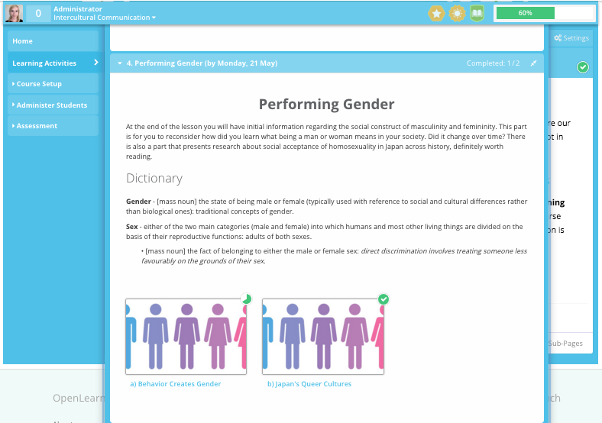

Figure 6. *Performing Gender*. Dobkowska, openlearning.com, 2018.

* 1. Introduction to Judith Butler’s research in form of a video where she explains that there are powers and practices that keep us in a norm of gender. Judith Butler asks how we can reconsider the boundaries that define our gender. She argues that gender is socially formed and defined by idealized gender norms. The danger of this system is revealed when those who are not meeting the standards face violence and lack of respect from society. Students had to watch the video and reflect on their experience.
  2. *Japan's Queer Cultures* by Mark McLelland introduced a research about the history of sexuality in Japan through early records in Medieval times to contemporary times. In accordance with the research, homosexuality was normalised before westernization of culture. English terminology adopted to describe homosexuality was used after the second world war and it was not accurately applied. English names can be misleading, “by the mid 1950s, the newly imported term *gei*, which had been introduced during the US Occupation, was being deployed as a trendy term to refer to homosexual nightspots and the professional young men who worked there (but not to the customers). Since many of the ‘boys’ working in these establishments exhibited transgender characteristics, *gei* came to represent a group of professional bar workers who engaged in transgender and other performances to entertain a clientele of more gender-normative customers referred to as *homo*” (McLelland, 2011, p.7). Full article was embedded after introduction to the research topic, however the article was not traced for progress purposes due to language difficulty.

Above is the final form of the course but after drafting the initial ideas I have received feedback from the senior members of staff at Meio University, especially regarding workload and appropriate language level of the particular students (K2). I have also received advice on my syllabus from a senior member of academia in the UK, my academic mentor who is a researcher in intercultural theatre. After receiving their feedback I added videos that have Japanese subtitles, as well as additional content about sexuality with regard to students’ geographical context (K1).

**Project Schedule and Observation**

In the beginning, I conducted research about the elements that make an online course enjoyable and easy to engage. I went through some online courses available on FutureLearn platform (K6). In February and March (A5) I studied: *Becoming a Student Assistant* by the University of Groningen in the Netherlands (five-week course throughout February and March), *Introduction to Intercultural Studies* by the University of Leeds (two-week course in March), *Physical Theatre: Meyerhold and Biomechanics* by the University of Leeds (three-weeks course in February and March), and *Zero Suicide Alliance Free Training* from NHS Foundation Trust (20 minutes course). I realised that the answer is in the audience, not only the course itself. To make an engaging course I have to think about my students, their university level, their cultural aesthetics, and their preferences regarding privacy. I designed the course accordingly. My project went through the following stages:

**February - 19 March:** Research

**19 March - 9 April:** Designed and prepared four lessons in the online environment and placed them on openlearning.com educational platform. Organised a support network at Meio University, where the Language Leaning Center (LLC) was the physical place for students to come if they needed support with online learning. I designed a handbook for the LLC tutors and provided a detailed introduction of the project to Associate Professor, who is in charge of the LLC.

**16 April:** I did an initial survey to check students’ current exposure to online learning. I designed a handbook to my students and organised time during the lecture to go through the steps to log in and navigate in the online environment. After class, I sent invitations to my course on openlearning.com and students had one week to join.

**23 April:** After the introduction to the project about identity and culture, students had one week to go through online lesson 1, the due date for this lesson was 2 May.

**2 May:** Lesson 1 *Belonging and Multilingualism*, during the lesson we went through the theory introduced in online learning. Although the topic was the same, the online lessons were designed to introduce the concept and give students time to think about their experience. In class, the subject was expanded to activities and additional information. At the end of the lesson, online lesson 2 was assigned to be done by 7 May.

**7 May:** Lesson 2 *Belonging and Globalisation*, in class activities about the lesson with introduction to the language of culture shock. Online lesson 3 was assigned to be done by 14 May.

**14 May:** Lesson 3 *Race and Power*, with in class activities and a short lecture. Online lesson 4 assigned by 21 May.

**21 May:** Lesson 4: *Performing Gender and Sexual Identity*, a lecture about gender studies with reflection activity, and student anonymous survey about online learning and in-class learning (K5).

**August:** Flipped classroom anonymous survey and project evaluation.

After designing, implementing, and evaluation of the project I have recorded a short presentation about the process. I posted the video online on VLE to keep my PGCLTHE tutors and peers informed about the progress. I have received immediate feedback, which encouraged me to work further on developing my online teaching practice into the area of student participation. In particular, I have chosen setting up guidelines for online video sharing and etiquette guideline for online interaction. The potential for this project is in mapping human interaction or non-verbal behavior in digital environment. This can be especially important to researchers and practitioners of theatre studies, because human behaviour is at the heart of the discipline. Therefore to develop online education we need to find ways to help students engage, participate, and find humanity in digital space.

**Conclusion**

Reflecting on the project goals set up at the beginning of the process, I have full confidence that I achieved my own growth through practice and research in the area of online learning. I also have developing understanding of the role of nonverbal communication in the digital environment. I collaborated with my academic colleagues at Meio University, as well as my peer group in the PGCLTHE course. Through this project I have introduced the students to the online learning environment, and hopefully that ignited their interest in lifelong learning. I have also learned from my older student that passion for learning does not fade with age. That gives me hope for the future. Student confidence in class can be seen through their participation and engagement, and their thoughts in anonymous surveys, as well as their successful completion of the module. The PGCLTHE tutor observation and peer observation made it easier to identity the impact of physical environment on student participation. Addressing students’ cultural style of learning has also been successful in reflecting on their cultural identity and values. After repeating McNally’s (et al.) survey in my classroom, I can also confirm the initial findings that the flipped strategy is positively received by students who learn English as a foreign language.

From the example presented in the introduction about online learning in the UK and in the US, I learned that the attitude and developed support system are significant in online learning. I noticed that making the project appear friendly is important in setting the right attitude for student participation. However, online learning should also be developed with academic rigour and be maintained regularly. New technology will need to develop greater possibility for personal interaction and this is certainly the direction we are going towards.

The project could be further developed into an entire course merging in-class and online learning with flipped classroom arrangement. Research indicated that student grades can improve if all the course is flipped, not only one project (McNally, et al. 2016, p. 293). This is a scope for development to serve better student outcomes. The effectiveness of teaching can be seen through student responses, feedback and formative assessment (Van de Grift 2014), and through those prisms I can see that my project was successful. The following note is from one of my students. It has been made in the anonymous, final survey.

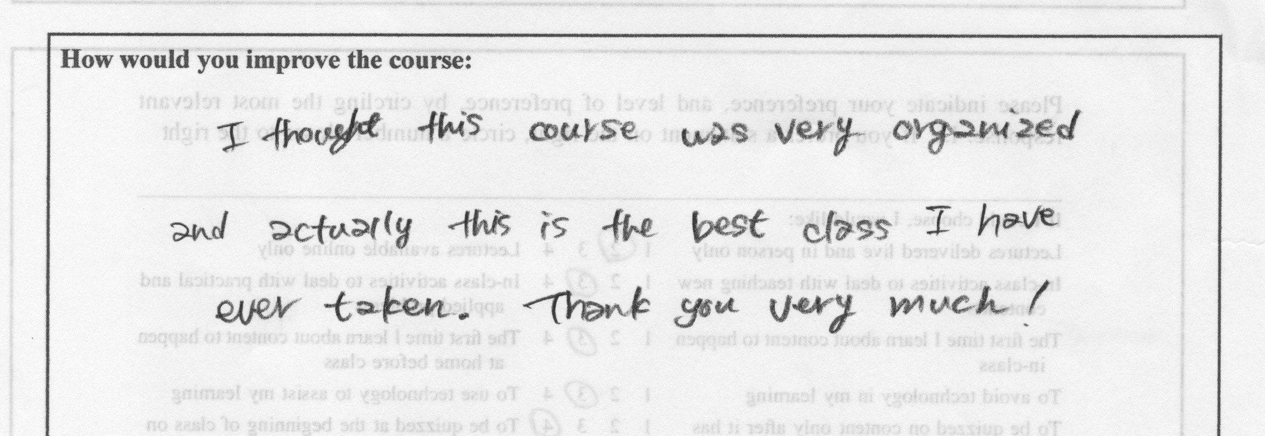

Figure 7. *Student’s Comment*. Anonymous Survey. 2018

Word count: 4,697

**References**

Ball, D. L. (2000) “Bridging practices: Intertwining content and pedagogy in teaching and learning to teach”. *Journal of Teacher Education,* 51(3), pp. 241–247.

*Becoming a Student Assistant*. (n.d.). The University of Groningen. [online] Available at: [https://www.futurelearn.com](https://href.li/?https://www.futurelearn.com) [Accessed 2 March 2018].

Bertalanffy, L. (1956) *General systems theory*. General Systems, 1, pp. 1-2.

Biggs, J., and Tang, C. (2011) *Teaching for quality learning at university (4th ed.)*. Berkshire, England: Open University Press.

Coleman, N. (2014) “Online learning: the UK’s scepticism is holding it back”. *The Guardian*. [online] Available at: <https://www.theguardian.com/higher-education-network/blog/2014/sep/07/online-learning-uk-scepticism-holding-it-back> [Accessed 9 August 2018].

Deci, E. L., and Ryan, R. M. (2000) “The ‘what’ and ‘why’ of goal pursuits: Human needs and the self-determination of behavior”. *Psychological Inquiry*, 11, 227-268.

Dobkowska, S. (2018) *Reflective Journal*. [online] Available at: [https://my-reflective-journey.blogspot.jp](https://href.li/?https://my-reflective-journey.blogspot.jp) [Accessed 15 March 2018].

Dweck, C. S. (2006) *Mindset: The new psychology of success*. New York, NY: Random House.

Dweck, C. S. (1999) Self-theories: Their role in motivation, personality, and development. Philadelphia, PA: Psychology Press.

Hall, R. (2018) “Guardian University Awards 2018: the winners”. *The Guardian*. [online] Available at:

<https://www.theguardian.com/higher-education-network/2018/apr/24/guardian-university-awards-2018-the-winners> [Accessed 9 August 2018].

Hampsten, K. (2016) *How miscommunication happens (and how to avoid it)*. [online] Available at: <https://www.youtube.com/watch?v=gCfzeONu3Mo> [Accessed 26 March 2018].

Hutchings, M.; Quincy, A. (2015) “The Flipped Classroom, Disruptive Pedagogies, Enabling Technologies and Wicked Problems: Responding to ‘the Bomb in the Basement’”. *The Electronic Journal of e-Learning* Volume 13 Issue 2 2015, p. 106-119. Available at: [www.ejet.org](http://www.ejet.org) [Accessed 28 July 2018].

*Introduction to Intercultural Communication*. (n.d) Shanghai International Studies University. [online] Available at: https://www.futurelearn.com [Accessed 4 March 2018].

Jandt, Fred E. (2017) *An introduction to intercultural communication: Identities in a global community*. Sage Publications.

Jantsch, E. (1980) *The self-organizing universe: Scientific and human implications of the emerging paradigm of evolution*. Pergamon: New York.

Jolin, L. (2015) “Distance learning taps in to virtual reality technology”. *The Guardian*. [online] Available at: <https://www.theguardian.com/education/2015/feb/19/distance-learning-taps-in-to-virtual-reality-technology> [Accessed 9 August 2018].

Kolb, D.A. (1984) “The process of experiential learning”. In Kolb, D.A. (Ed.), *Experiential learning: experience as the source of learning and development*. Upper Saddle River, NJ: Prentice Hall. pp. 20-39.

McLelland, M. (2011) “Japan's Queer Cultures”, in Theodore and Victoria Bestor (eds), *The Routledge Handbook of Japanese Culture and Society*. Routledge: New York. pp. 140-149.

McLuhan, M (1962) *The Gutenberg galaxy*. New American Library: New York.

McNally, B.; Chipperfield, J.; Dorsett, P.; Del Fabbro, L.; Frommolt, V.; Goetz, S.; Lewohl, J.; Molineux, M.; Pearson, A.; Reddan, G.; Roiko, A.; Rung, A. (2016) “Flipped classroom experiences: student preferences and flip strategy in a higher education context.” *Higher Education*. 73(2):281–298.

*Physical Theatre: Meyerhold and Biomechanics*. (n.d) University of Leeds. [online] Available at: [https://www.futurelearn.com](https://href.li/?https://www.futurelearn.com) [Accessed 2 March 2018].

Samovar, A. L; Porter, E. R; Stefani, A. L. (1997) *Communication Between Cultures*. Carolyn Sexton Roy: Books.

Toffler, A. (1980) *The third wave*. Bantam Books: New York.

Van de Grift, W. (2014) “Measuring Teaching Quality in Several European Countries”. *School Effectiveness and School Improvement*, 25(3), 295-311.

Weale, S. (2016) “Moocs to earn degree credits for first time in UK at two universities”. *The Guardian*. [online] Available at: <https://www.theguardian.com/education/2016/may/26/moocs-earn-degree-credits-first-time-two-uk-universities> [Accessed 9 August 2018].

*Zero Suicide Alliance Free Training* (n.d.) NHS Mersey Care NHS Foundation Trust. [online] Available at: <https://www.relias.co.uk/hubfs/ZSACourse3/story_html5.htmlutm_source=Relias&utm_campaign=Training-Landing-Page> [Accessed 27 March 2018].